UNITED NATIONS CHILDREN’S FUND
GENERIC JOB PROFILE (GJP)

I. Post Information

Job Title: Admin Assistant (Travel & Transport)  Supervisor and title: Admin/Finance Specialist, NO3  Organizational Unit: Field Office Aden  Post Location: Aden, Yemen  Case # YEM22058 | Job Level: G-5  Job Profile No.:  CCOG Code:  Functional Code:  Job Classification Level: G-5

II. Organizational Context and Purpose for the job

The fundamental mission of UNICEF is to promote the rights of every child, everywhere, in everything the organization does — in programs, in advocacy and in operations. The equity strategy, emphasizing the most disadvantaged and excluded children and families, translates this commitment to children’s rights into action. For UNICEF, equity means that all children have an opportunity to survive, develop and reach their full potential, without discrimination, bias or favoritism. To the degree that any child has an unequal chance in life — in its social, political, economic, civic and cultural dimensions — her or his rights are violated. There is growing evidence that investing in the health, education and protection of a society’s most disadvantaged citizens — addressing inequity — not only will give all children the opportunity to fulfill their potential but also will lead to sustained growth and stability of countries. This is why the focus on equity is so vital. It accelerates progress towards realizing the human rights of all children, which is the universal mandate of UNICEF, as outlined by the Convention on the Rights of the Child, while also supporting the equitable development of nations.

Job organizational context: (Please provide an overview of the office context in which this position works, briefly summarizing UNICEF’s current objectives in that particular office/division, as well as the specific role of the positions section in contributing to their achievement) Located in the UNICEF Aden Field Office, this position will report to Administrative and Finance Specialist, NO3, whilst supporting collaboratively Staff and colleagues on the daily Administrative, travel, accommodation and transport management.
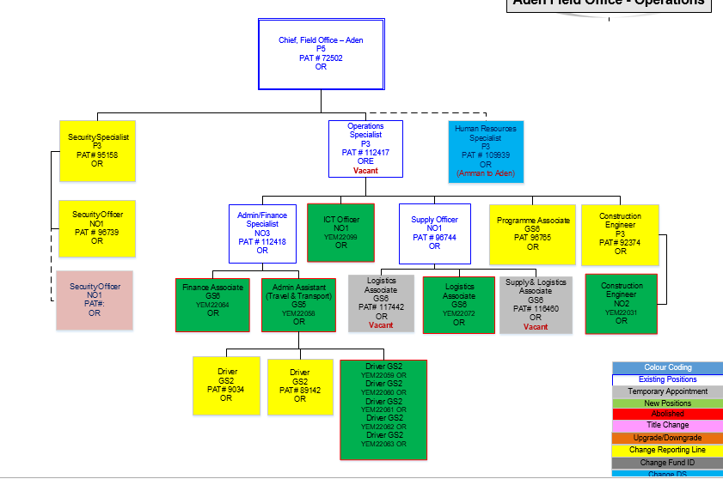

Purpose for the job:

Under the supervision and guidance of the supervisor, the Administrative and Travel Assistant is responsible for executing a broad variety of routine tasks and some specialized for the respective section, requiring thorough knowledge of UNICEF administrative procedures, processes and policies.
S/he is responsible for providing travel and transportation support as per established UN travel rules and regulations for official purposes. Review, evaluate and distribute work to the drivers and to the transport service providers. S/he makes travel arrangements for the Office and performs liaison duties with other units.

III. Key functions, accountabilities and related duties/tasks

Summary of key functions/accountabilities:

- Travel and guest house accommodation
- Invoice processing
- Procurement support for operations
- Office correspondence
- Fleet and drivers management
- General Administrative duties

Travel and guest house accommodation:

- Arrange and timely process travel authorization and travel entitlement and verifies travel claim settlement.
- Process and obtain visas for international staff member when required
- Extracts, inputs, maintains, and verifies correctness of travel records in the organization’s travel system to ensure accurate transactions related to travel costs and staff travel.
- Monitors travel certification and report back to the team.
- Act as a focal point for Aden guest house to process accommodation booking for international staff. Keep the GH booking record update for permanent and temporary guest using available system for GH booking and reservation.

Invoice Processing:

- Responsible for collecting invoices for goods/services and filing documents for approval and, thereafter processing in VISION on timely manner.
- Uploads electronic files and verifies results to destination system.
- Responds to client transaction status and other inquiries.

Procurement support for operations:

- Consolidates procurement requirements for Aden field Office with relevant staff and ensures provision of office supplies and services.
- Raise Purchase requisitions for local procurements in VISION and
- timely conduct low value procurement through Low Value Purchase Orders (LVPOs).

Office correspondence:
- Dispatch and receive pouches to/from country office and outpost/Hubs. Timely handover of all incoming mails to concern staff member.
- Draft correspondences, memorandum and reports via oral instructions, previous correspondences, other available information, or specialized tasks which may be of a confidential nature within the assigned area of responsibility, in accordance with standard office procedures.

Fleet and drivers management:
- Supervision of transport unit for implementing UNICEF vehicles management procedures, policies and guidelines in managing fleet.
- Ensure vehicles are equipped with required tools and communication equipment.
- Maintain vehicles in good working condition, ensures timely maintenance and repair of transport assets and drivers maintain up to date log on vehicles.
- ensure fuel/spare parts availability, proper utilization and reporting, including fuel consumption and efficiency reports and spare parts usage reports prepared and shared with operation for review and record.
- Supervises drivers and arranges daily transport needs. Prepare driver duty schedule on weekly/monthly bases for effective utilization of available drivers and vehicles considering working hours, weekend, night duties.
- Provide timely guidance and support to drivers for managing their duties, capacity building, leave balances and overtime as per office policies and procedures.

General Administrative duties:

- Maintain hard and electronic files and update data base systems ensuring timely and appropriate recording, safekeeping and disposal of confidential information
- Support effective working relations with other agencies, local authorities and implementing partners on issues relating to administrative matters through information exchange, collaboration, and harmonization. Cooperates with other UN agency counterparts in the UN reform initiatives (including common services and premises agenda, etc.).
- Performs any other tasks assigned by the supervisor.

IV. Impact of Results
The scope of key results extends beyond small, discrete teams to impact support services of larger, more complex organizational structures. S/He supports the supervisor in the compilation and coordination of work products, ensuring deadlines are met and that established rules and procedures are followed. The work is standardized; yet the incumbent must apply a good knowledge of guidelines, to operationally support the Division/Office. Key performance indicators go beyond the timeliness and accuracy of work to include planning and organizing the work of the team.

Administrative Assistants at this level represent the supervisor in communications involving the exchange of non-routine information, coordinating and following up on deadlines as well as establishing and maintaining communications with staff across various divisions. Communications require tact and discretion. They may also provide guidance and direction to temporary or lower level staff.

Travel related decisions and transport leasing recommendations have to conform to organizational rules and procedures and cost effectiveness, and any exceptions are properly documented for clearance from the Approving officer.

V. Competencies and level of proficiency required (based on UNICEF Professional Competency Profiles)

i) Core Values

- Care
- Respect
- Integrity
- Trust
- Accountability

ii) Core Competencies (For Staff without Supervisory Responsibilities) *

- Demonstrates Self Awareness and Ethical Awareness (1)
- Works Collaboratively with others (1)
- Builds and Maintains Partnerships (1)
- Innovates and Embraces Change (1)
- Thinks and Acts Strategically (1)
- Drive to achieve impactful results (1)
- Manages ambiguity and complexity (1)

*The 7 core competencies are applicable to all employees. However, the competency Nurtures, Leads and Managers people is only applicable to staff who supervise others.

VI. Skills

- Training and experience using MS Word, Excel, PowerPoint and other software such as SharePoint; knowledge of integrated management information systems required.
- Thorough knowledge of administrative policies and procedures.
- Organizational, planning and prioritizing skills and abilities.
- Ability to deal patiently and tactfully with visitors.
- High sense of confidentiality, initiative and good judgment.
- Ability to work effectively with people of different national and cultural background.
- Ability to work in a team environment to achieve common goals and to provide guidance to more junior support staff

VII. Recruitment Qualifications

Education: | Completion of secondary education is required, preferably supplemented by technical or university courses related to the field of work.
Experience: | A minimum of 5 years of relevant administrative or clerical work experience is required.
Language Requirements: | Fluency in English and Arabic is required. Knowledge of another UN language or local language of the duty station is considered as an asset.

VII. Signatures- Job Description Certification

Name: Samer Abdullah Signature Date
Title: Admin/Finance Specialist

Name: Charles Nzuki Signature Date
Title: Chief field office

Name: Philippe Duamelle Signature Date
Title: Representative

