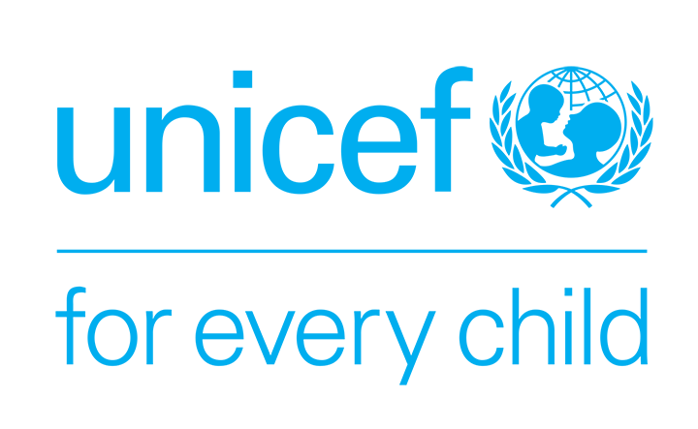 | UNITED NATIONS CHILDREN’S FUND  JOB PROFILE

I. Post Information

Job Title: Communication for Development Officer  Supervisor Title/ Level: Chief of Field Office Organizational Unit: Program Section  Post Location: Solomon Islands Field Office | Job Level: Level 2  Job Profile No.:  CCOG Code:  Functional Code:  Job Classification Level:

II. Organizational Context and Purpose for the job

Strategic office context :
UNICEF promotes the rights and wellbeing of every child, in everything we do. Together with our partners, we work to translate that commitment into practical action, especially for the most disadvantaged children.
In the Pacific we work in Cook Islands, Fiji, Kiribati, Marshall Islands, Federated States of Micronesia, Nauru, Niue, Palau, Samoa, Solomon Islands, Tokelau, Tonga, Tuvalu, Vanuatu: These 14 Pacific island countries are home to 2.3 million people, including 1.2 million children and youth, living on more than 660 islands and atolls stretching across 17.2 million square kilometres of the Pacific Ocean, an area comparable to the combined size of the United States of America and Canada.
UNICEF field offices are established in Kiribati, Vanuatu and Solomon Islands to support the multi-country programme in the Pacific region. This Communication for Development Officer post will be based in the Solomon Islands Field Office to support the team on communication, advocacy and communication for development activities.
Purpose of the job: The Communication for Development Officer reports to the Chief of Field Office (and second reporting line to Chief of Communication & C4D Specialist, Suva) for close supervision and guidance.

There are two key areas of the Communication Officer role:

- Assists in planning, implementing, monitoring and evaluating an advocacy and communication strategy to get children’s and women’s issues into the public domain, strengthen political will in support of UNICEF's mission and objectives in the country, and enhance the organization’s credibility and brand.
- Provide technical and operational support to the Supervisor and Communication for Development team by administering, executing and implementing a variety of tasks to promote community engagement and participation, and measureable behavioral and social change/mobilization.

III. Key functions, accountabilities and related duties/tasks

1. Support to UNICEF Pacific communication, advocacy and communication for development strategies and work plans at country level

- The production of communication products and materials to support the UNICEF Pacific communication strategies ensuring country context;
- Develop content and coverage of relevant country efforts to identify effective relevant country programme activities and results;
- Develop complementary, country specific and local community materials and activities (e.g. briefing notes, images, videos, web pages etc.) that meet the country and global standards as set out in the Communication Toolkit;
- Assist in drafting and editing articles, press releases, human interest stories and other advocacy/information materials for both web-based and traditional media, as appropriate. Recommend appropriate information and communication materials for use in media, and other advocacy and communication activities;
- Support research and/or participate in conducting comprehensive C4D situation analysis of social, cultural, economic, communication and political issues in the country/region;
- Support evidence-based communication strategies for social and behavior change related programme results, as well as for public information and advocacy purposes;
- Support the identification and maintenance (stock take) of resources, channels, tools, contacts, and networks to support maximum impact and outreach of communication and community engagement initiatives;

2. Advocacy, media management and partnership building

- Effective and timely professional assistance and support are provided in developing, drafting and maintaining contact information, materials and relationships with journalists and media outlets covering all media in the country to communicate the story of UNICEF's cooperation to a wider audience;

- Ensure that the field office’s contact list of individuals, groups, organizations and fora (including Government, UN, and bilateral counterparts), are maintained and further developed, whose support is essential to/can assist in achieving the advocacy and communication objectives and who support and are able to actively participate in special events and activities that further the country programme goals;
- Build and maintain partnerships through networking and proactive collaboration with national and international civil society organizations, community groups, leaders and other critical partners in the community and civil society to reinforce cooperation through engagement, empowerment and self determination and to pursue opportunities for greater advocacy to promote UNICEF mission and goals for child rights, social equity and inclusiveness;

- Collaborate with internal global/regional communication partners to harmonize, link and/or coordinate messaging to enhance Communication for Development outreach and contribution to programmatic outcomes;

- Support the organization of public events and mobilization activities to ensure maximum outreach and intended impact of communication strategies (C4D, Advocacy).

3. Support capacity building and systems strengthening initiatives

- Support UNICEF Pacific partners in the Solomon Islands in media engagement and capacity building initiatives for appropriate reporting of children rights and wellbeing issues;
- Support the organization, administration and implementation of capacity building initiatives to enhance the communication competencies of clients/stakeholders/partners/media across programme sectors in support of program goals in development and humanitarian agenda.

4. Monitoring, Evaluation, and Knowledge management

- Monitor/track the implementation and progress of communication/advocacy and communication for development activities implemented;
- Support the evaluation of results of communication strategies implemented in support of programme goals, assessing contribution, impact and lessons learned.

IV. Impact of Results

- UNICEF Pacific advocacy and communication strategy to get children’s and women’s issues into the public domain supported, strengthened political will in support of UNICEF's mission and objectives in the country, and enhancement of organization’s credibility and brand
- Community engagement and participation, and measureable behavioral and social change/mobilization achieved in line with the Communication for Development strategies

V. Competencies and level of proficiency required (please base on UNICEF Competency Profiles)

Core Values  - Commitment  - Diversity and inclusion  - Integrity  Core competencies  - Communication (II)  - Working with people (I)  - Drive for results (I) | Functional Competencies:  - Formulating strategies/concepts (I)  - Relating and networking (I)  - Persuading and influencing (I)  - Applying technical expertise (I)  - Learning and researching (II)  - Planning and organizing (II)

VI. Recruitment Qualifications

Education: | A University Degree in Communications, Journalism, Public Relations, social and behavioral science or other related field is required.
Experience: | At least two years of professional experience in areas of communication, print and broadcast media, digital media, social development program planning, or related areas
Language Requirements: | Fluency in English is required. Knowledge of another official UN language or a local language is an asset

VII. Signatures- Job Description Certification

Name: Signature Date
Title:

Name: Signature Date
Title:

