JOB TITLE: Planning Specialist, Post # 68354  JOB LEVEL: NO-C  REPORTS TO: Chief Planning (P4), Post # 87210  Organizational Unit: Programme  LOCATION: Jakarta, Indonesia | JOB PROFILE NO.:____________  CCOG CODE:____ ____________  FUNCTIONAL CODE: __  JOB CLASSIFICATION ________
PURPOSE OF THE JOB
Under the Chief, Planning's direct supervision, assures the quality of child rights-based programmes through consistent and effective planning, design, implementation, monitoring and/or evaluation of programmes and projects. Brings coherence, synergy and added value to the programme planning and design processes using a results-based management approach to programme design.

This will include active involvement in developing country programme planning documents, including CPDs, CPAPs, and relevant work plans with the Government of Indonesia and ensuring effective synchronization of UNICEF with Government of Indonesia planning processes and related UN Indonesia coordination.

The incumbent will play a a significant role in the Country Office’s end-to-end budget planning processes with donors / development partners, including grants management, budget monitoring and reporting on fund utilization, and providing timely advice to programme colleagues related to grant requirements and conditions.

The incumbent will also have responsibility for capacity building of Programme section and field office colleagues in effective planning, budgeting, and partnership management processes including efficient and effective application of the Harmonized Approach to Cash Transfer procedures.

The incumbent will coordinate closely his/her work with the Chief, Planning, the Deputy Representative Programmes, programme colleagues in Jakarta and field offices, and relevant colleagues in Operations.

KEY END-RESULTS
- Programme Planning and Design
- Grants Management
- Programme Results Monitoring
- Compliance with HACT policies and procedures
- Oversight for CSO partnership processes
- Rights-Based and Results-Based Approach to Programming
KEY ACCOUNTABILITIES and DUTIES & TASKS
Within the delegated authority and the given organizational set-up, the incumbent may be accountable for all or assigned areas of the following major duties and end results.
Programme Planning and Design: Supports the Country Office and national partners to develop an equity-focused and results-based and measurable Country Programme and workplans that provide the basis for implementation, performance monitoring and reporting. Specifically,
- Contributes to the preparation of country programme documentation and other related planning documents such as, Country Programme Document, Country Programme Action Plan, Country Programme Management Plan, Annual Work Plan, Annual Management Plan, and other planning documents agreed with key partners. Provides quality assurance in developing those documents to ensure alignment with UNICEF's Programme Policy and Procedure manual (PPP) and other guidance. Provides technical advice to programme staff, government officials and other counterparts on planning as needed.
- Leads effective coordination of work planning and review processes with the key main government partners (Ministry of Planning/Bappenas and Ministry of Home Affairs/Bangda).
- Supports and facilitates development of equity-focused, results-based and risk-informed work plans and review exercises of the same.
- Coordinates development, quality assurance and entry of workplans in the RAM system for programme sections and maintenance of the country programme results framework, including indicators, baselines and targets, the identification of PIDB codes and humanitarian / gender / climate markers, and quality assures its reflection in VISION.
- Provides technical support and capacity development for decentralization of the development and implementation of the workplan in close collaboration with Programme sections and field office staff. Ensures effective use of planning tools in field offices and Programme sections in line with the results-based management principles and standards.

Grant Management: Supports grant management processes including the issuance, allocation, utilization, conformity with donor conditions, amendments and adjustments, and reporting. Ensures reports are available to monitor and manage optimal use of resources appropriately. Specifically,
- Focal point for management of grants, including clearance of proposals/agreements by PPD/PFP HQ, grant issuance, follow up on tranches and extension requests, and performing allocation of budgets in VISION in a timely and appropriate manner.
- Manage grant allotment and funding allocation/re-allocation including rephasing.
- Monitors commitments and expenditures to ensure timely utilization and use conforming to donor conditions and reconciling and resolving all discrepancies as needed.
- Liaise with the Deputy Representative to ensure decisions are taken on budget management within the programme framework and donor objectives to ensure financial information meets targets, goals and objectives.
- Prepares the programme/grant status reports required for management, board, donors, budget reviews, programme analysis, and annual reports.
- Participates in intersectoral collaboration with operations and programme colleagues in tracking programme financial inputs and outputs.
Programme Results Monitoring: Oversees timely and quality progress monitoring and reporting on country programme results. Specifically,
- Supports periodic programme reviews internally as well as with government counterparts and other partners. Prepares and consolidates inputs for programme mid-term review, annual reviews and other relevant meetings. Analyzes and evaluates data to ensure achievement of objectives and recommends corrective actions when necessary. Monitors implementation of agreed follow-up actions. Ensures lessons learned and recommendations from reviews inform planning processes.
- Ensures the accurate and timely input of programme information in the computerized programme system, and issuance of status reports for monitoring purposes. Drawing on monitoring and analysis of key programme performance indicators, provides professional inputs to management reports, including the Annual Report, RAM and Strategic Monitoring Questions (SMQs).
- Supports Country Management Team oversight by monitoring management indicators and compliance with relevant SOPs and UNICEF Key Performance Indicators in Regional and Office Dashboards and office-specific indicators.

Compliance with HACT policies and procedures: Ensures compliance with the respective operational policies and procedures of the Harmonized Approach to Cash Transfer (HACT). Specifically,
  - Monitors the status and compliance of HACT implementation at the country level using corporate tools and systems such as eTools and InSight.
  - Oversees the HACT assurance plan and advises management on compliance with regional and global HACT targets with support from HACT Officer and HACT Associates.
  - Coordinates the spot check process of implementing partners in collaboration with the in-house spot check roster that consists of section and field office Programme Associates, Finance team, and HACT Officer and Assistant in PME.
  - Guides, advises and supports programme colleagues and Implementing Partners (IPs) on overall HACT compliance and good practices, including the different types of assurance activities.
Oversight of CSO partnership Management: Ensures compliance with the UNICEF Procedure for Country Office CSO Implementing Partnerships. Specifically,
  - Guides, advises and supports programme colleagues in quality assurance activities related to PCAs, SSFAs, MoUs, other agreements and any other implementation-related documents.
  - In close collaboration with the Secretary to the Partnership Review Committee (PRC), ensures that the establishment of partnership agreements with civil society partners comply with UNICEF’s Procedure for CSO Implementing Partnerships, and suggests appropriate measures to safeguard UNICEF resources and reputational risks associated with the partnership environment.
  - Supports the Office’s use of eTools for implementing partnership management, including for parthership selection, management and monitoring of CSO partnerships to deliver results for children.
  - Supports oversight role in risk assessment of CSO partnerships from a HACT perspective, and consults with the Deputy Representatives for Programmes and Operations on issues raised from assurance activities that require management attention.
  - Monitors and provides the CMT with key performance indicator data related to partnerships and cash disbursements and timely liquidation on regular basis.
  - Supports and facilitates capacity development activities for staff and IPs on CSO partnerships management, including sharing of good practices.
Rights-Based and Results-Based Planning Approach to Programming
- Ensures viable recommendations on project implementation, alternative approaches, and optimal utilization of resources that contribute effectively to the fulfilment of the rights of children and women, and recommendations on new programme initiatives and management issues to ensure achievement of stated objectives.
- Supports planning, monitoring and reporting of joint UN initiatives and processes relating to the United Nations Sustainable Development Cooperation Framework (UNSDCF) or One UN, updating information in the joint workplan through UN INFO, to ensure that UNICEF's areas of focus/contributions are captured and assists UNICEF's participation in the UNSDCF process ensuring adequate inputs on the advancement of the rights of children and women.

POSITION GRADE FACTORS

P3/NOC - As a line manager, effective and efficient programme planning, design, implementation and administration of either a small programme or specific project activities within a major programme that focuses on achievement of UNICEF's programmatic priorities.
- As a technical expert, provide timely and effective expert advice, guidance and input on situation analysis, programme strategy, planning, implementation and evaluation and human resources.
- Make viable recommendations on project implementation, alternative approaches, and optimal utilization of resources that contribute effectively to the fulfilment of the rights of children and women.
- Responsible for certification of allocation and disbursement of funds; determination of supply and cash needs to ensure programme delivery meets targeted goals and objectives.
QUALIFICATION and COMPETENCIES ([ ] indicates the level of proficiency required for the job.)
- Education
Advanced university degree in Social Sciences, International Relations, Government, Public Administration, Public Policy, Social Policy, Social Development, Community Development, or other relevant disciplines, with specialized training in conflict resolution.
- Work Experience
Five years of relevant professional work experience.
National or field work experience.
Background/familiarity with emergency response will be an asset.
- Language Proficiency [ II ]
Fluency in English and Bahasa Indonesia.
4. Competency Profile (For details on competencies please refer to the UNICEF Professional Competency Profiles.)
i) Core Values (Required)
- Commitment • Diversity and Inclusion • Integrity
ii) Core Competencies (Required)
• Communication [ II ] • Working with People [ II ] • Drive for Result [ II ]

UNICEF's values of Care, Respect, Integrity, Trust, and Accountability (CRITA) and core competencies as follow:
- Builds and Maintains Partnerships
- Demonstrates self-awareness and ethical awareness
- Drive to achieve results for impact
- Innovates and embraces change
- Manages ambiguity and complexity
- Thinks and acts strategically
- Works collaboratively with others
- Nurtures, leads and manages people

- Functional Competencies (Required)
• Leading and Supervising [ II ] • Formulating Strategies and Concepts [ II ]
• Analyzing [ II ] • Relating and Networking [ II ]
• Persuading and Influencing [ II ] • Creating and Innovating [ II ]

iii) Technical Knowledge
a) Common Technical Knowledge Required (for the job group)
• Methodology of programme/project management
• UNICEF programmatic goals, visions, positions, policies and strategies.
• Knowledge of global human rights issues, specifically relating to children and women, and the current UNICEF position and approaches.
• UNICEF policies and strategy to address national and international issues, particularly relating to conflicts, natural disasters, and recovery.
• UNICEF emergency programme policies, goals, strategies and approaches.

b) Specific Technical Knowledge Required
(Technical knowledge requirements specific to the job can be added here as required.)
• Rights-based and Results-based approach and programming in UNICEF.
• UNICEF programme policy, procedures and guidelines in the PPP manual and specific procedures on Harmonized Approach to Cash Transfer (HACT) and CSO partnerships.
• UNICEF Strategic Plan
- Knowledge on UNICEF databases, implementation, planning and reporting tools, such as VISION, InSight, RAM & eTools.
c) Technical Knowledge to be Acquired/Enhanced (for the Job)
• UN policies and strategy to address international humanitarian issues and the responses.
• UN common approaches to programmatic issues and UNICEF positions
• UN security operations and guidelines.
• UNSECORD training for members of Security Management Team.

SIGNATURES – Certification of Job Description
Chief of Section: Chief, Planning | Signature Date
Debora Comini, Representative | Signature Date

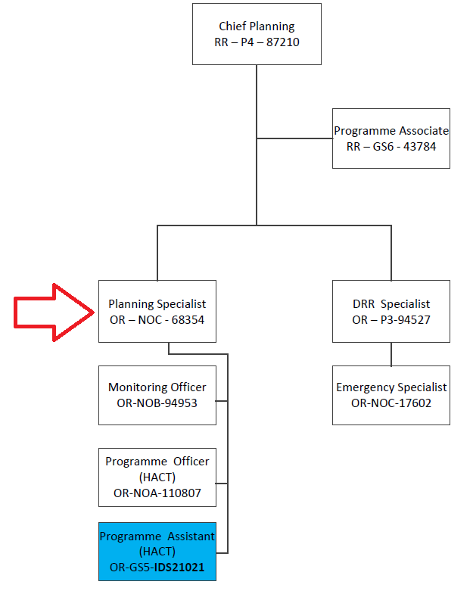

Position grade differences reflect various differences, among others, in the nature of work, individual contribution, scope of professional expertise required, organizational context, risks, coordination and networking, engagement, partners, beneficiaries, clients/stakeholders relations, impact of decisions, actions and consequences, and leadership roles.

