JOB TITLE: Private Sector Fundraising (PSFR) Assistant (Donor Care), Case # IDS21035, Post # 114084  JOB LEVEL: GS-4  REPORTS TO: PSFR Associate (TL Donor Care) (GS6), Case # IDS21033  Organizational Unit: PFP  LOCATION: Country Office - Jakarta, Indonesia | JOB PROFLE NO.:___ _  CCOG CODE:_____________  FUNCTIONAL CODE: __ __  JOB CLASSIFICATION ________
PURPOSE OF THE JOB
UNICEF’s work in Indonesia is entirely funded by voluntary contributions, with an essential part being regular monthly contributions from almost 60,000 individual donors – our “Pendekar Anak”. An additional 10,000 donors donate one-off or repeated times over a year, without monthly commitment.

Support UNICEF Indonesia’s Customer services, with the goal to continuously improve donors’ experiences, retention and saving rate.
KEY END-RESULTS

Improve experiences of donors with UNICEF: improve donor’s experiences from supporter servicing, welcome call, retention, and saving cancellation through various channels
KEY ACCOUNTABILITIES and DUTIES & TASKS
- Ensure the consistent provision of professional, donor-focused customer service by (40%):
• Performing enquiries from various sources in a timely fashion.
• Performing case escalations and ensure all cases are closed.
• Enlisting relevant assistance from various internal teams and external party/ies to support enquiries
- Supporting customer service function to deliver the highest level of donor at all times. (20%)
- Assist in data entry of donor profiles and donations and other matters that may arise. (20%)
- Work closely with Donation Processing Assistant and Donor Database and Application for other matters that may arise. (15%)
- Perform other reasonably related duties as assigned by Fundraising Specialist (Donor Management). (5%)
JOB GRADE FACTORS
- Reports to PSFR Associate – Donor Care (GS6)
- Operates in the context of a medium-sized country office or an area office.
- Responsible for providing of data to produce analysis, and reports
- Work under the general supervision of Donor Care Associate. The supervisor defines the parameters of assignments and outlines approaches to problem areas.
- Incumbent operates within rules and regulations, and report to supervisor when a deviation from guidelines or changes in procedures is required.

QUALIFICATION and COMPETENCIES ([ ] indicates the level of proficiency required for the job.)
- Education
Completion of secondary education; proven customer service ability; data entry and knowledge of data management an asset.
- Work Experience
At least four (4) years of administrative/ clerical experience: 2 years Customer Service experience. And at least 1 years managing Customer Service team in retails industry (experience in banking, telco industry or fundraising organization is an assets)

- Language Proficiency [ II ]
Fluency in English and Bahasa Indonesia required.
4. Competency Profile (For details on competencies please refer to the UNICEF Professional Competency Profiles.)
i) Core Values (Required)
Care ; Respect ; Integrity; Trust; Accountability
ii) Core Competencies (Required)
• Communication [ II ] • Working with People [ I ] • Drive for Results [ I ]

- Functional Competencies (Required)
• Applying Technical Expertise [ I ]
• Analyzing [ I]
• Learning & Researching [ II]
• Applying Technical Expertise [ I]

iii) Technical Knowledge
a) Specific Technical Knowledge Required
Specific and up-to-date working knowledge of:
- Client/Customer/People Management
- Customer handling, pleasant personality and service oriented
- Good communication skill

b) Common Technical Knowledge Required (for the job group)
General knowledge of:
- Computer systems, including internet navigation, and office applications.
- Good understanding of the context of United Nations/international organizations, world affairs, current events and international development issues
c) Technical Knowledge to be Acquired/Enhanced (for the Job)
- Technical knowledge of UNICEF’s regular donor strategies and techniques
- All relevant technical aspects of the IT used by UNICEF
- UN common approaches to programmatic issues and UNICEF positions
- UN security operations and guidelines.

SIGNATURES – Certification of Job Description
Chief of Section: Gregor Henneka, Chief Resource Mobilization and Partnerships | Signature Date
Debora Comini, Representative | Signature Date

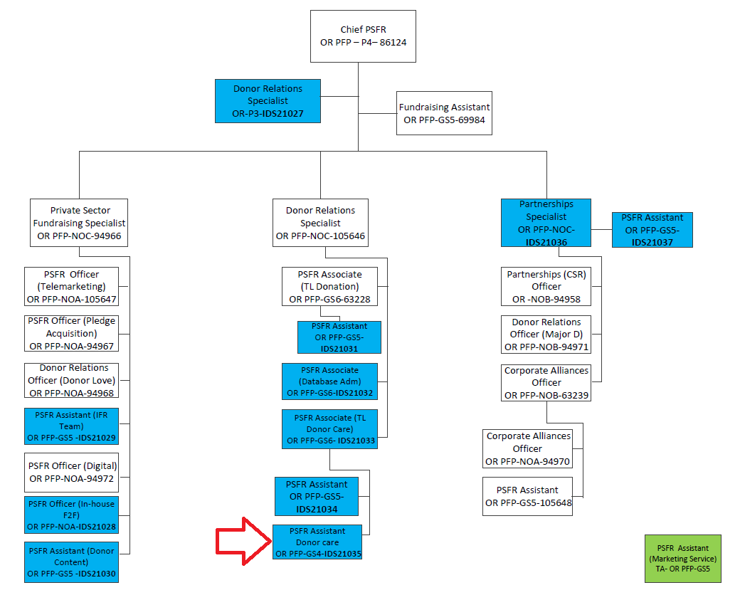

The differences in the grades of jobs and positions reflect various differences, among others, in the nature and scope of work, individual contribution, professional expertise required, organizational context, risks, coordination and ,etworking, engagement, partners, beneficiaries, clients/stakeholders relations, impact of decisions, actions and consequences, and leadership roles.

