UNITED NATIONS CHILDREN’S FUND
SPECIFIC JOB PROFILE (SJP)

I. Post Information

Job Title: Child Protection Officer (MRM Data Base) Level: NO-2  Supervisor Title/ Level: Child Protection Specialist (MRM/CAAC) P-3  Organizational Unit: Child Protection  Post Location: Yemen CO, O/P Amman, Jordan  Position #118489 | Job Level:  Job Profile No.:  CCOG Code:  Functional Code:  Job Classification Level:

II. Organizational Context and Purpose for the job

The fundamental mission of UNICEF is to promote the rights of every child, everywhere, in everything the organization does — in programmes, in advocacy and in operations. The equity strategy, emphasizing the most disadvantaged and excluded children and families, translates this commitment to children’s rights into action. For UNICEF, equity means that all children have an opportunity to survive, develop and reach their full potential, without discrimination, bias or favoritism. To the degree that any child has an unequal chance in life — in its social, political, economic, civic and cultural dimensions — her or his rights are violated. There is growing evidence that investing in the health, education and protection of a society’s most disadvantaged citizens — addressing inequity — not only will give all children the opportunity to fulfill their potential but also will lead to sustained growth and stability of countries. This is why the focus on equity is so vital. It accelerates progress towards realizing the human rights of all children, which is the universal mandate of UNICEF, as outlined by the Convention on the Rights of the Child, while also supporting the equitable development of nations.

Job organizational context:
The conflict-driven humanitarian crisis in Yemen is described as the largest emergency in the world. More than 20 million people require humanitarian assistance. Conflict has led to the internal displacement of 3 million people, Children are the primary victims with multiple violations documented and verified including killing and maiming, use and recruitment of children, the damage and closure of schools threaten children's access to education, Yemen continues to face a severe protection crisis, with serious risks to the safety, well-being and basic rights of children. The situation for children was already dire before the crisis, and security challenges, conflict and widespread poverty have led to the further breakdown of family protective mechanisms, hence damaging the lives of children and threatening the realization of children's rights. there are notable 13 active parties to the conflict in Yemen in which 6 parties have been listed consecutively since 2015 for perpetrating various child right violations. Monitoring and reporting mechanism as one of the main part of children and armed conflict is established Pursuant to UN Security Council Resolution 1612 and activated in Yemen in 2011.

UNICEF Yemen’s child protection programme ensures that all children, especially the most vulnerable, are better protected from violence, exploitation, abuse and harmful practices. As the conflict continues into its sixth year, Yemen continues to face a severe protection crisis, with serious risks to the safety, well-being and basic rights of children. The situation for children was already dire before the crisis, and security challenges, conflict and widespread poverty have led to the further breakdown of family protective mechanisms, hence damaging the lives of children and threatening the realization of children's rights.
As mandated by Security Council Resolutions 1612 (2005), 1882 (2009) and 1998 (2011) on children and armed conflict (CAAC), the MRM aims to prevent violations against children in the context of armed conflict, hold parties to the conflict accountable for such violations, and provide appropriate responses to children affected by the conflict in collaboration with all relevant stakeholders. As the UN’s lead agency for children, UNICEF carries a special responsibility for the effective implementation of the MRM at country, regional and HQ levels, and particularly to support timely and adequate monitoring, response programming, advocacy and services for children.
UNICEF works with the UN Country Taskforce on the Monitoring and Reporting Mechanism by reporting on grave child rights violations, in line with the Security Council Resolution (SCR) 1612. UNICEF ensures that all six grave rights violations outlined in SCR 1612 are brought to the attention of the Council and UN member states as well as the authorities in Yemen. Since the Monitoring and Reporting Mechanism (MRM) has yielded evidence on verified grave violations related to child protection, the CAAC agenda is one of the main prioritized issues under UNICEF's child protection programme.
Child Protection Officer (data management) will support the data management and reporting of the data for MRM.
The Child Protection Officer (data management) reports to Child Protection Specialist, P-3.

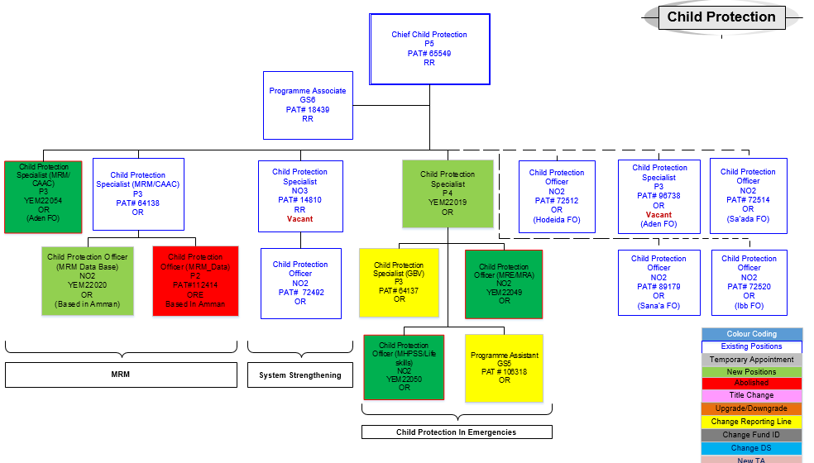

Purpose for the job:

The Child Protection Officer reports to the Child Protection Specialist (MRM/CAAC) for supervision. H/She prepares, executes, manages, and implements a variety of technical and administrative programme tasks to facilitate programme development, implementation, programme progress monitoring, evaluating and reporting.

III. Key function, accountabilities and related duties/tasks

Summary of key functions/accountabilities:

- Support to programme development and planning
- Programme management, monitoring and delivery of results
- Technical and operational support to programme implementation
- Networking and partnership building
- Innovation, knowledge management and capacity building

- Support to programme development and planning
- Conduct and update the situation analysis for the development, design and management of the CAAC and MRM components child protection related programmes/projects. Research and report on development trends (e.g. economic, social, health) and data for use in programme development, management, monitoring, evaluation and delivery of results.
- Contribute to the development and establishment of Children and Armed Conflict sectoral programme goals, objectives, strategies, and results-based planning through research, analysis and reporting of child protection and other related information for development planning and priority and goal setting.
- Provide technical and operational support throughout all stages of programming processes by executing and administering a variety of technical, programme, operational, and administrative transactions, preparing related materials and documentations, and complying with organizational processes and management systems, to support programme planning, results-based planning (RBM) and monitoring and evaluating of results.

- Prepare required programme documentations, materials and data to facilitate the CAAC and MRM programme review and approval process.

- Programme management, monitoring and delivery of results

- Work closely and collaboratively with colleagues and CAAC/MRM partners to discuss implementation issues, provide solutions, recommendations and/or to alert appropriate officials and stakeholders for higher-level interventions and/or decisions. Keep records of reports and assessments for easy reference and/or to capture and institutionalize lessons learned.

- Participate in monitoring and evaluation exercises, programme reviews and annual sectoral reviews with MRM/CAAC counterparts to assess programmes/projects, and to report on required action/interventions at the higher level of programme management.

- Monitor and report on the use of MRM/ CAAC programme resources (financial, administrative and other assets), verifying compliance with approved allocations, organizational rules, regulations, procedures and donor commitments, standards of accountability and integrity. Report on critical issues and findings to ensure timely resolution by management and stakeholders. Follow up on unresolved issues to ensure resolution.

- Prepare regular and mandated MRM/CAAC reports for relevant partners, supervisor and chief of child protection to keep them informed of programme progress.

- Technical and operational support to programme implementation

- Conduct regular programme field visits and surveys and exchange information with partners/stakeholders to assess progress and provide technical support. Take appropriate action to resolve issues and/or refer to relevant officials for resolution. Report on critical issues, bottlenecks and potential problems for timely action to achieve results.

- Provide technical and operational support to government counterparts, NGO partners, UN system partners and other country office partners/donors on the application and understanding of UNICEF policies, strategies, processes and best practices in child protection, to support programme implementation.

- Networking and partnership building

- Build and sustain close working partnerships with MRM/CAAC partners and stakeholders through active sharing of information and knowledge to facilitate programme implementation and build capacity of stakeholders to achieve and sustain results on child protection.
- Participate in inter-agency meetings/events on programming to collaborate with inter-agency partners/colleagues on UN operational planning and preparation of child protection programmes/projects, and to integrate and harmonize UNICEF’s position and strategies with UN development and planning processes.

- Research information on potential donors and prepare resource mobilization materials and briefs for fund raising and partnership development purposes.

- Draft communication and information materials for CO programme advocacy to promote awareness, establish partnership/alliances and support fund raising for child protection programmes.

- Innovation, knowledge management and capacity building

- Identify, capture, synthesize, and share lessons learned for knowledge development and to build the capacity of stakeholders.

- Apply innovative approaches and promote good practices to support the implementation and delivery of concrete and sustainable programme results.

- Research and report on best and cutting-edge practices for development planning of knowledge products and systems.

- Participate as a resource person in capacity building initiatives to enhance the competencies of clients and stakeholders.

IV. Impact of Results

The efficiency and efficacy of support provided by the Child Protection Officer to programme preparation, planning and implementation, contributes to the achievement of sustainable results to create a protective environment for children against harm and all forms of violence, and ensures their survival, development and well-being in society. Success in child protection programmes and projects in turn contributes to maintaining and enhancing the credibility and ability of UNICEF to provide programme services for mothers and children that promotes greater social equality in the country.

V. UNICEF values and competency Required (based on the updated Framework)

i) Core Values

- Care
- Respect
- Integrity
- Trust
- Accountability

ii) Core Competencies

- Demonstrates Self Awareness and Ethical Awareness (1)
- Works Collaboratively with others (1)
- Builds and Maintains Partnerships (1)
- Innovates and Embraces Change (1)
- Thinks and Acts Strategically (1)
- Drive to achieve impactful results (1)
- Manages ambiguity and complexity (1)

VI. Recruitment Qualifications

Education: | A university degree in one of the following fields is required: international development, human rights, psychology, sociology, international law, or another relevant social science field.
Experience: | A minimum of two years of professional experience in information management or data management is required.  Social development planning and management in child protection related areas is preferred  Relevant experience in programme development in child protection related areas in a UN system agency or organization is considered as an asset.  Experience in both development and humanitarian contexts is an added advantage.
Language Requirements: | Fluency in English and Arabic are required. Knowledge of a local language is an asset.

VII. Signatures- Job Description Certification

Name: Senathirajah Ravindran Signature Date
Title: Child Protection Specialist (MRM/CAAC)

Name: Makiba Yamano Signature Date
Title: Chief Child protection

Name: Philippe Duamelle Signature Date
Title: Representative

