Heading:
National Consultant for Human Resources for Health (HRH)Rapid Assessment in Ethnic Health Organizations (EHOs) of Kachin and Shan

Section in Charge: Health and Nutrition

How does the consultancy relate to Multi Year Work Plan 2020-2021:
0600/A0/05/201/003/010: Support Capacity Development in Reaching Equitable Access to Reproductive, Maternal, Newborn, Child and Adolescent Health (RMNCAH) & Nutrition Services in ethnic and hard-to-reach communities in Kachin
0600/A0/05/201/003/011: Support Capacity Development in Reaching Equitable Access to RMNCAH & Nutrition Services in ethnic and hard-to-reach communities in northern and eastern Shan

Outcome reference: 0600/A0/05/201
By 2022, more children under five and women of reproductive age equitably access and utilize evidence-based health, HIV & nutrition interventions, including adoption of key behaviours, especially among vulnerable populations in most deprived states/ regions, conflict-affected and peri-urban areas
Output reference: 0600/A0/05/201/003
By 2022, national and sub national health care institutions and front-line health workers have improved capacity to reach more vulnerable populations with quality immunization and maternal newborn and child health (MNCH) (including prevention of mother to child transmission (PMTCT)) services in at least four most deprived States/Regions and in conflict, disaster affected and peri-urban areas in Yangon

- Background:
According to Myanmar Demographic and Health Survey (DHS) 2015-16, health status of women and children in Kachin and Shan, as represented by maternal mortality ratio (MMR), neonatal mortality rate (NMR) and under-five mortality rate (U5MR), are above national averages, with disparities and pockets. Although wasting and stunting in both States are comparable to national averages, elevated conflict in these areas can easily exacerbate the situation, affecting mortality burden.

Major underlying causes of maternal and U5 mortality in these states/regions include lack of access to essential, quality health interventions across the continuum of care, given protracted conflict and geographical vastness/remoteness. Knowledge and behaviours on health and care, including nutrition and hygiene are also limited. Special regions in Kachin and Shan have vulnerabilities linked to years of conflict which has debilitated basic social services and systems. Figure 2 shows current health system characteristics in 5 special regions, that have been shaped by their local context. In recent years, dialogue between ministry of health and sports (MOHS) and EHO (facilitated by partners like health poverty action (HPA)) has improved, providing the opportunity for further collaboration and system-to-system linkages – which the proposed RMNCAH programme will build upon and strengthen.

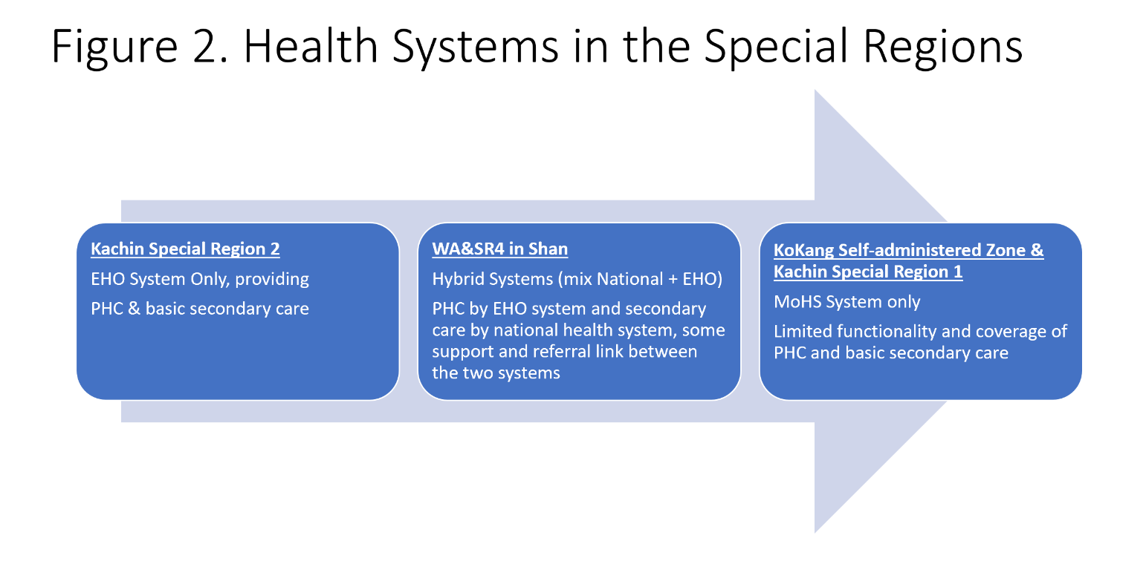
An HPA survey in 2016 showed that overall special regions have much lower health service coverage compared to state and national averages (Figure 3).

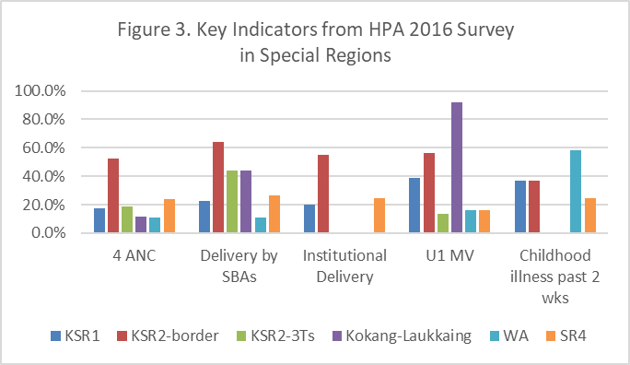

To tackle access to health issues in vulnerable areas of Kachin and Shan, UNICEF, HPA along with 3 EHOs and 1 civil society organization (CSO) have decided to work and coordinate together under the Access to Health Fund (ACCESS). The programme will cover 19 townships where 5 special regions are located. UNICEF will provide a technical assistance role to HPA, with HPA as direct implementing partners of ACCESS activities in collaboration with EHOs. The proposed RMNCAH programme aims to address specific supply and demand side barriers to health services access and utilisation.

In July 2018, an analysis of health access bottlenecks was conducted in consultation with each of the special regions, engaging EHOs, District Medical Officer (DMO)/Township medical Officers (TMOs), women’s associations, CSOs, community representatives, humanitarian actors, etc. Some key barriers related to human resources for health identified:
- Low literacy rates among local ethnic committees means health workers are not able to follow all MOHS technical protocols and guidelines. Skills-based training needs to be adapted to local capacities.
- Geographical access, poor roads, long distances
- Limited financial access especially for people in remote areas
- Limited EHO management capacity to deliver quality, full services.
- Lack of on-the-job training and monitoring support, affecting motivation and service quality.
A Human Resource for Health Rapid Assessment is a key entry for EHOs to drive system strengthening using evidence-based HRH development plan: training mapping, analysis and planning. It provides a systematic way to identifying development steps on defined essential MNCH and Nutrition programming competencies within the health system strengthening approach.

As a first step the Human Resource for Health Rapid Assessment systematically assess the four pathways (Staffing, Skills, Working Conditions and Motivation) that need to be in place for optimal staff performance. This to be applied in all identified levels of Ethnic Health Organizations: Central, regional, district/township and service delivery points (Health Facility).

The proposed RMNCAH programme aligns and contributes to strengthening implementation of Myanmar National Health Plan as follows:
NHP Outcomes | NHP Outputs
- Increased accountability and responsiveness | Adequate HR in health facilities, with right skills
 | Adequate infrastructure and equipment
 | Availability of essential drugs and supplies
 | Minimum standards of care met by all providers

The reference methodology will be using Human resources for health (HRH) tools and guidelines https://www.who.int/hrh/tools/en/Rapid_Assessment_guide.pdf?ua=1

- Objectives of the consultancy:
National consultant will facilitate and provide technical and managerial support including organisation of a Human Resources for Health Rapid Assessment including its online rapid data collection and analysis in ethnic health organizations in Kachin, Shan North and Shan East, to determine immediate competency gaps and allows ethnic health organizations to align training opportunities to immediate needs. The consultancy offers structured and sustainable approach to training through detailed skills mapping, analysis and planning that is local driven. The work should be coordinated with UNICEF, Health Poverty Action and REACH consortium partner EHOs and CSO: Wa Health Department (EHO), Shan Special Region 4 (SR4) Health Department (EHO), Kachin Special Region 2 (KSR2)Health Department (EHO) and Kokang Charity Alliance (CSO), and relevant Township Health Department of Ministry of Health and Sports. To note that Google-based platform cannot work in majority of these areas due to reliance to Chinese mobile network and internet connection

- Geographic Area: [Myitkyina and Kachin Special Region 2 (KSR2) areas], Shan North (Lashio and WA Special Region 2 (SR2) including Southern Wa areas (part of SR2), and Shan East (Kengtung and SR4 areas . Duty station will be Yangon.
Consultancy tasks will be approximately allocated as 12 days field assessment, 10 days adapting the data collection tools and 8 days for trainings (2 trainings, 1 for Kachin, 1 for Shan) and 10 days for data analysis and reporting, 40 days total field work maximum. Besides, dissemination Workshop on SARA and HRH results in EHO areas with MoHS and EHOs, 2 days each for WA in Shan North, SR4 in Shan East and KSR2 in Kachin.

Expense of travel and DSA to the fields will be based on actual cost of travel, which will be reserved by UNICEF in addition to the consultant fee.

- Duration (including potential extension):
August – December 2020. Assignment will be full time with regular office hours based in Yangon with frequent travels to fields such as Kachin, Shan North and Shan East States.
- Supervisor: Health Specialist (Health in Emergency), UNICEF Myanmar Country Office

- Type of Supervision/support required from UNICEF:
Supervision will be required on coordination with field offices, in-country travel and administrative support: Liaise with stakeholders and participants prior to the workshop for any preparatory activity; Organize and facilitate logistical support for the workshop; Provide consultant with relevant information to prepare adequately for HRH assessment data collection, analysis and dissemination
- Description of assignment:

Tasks | End Product/deliverables | Duration/  Deadline/ % of fee Payable
Assessment planning and preparation | Inception Report containing  - HRH-EHO coordinating group of UNICEF-HPA-EHOs stakeholders established to oversee and facilitate the objectives, scope, design, schedule, implementation and analysis plan  - Adapted simplified online questionnaires based on WHO’s HRH assessment guidelines to meet EHO’s programmatic and administrative -context-specific needs, adapted in tablet, smartphone format or electronic/mobile platform – Kobo Collect/ODK  - Designed data collection, data entry/processing and analysis regarding different qualification for different level of staff, different types of training received etc., using questionnaire targeting to EHO’s staff of managerial level  - Assessment sampling universe with mobile numbers/email address of health workers established  - Training guide for local enumerators drafted in case online questionnaires cannot be collected  - Pilot assessment to different HRH stakeholders | September 2020/30% fee payable
On-line Data collection or in the field (if online cannot be done) | Implementation report  - Data collection (e-mail/letter of introduction, health workers contacts response record)  - Materials and tools for data collection  - Compilations of issues during online data collection, KOBO collect application, and how to resolve  - Completed electronic forms and periodically transferred electronic files to centralized database/dashboard  - Dashboard update when data collection is complete | October 2020/30% fee payable
Data entry, analysis and interpretation | - Data entered using licensed application  - Edited, validated and clean data set, presented and checked for consistency and accuracy  - Exported data set for analysis (HRH indicators)  - Analysis of HRH data using the standard core indicators as well as any context-specific indicators of interest | November 2020/30% fee payable
Results dissemination | - HRH-EHO coordinating group facilitated to analyse and interpret assessment results and to finalize recommendations  - Final report  - Dissemination plan drafted  - Documented and archived assessment using metadata standards | Dec 2020/10% fee payable
- Advertisement / Invitation / Request for Expression of Interest
The consultancy will be published to the UN vacancy and UNICEF open vacancy will be circulated to the roster of national consultants in health and PME technical networks. The vacancy will be marked ‘For Myanmar Nationals only’
HR Unit will be responsible for publishing in UN and UNICEF websites
- Selection process (EOI to be attached to TOR)
Interested candidates are required to complete the Expression of Interest Form circulated with the call for proposals, answering the technical questions included.
The consultant will be identified by UNICEF based on a competitive selection process, considering the candidate’s experience, the quality of the answers produced, and of the lump-sum requested.
If deemed opportune, UNICEF will require a telephone interview with shortlisted candidates.
- Qualification and specialized knowledge/experience required for the assignment:
- Bachelor degree is a requirement and Masters’ is an asset. One of the following fields is required: medical, public health, paediatric health, family health, health research, global/international health, health policy and/or management, biostatistics/statistics, epidemiology or another relevant technical field.
- A minimum of 5 years of professional experience in one or more of the following areas, is required: public health planning and management, maternal, neonatal and child health care, and nutrition or health emergency/humanitarian preparedness
- Additional technical experiences such as data analysis, survey, report writing, organizing and facilitating workshop, advocacy and coordination is an asset.
- Prior experience of working on Human Resource for Health Development/Health Planning and Assessment is an needed
- Relevant experience working with ethnic health organization is an asset

- Other conditions:
The consultant should be able to work remotely if COVID-19 situation does not allow direct meetings or on-site visits
The consultant will travel from place of origin and to areas stated in the ToR
The consultant will utilise personal laptop and licensed software during consultancy with own internet access

Life and health insurance
UNICEF does not provide or arrange life or health insurance coverage for consultants and individual contractors, and consultants and individual contractors are not eligible to participate in the life or health insurance schemes available to United Nations staff members. Consultants and individual contractors are fully responsible for arranging, at their own expense, such life, health and other forms of insurance covering the period of their services as they consider appropriate. The responsibility of UNICEF is limited solely to the payment of compensation for service-incurred death, injury or illness as per the provisions detailed below.

Insurance for service-incurred death, injury or illness
Consultants and individual contractors who are authorized to travel at UNICEF expense or who are required under their contract to perform services in a UNICEF or United Nations office shall be provided with insurance coverage, through a UNICEF-retained third-party insurance provider, covering death, injury and illness attributable to the performance of official UNICEF duties. Compensation in the event of service-incurred death, injury or illness shall be equivalent to amounts stipulated in the agreement between UNICEF and the insurance provider.

Payment
Payment schedules should be directly linked with deliverables at specific time intervals. Payments should be processed based on satisfactory delivery of the services/products as certified by the supervisor/ manager.

Confidentiality:
The documents produced during the period of this consultancy will be treated as strictly confidential, and the rights of distribution and/ or publication will reside solely with UNICEF.

The contract signed with the consultant will include the other general terms defined by UNICEF.
- Nature of Penalty Clause to be stipulated in the contract:
UNICEF Myanmar reserves the right not to pay the Contractor or withhold part of the payable amount if one or more requirements established for this assignment is not met or deadline set for the accomplishment of the tasks is missed.

