UNITED NATIONS CHILDREN’S FUND
GENERIC JOB PROFILE

I. Post Information

Job Title: Supply & Logistics Officer (Education)  Supervisor Title/ Level: Supply & Logistics Specialist/P3  Organizational Unit: Supply & Logistics  Post Location: Sana’a, Yemen | Job Level: NOB  Job Profile No.:  CCOG Code:  Functional Code:  Job Classification Level:

II. Organizational Context and Purpose for the job

The fundamental mission of UNICEF is to promote the rights of every child, everywhere, in everything the organization does — in programs, in advocacy and in operations. The equity strategy, emphasizing the most disadvantaged and excluded children and families, translates this commitment to children’s rights into action. For UNICEF, equity means that all children have an opportunity to survive, develop and reach their full potential, without discrimination, bias or favoritism. To the degree that any child has an unequal chance in life — in its social, political, economic, civic and cultural dimensions — her or his rights are violated. There is growing evidence that investing in the health, education and protection of a society’s most disadvantaged citizens — addressing inequity — not only will give all children the opportunity to fulfill their potential but also will lead to sustained growth and stability of countries. This is why the focus on equity is so vital. It accelerates progress towards realizing the human rights of all children, which is the universal mandate of UNICEF, as outlined by the Convention on the Rights of the Child, while also supporting the equitable development of nations.

Job organizational context:
In this context, there is a need to have a comprehensive supply planning, procurement, distribution and monitoring system established and functioning to achieve the desired results (incl. goods and services, institutional contracts and rehabilitation & construction related works). There are weaknesses and challenges in supply management in the Education sector and capacity of stakeholders and actors must be built to address this. Due to the complexity of the Education programme of UNICEF in a fragile environment, including armed conflict and structural challenges in governance, supply management in the Education sector requires a dedicated specialist who will work closely with Education programme staff, the Supply and Logistics section, Construction Unit, education authorities and partners in order to strengthen harmonized and systematic implementation of the supply planning, procurement, distribution and monitoring processes.

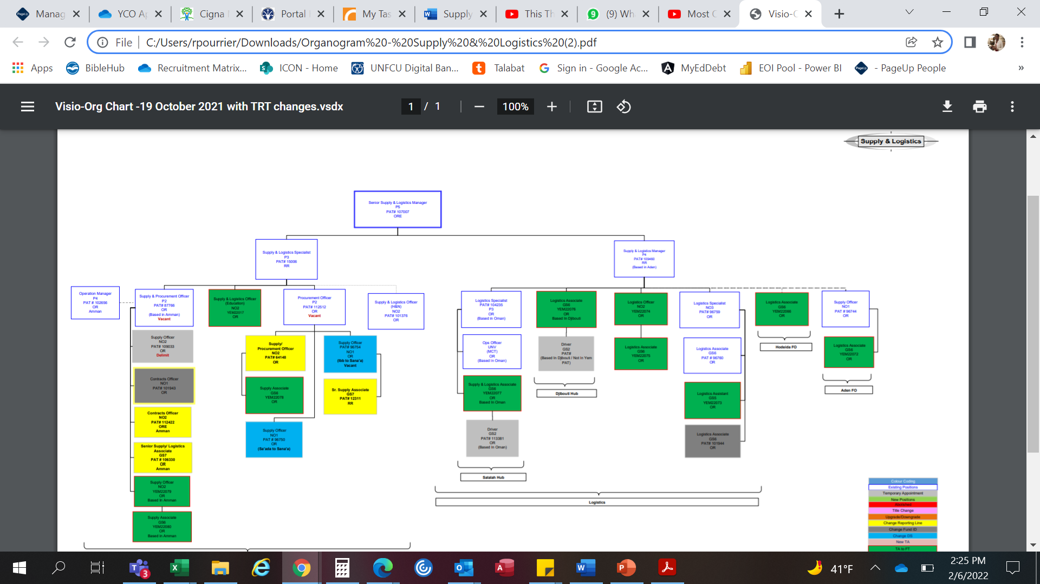

Purpose for the job

The Supply & Logistics Officer for the Education Section of UNICEF Yemen supports in streamlining the large Education supply chain (incl. goods and services, institutional contracts and rehabilitation & construction related works) in Yemen at national, governorate and district levels, while working closely and in collaboration with the UNICEF Supply and Logistics Section the Construction Unit, education authorities at all levels, and other partners in strengthening supply chain capacities of all stakeholders.

III. Key functions, accountabilities and related duties/tasks (Please outline the key accountabilities for this position and underneath each accountability, the duties that describe how they are delivered. Please limit to four to seven accountabilities)

Summary of key functions/accountabilities:

Under the direct supervision of the P4 Education Manger (Access), the incumbent administers the supply and logistics operations to facilitate and accelerate implementation of the harmonized business practices in supply for the Education Section. The responsibilities of the incumbent include, but are not limited to, the following:

- Works closely with Education programme colleagues on forecasting and on the development of Annual Supply Plans. Provides technical advice on specifications/Terms of Reference, facilitating efficient procurement.
- Ensures all procurement activities are in compliance with the UNICEF Financial Rules and Regulations, Supply Division Manual, and all other applicable procurement procedures.
- Advises on raising Requisitions (Sales Orders, Purchase/Service Requisitions) and Ensures development of appropriate evaluation criteria, solicitation documents, evaluation of offers, negotiation and formulation of contracts and long-term arrangements (LTAs) with suppliers and contractors in collaboration with the Supply & Logistics section and Construction Unit as and when required.
- Contributes to the solicitation and evaluation of bids/proposals/quotations to ensure overall competitiveness, quality and conformity to specified requirements, as appropriate.
- Compiles and presents procurement data for Education, prepares all relevant supporting documents and recommend approval of the Service Contract, Long Term Arrangements (LTA) or purchase order; may authorize procurements in line with delegated authority, and, in cases where the amount exceeds authorized signature authority, prepare submissions to the Contract Review Committee.
- Review workload and coordinates placement of Contracts and/or Purchase Orders to ensure quick response to requests received from sections.
- Works in close contact with the other sections in the CO to ensure successful implementation of the procurement cycle.
- In collaboration between Education and the Supply & logistics unit, contributes to evaluation of Contractors/Suppliers with the area of delegated authority with respect to service delivery performance and commercial acceptability.
- Ensures effective and accurate supply planning and forecasting, including goods and services, institutional contract and rehabilitation & construction related works
- Builds capacity on Supply management for the UNICEF Yemen Education staff at Country and Field Offices, at that national and governorate and district levels and education services delivery points – in collaboration with the Supply & Logistics Unit
- Harmonizes stock and service delivery data with multiplicity of partners in the Education supply chain space, data flow, quality and reporting as well as monitoring of stock indicators for decision-making.
- Coordinates with the Supply and Logistics Section of UNICEF Yemen on matters related to storage capacity, supply planning, pipeline monitoring and delivery modality planning, dispatch status, distribution schedule/plan, order consolidation for route optimization.
- Contributes to supply chain data visibility in VISION (warehouses, pipeline, SO and POs requisition raised, pending etc.); and
- Other tasks as required by the supervisor.

IV. Impact of Results

The ability of the Supply and Logistics Officer to successfully plan, manage and oversee the effective and efficient supply chain management of goods, services and construction works for UNICEF programmes and the Government, directly impact on program goals and results for children. This in turn contributes to maintaining/enhancing the credibility of UNICEF as an effective and responsible manager of funds entrusted to the organization and to furthering UNICEF image as a competent organization for delivering cost effective and sustainable program results for children.

The Education programme section will benefit in the following areas:
- Ensure service-delivery on country programme and procurement services requests that is timely, responsive, and appropriate, achieves value for money and works in concert with national systems and partners. Accomplish such via targeted procurement strategies, including quality and end to end supply chain performance objectives and monitoring.
- Requirements for coordinated supply and deliveries to sections for the designated needs are met.
- Contribute to UNICEF Yemen commitments and relationships with strategic partners and contribute to the team’s innovation and process improvement activities.
- Rapid and relevant responses and assistance provided to evolving education needs and situation, including emergency situations, with a priority on achieving value for money.
- Integrity, standards and accountability monitored, administered and maintained by implementing sound, accurate supply/logistics management systems, procedures, documentation and accurate reporting.
- Professional assistance and training provided for capacity-building in order to enhance efficient, effective and timely delivery of education supplies (goods and services, institutional contracts, rehabilitation & construction related works) so that UNICEF, education authorities and all implementing partners’ accountability is ensured.
- The capacity of education authorities (national, governorate, district level) is strengthened on supply chain management and all counterparts are trained in UNICEF supply assistance policies and procedures.
- Effective procurement processes followed with Supply and Logistics Section and the Construction Unit to attain lowest cost without sacrificing quality.
- Supply planning and forecasting, procurement, distribution and monitoring processes are harmonized.
- End-user monitoring and rights-holder monitoring strengthened, including through but not limited to third-party and remote monitoring.

V. Competencies and level of proficiency required (please base on UNICEF Competency Profiles)

i) Core Values

- Care
- Respect
- Integrity
- Trust
- Accountability

ii) Core Competencies

- Demonstrates Self Awareness and Ethical Awareness (2)
- Works Collaboratively with others (2)
- Builds and Maintains Partnerships (2)
- Innovates and Embraces Change (2)
- Thinks and Acts Strategically (2)
- Drive to achieve impactful results (2)
- Manages ambiguity and complexity (2)

VI. Recruitment Qualifications

Education: | - University degree in Business Administration, Management, Contract/commercial Law or related areas of specialization, including credited courses in supply, logistics, purchasing, finance, contracting or a recognized qualification in procurement and contracting.  - Educational qualification in relevant areas (transport or logistics operations/management, supply change management, etc.)
Experience: | - A minimum of two (2) years of in procurement and contracting.  - Experience working in the UN environment is an asset.  - Demonstrated experience in emergency context and fast responding is required.
Language Requirements: | - Fluency in English and Arabic are required.

VII. Signatures- Job Description Certification

Name: Ali Abdullah Signature: Date:
Title: Supply & Logistics Specialist

Name: Andrey Demidovich Signature: Date:
Title: Senior Supply & Logistics Manager

Name: Philippe Duamelle Signature: Date:
Title: Representative

