Heading:
National Consultant for Essential Reproductive, Maternal, Newborn, Child and Adolescent Health (RMNCAH) and Nutrition Service Availability and Readiness Assessment (SARA) in Ethnic Health Organizations (EHOs)’ facilities of Kachin and Shan

Section in Charge: Health and Nutrition

How does the consultancy relate to Multi Year Work Plan 2020-2021:
0600/A0/05/201/003/010: Support Capacity Development in Reaching Equitable Access to RMNCAH & Nutrition Services in ethnic and hard-to-reach communities in Kachin
0600/A0/05/201/003/011: Support Capacity Development in Reaching Equitable Access to RMNCAH & Nutrition Services in ethnic and hard-to-reach communities in northern and eastern Shan

Outcome reference: 0600/A0/05/201
By 2022, more children under five and women of reproductive age equitably access and utilize evidence-based health, HIV & nutrition interventions, including adoption of key behaviours, especially among vulnerable populations in most deprived states/ regions, conflict-affected and peri-urban areas
Output reference: 0600/A0/05/201/003
By 2022, national and sub national health care institutions and front-line health workers have improved capacity to reach more vulnerable populations with quality immunization and Maternal Newborn and Child health (MNCH) (including Prevention of Mother to Child Transmission (PMTCT)) services in at least four most deprived States/Regions and in conflict, disaster affected and peri-urban areas in Yangon

- Background:
According to Myanmar Demographic and Health Survey (DHS) 2015-16, health status of women and children in Kachin and Shan, as represented by maternal mortality ratio (MMR), neonatal mortality rate (NMR) and under-five mortality rate (U5MR), are above national averages, with disparities and pockets. Although wasting and stunting in both States are comparable to national averages, elevated conflict in these areas can easily exacerbate the situation, affecting mortality burden.

Major underlying causes of maternal and U5 mortality in these states/regions include lack of access to essential, quality health interventions across the continuum of care, given protracted conflict and geographical vastness/remoteness. Knowledge and behaviours on health and care, including nutrition and hygiene are also limited. Special regions in Kachin and Shan have vulnerabilities linked to years of conflict which has debilitated basic social services and systems. Figure 2 shows current health system characteristics in 5 special regions, that have been shaped by their local context. In recent years, dialogue between Ministry of Health and Sports (MOHS) and EHO (facilitated by partners like Health Poverty Action (HPA)) has improved, providing the opportunity for further collaboration and system-to-system linkages – which the proposed RMNCAH programme will build upon and strengthen.

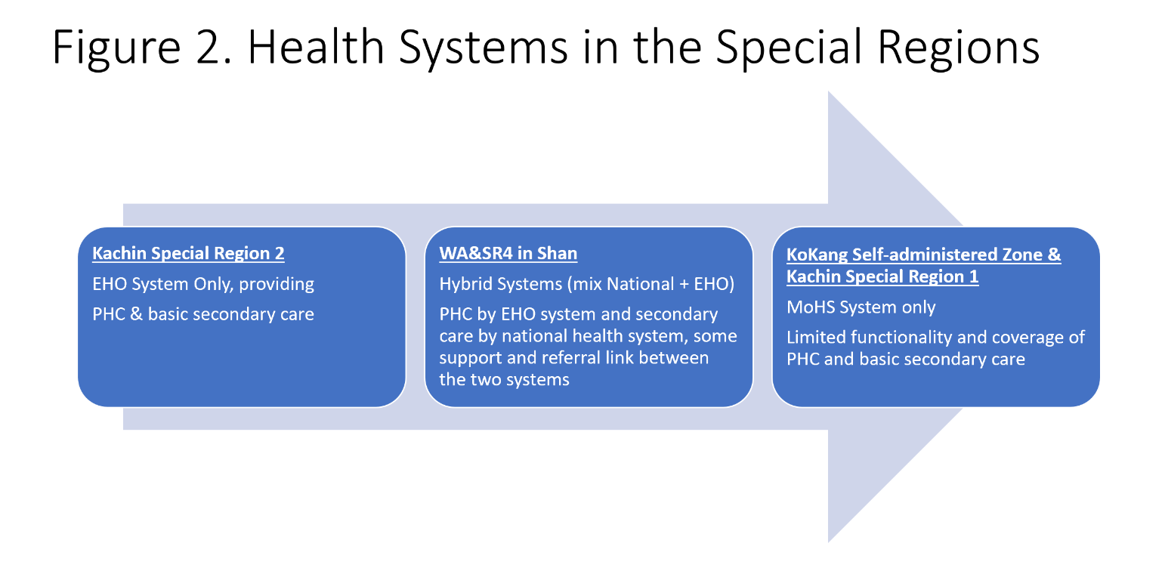
An HPA survey in 2016 showed that overall special regions have much lower health service coverage compared to state and national averages (Figure 3).

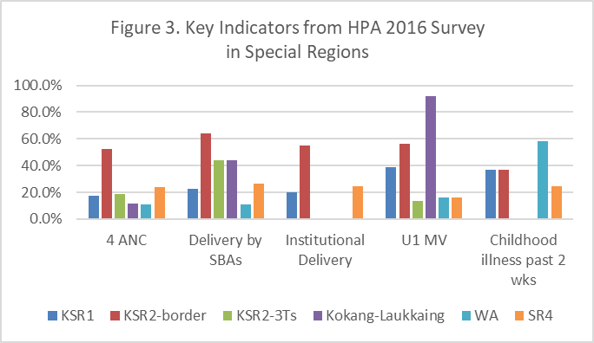

To tackle access to health issues in vulnerable areas of Kachin and Shan, UNICEF, HPA along with 3 EHOs and 1 Civil Society Organization (CSO) have decided to work and coordinate together under the Access to Health Fund (ACCESS). The programme will cover 19 townships where 5 special regions are located. UNICEF will provide a technical assistance role to HPA, with HPA as direct implementing partners of ACCESS activities in collaboration with EHOs. The proposed RMNCAH programme aims to address specific supply and demand side barriers to health services access and utilisation.

The proposed RMNCAH programme determines the most cost-effective combination of evidence-based interventions and Health System Strengthening strategies to reduce maternal and child mortality and malnutrition among the targeted areas in Kachin and Shan. These prioritized RMNCAH and Nutrition interventions include antenatal and postnatal care, newborn care and safe delivery, family planning, adolescent reproductive health, post-abortion care, management of STIs, diseases and childhood illness, , micronutrient supplementation, community-based nutrition promotion, management of acute malnutrition and behaviour change communication on essential health and nutrition practices, including hygiene and sanitation.

Ensuring access to quality health services is one of the main functions of a health system. Service access includes different components: availability, which refers to the physical presence or reach of the facilities; affordability, which refers to the ability of the client to pay for the services; and acceptability, which refers to the sociocultural dimension.

The quality of services is yet another dimension. A prerequisite to service quality is service readiness, i.e. the health facilities should have the capacity to deliver the services offered. This capacity includes the presence of trained staff, guidelines, infrastructure, equipment, medicines and diagnostic tests. Service availability and readiness are prerequisites to quality services, but do not guarantee the delivery of quality services.

Service Availability and Readiness Assessment (SARA) is a WHO-designed systematic survey to assess health facility service delivery. The objective of the survey is to generate reliable and regular information on service delivery including service availability, such as the availability of key human and infrastructure resources, and on the readiness of health facilities to provide basic health-care interventions relating to family planning, child health services, basic and comprehensive obstetric care, HIV/AIDS, tuberculosis, malaria and noncommunicable diseases. SARA is also an assessment tool for health system strengthening as well as effective implementation of RMNCAH programme through annual exercise and regular feedback mechanism with improvement plan.

The proposed RMNCAH programme aligns and contributes to strengthening implementation of Myanmar National Health Plan as follows:
NHP Outcomes | NHP Outputs
- Increased accountability and responsiveness | Adequate HR in health facilities, with right skills
 | Adequate infrastructure and equipment
 | Availability of essential drugs and supplies
 | Minimum standards of care met by all providers

The reference methodology will be using Service Availability and Readiness Assessment (SARA): An annual monitoring system for service delivery. Reference Manual (WHO, 2015) https://www.who.int/healthinfo/systems/sara_reference_manual/en/

- Objectives of the consultancy:
National consultant for SARA will facilitate and provide technical and managerial support including organisation of sessions, facilitation and reporting of Service Availability and Readiness Assessment (SARA) including its rapid data collection and analysis in ethnic health organizations’ facilities Kachin, Shan North and Shan East. The work should be coordinated with UNICEF, Health Poverty Action and REACH consortium partner EHOs and CSO: Wa Health Department (EHO), Shan Special Region 4 (SR4) Health Department (EHO), Kachin Special Region 2 (KSR2) Health Department (EHO) and Kokang Charity Alliance (CSO), and relevant Township Health Departments of Ministry of Health and Sports.

- Geographic Area: Kachin State [Myitkyina and Kachin Special Region 2 (KSR2) areas], Shan North (Lashio and Wa Special Region 2 (SR2) including Southern Wa areas (part of SR2), and Shan East (Kengtung and SR4 areas). Duty station will be Yangon.
Consultancy tasks will be approximately allocated as 12 days field assessment, 10 days adapting the data collection tools and 8 days for trainings (2 trainings, 1 for Kachin, 1 for Shan) and 10 days for data analysis and reporting, 40 days total field work maximum. Besides, dissemination Workshop on SARA and HRH results in EHO areas with MoHS and EHOs, 2 days each for WA in Shan North, SR4 in Shan East and KSR2 in Kachin.

Expense of travel and DSA to the fields will be based on actual cost of travel, which will be reserved by UNICEF in addition to the consultant fee.

- Duration (including potential extension):
August – December 2020. Assignment will be full time with regular office hours assignment based in Yangon with frequent travels to fields such as Kachin, Shan North and Shan East States.
- Supervisor: Health Specialist (Health in Emergency), UNICEF Myanmar Country Office

- Type of Supervision/support required from UNICEF:
Supervision will be required on coordination with field offices, in-country travel and administrative support: Liaise with stakeholders and participants prior to the workshop for any preparatory activity; Organize and facilitate logistical support for the workshop; Provide consultant with relevant information to prepare adequately for SARA data collection, analysis and dissemination
- Description of assignment:

Tasks | End Product/deliverables | Duration/  Deadline/ % of fee Payable
Assessment planning and preparation | Inception Report containing  - SARA-EHO coordinating group of UNICEF-HPA-EHOs stakeholders established to oversee and facilitate the objectives, scope, design, schedule, implementation and analysis plan for SARA assessment  - Adapted simplified questionnaires focusing on SARA assessment in line with WHO guideline to meet EHO’s programmatic-context-specific needs, adapted in electronic/mobile platform – Kobo Collect/ODK  - Designed ToT for key staff of UNICEF-HPA-EHOs in data collection using adapted SARA questionnaire targeting to EHO staff who will undertake service delivery at the community level, data entry/processing and analysis  - Assessment sampling frame of health facilities established  - Training guide regard to SARA assessment, data collection, reporting for enumerators drafted  - Pilot assessment in a selected number of health facilities | September 2020/30% fee payable
Data collection in the field | Implementation report containing  - Data collection visits (letter of introduction, contacts enumerator for each site, schedule)  - Materials and tools for data collection  - List of health facilities visited and collected SARA data  - Compilations of issues during data collection, KOBO collect application, and how to resolve  - Completed electronic forms and periodically transferred electronic files to centralized database/dashboard  - Dashboard update when data collection is complete | October 2020/30% fee payable
Data entry, analysis and interpretation | Completion report containing  - Data entered using the CSPro application  - Edited, validated and clean data set, presented and checked for consistency and accuracy  - Exported data set for analysis (SARA indicators)  - Analysis of SARA data using the standard core indicators (SARA automated tool for results graphs and tables) as well as any context-specific indicators of interest | November 2020/30% fee payable
Finalization and results dissemination | Final report containing  - SARA-EHO coordinating group facilitated to analyse, interpret assessment results and finalize recommendations  - Dissemination plan drafted and developed  - Documented and archived all assessment related information and resources using metadata standards | Dec 2020/10% fee payable
- Advertisement / Invitation / Request for Expression of Interest
The consultancy will be published to the wide UN vacancy and UNICEF open vacancy and will be circulated to the roster of national consultants in health and PME technical networks. The vacancy will be marked ‘For Myanmar Nationals only’.
HR Unit will be responsible for publishing in UN and UNICEF websites
- Selection process (EOI to be attached to TOR)
Interested candidates are required to complete the Expression of Interest Form circulated with the call for proposals, answering the technical questions included.
The consultant will be identified by UNICEF based on a competitive selection process, considering the candidate’s experience, the quality of the answers produced, and of the lump-sum requested.
If deemed opportune, UNICEF will require a telephone interview with shortlisted candidates.
- Qualification and specialized knowledge/experience required for the assignment:
- Bachelor degree is a requirement and Masters’ is an asset One of the following fields is required: medical, public health, paediatric health, family health, health research, global/international health, health policy and/or management, biostatistics/statistics, epidemiology or another relevant technical field
- A minimum of 5 years of professional experience in one or more of the following areas, is required: public health planning and management, maternal, neonatal and child health care, and nutrition or health emergency/humanitarian preparedness
- Prior experience of working on Service Availability and Readiness Assessment (SARA) or similar experience is required
- Additional technical experiences such as data analysis, survey, report writing, organizing and facilitating workshop, advocacy and coordination is an asset
- Relevant experience working with ethnic health organization is an asset

- Other conditions:
The consultant should be able to work remotely if COVID-19 situation does not allow direct meetings or on-site visits
The consultant will travel from place of origin and to areas stated in the ToR
The consultant will utilise personal laptop and licensed software during consultancy with own internet access

Life and health insurance
UNICEF does not provide or arrange life or health insurance coverage for consultants and individual contractors, and consultants and individual contractors are not eligible to participate in the life or health insurance schemes available to United Nations staff members. Consultants and individual contractors are fully responsible for arranging, at their own expense, such life, health and other forms of insurance covering the period of their services as they consider appropriate. The responsibility of UNICEF is limited solely to the payment of compensation for service-incurred death, injury or illness as per the provisions detailed below.

Insurance for service-incurred death, injury or illness
Consultants and individual contractors who are authorized to travel at UNICEF expense or who are required under their contract to perform services in a UNICEF or United Nations office shall be provided with insurance coverage, through a UNICEF-retained third-party insurance provider, covering death, injury and illness attributable to the performance of official UNICEF duties. Compensation in the event of service-incurred death, injury or illness shall be equivalent to amounts stipulated in the agreement between UNICEF and the insurance provider.

Payment
Payment schedules should be directly linked with deliverables at specific time intervals. Payments should be processed based on satisfactory delivery of the services/products as certified by the supervisor/ manager.

Confidentiality:
The documents produced during the period of this consultancy will be treated as strictly confidential, and the rights of distribution and/ or publication will reside solely with UNICEF.

The contract signed with the consultant will include the other general terms defined by UNICEF.
- Nature of Penalty Clause to be stipulated in the contract:
UNICEF Myanmar reserves the right not to pay the Contractor or withhold part of the payable amount if one or more requirements established for this assignment is not met or deadline set for the accomplishment of the tasks is missed.

