 | SPECIFIC JOB PROFILE

I. Post Information

POST NUMBER/ CASE NUMBER: YEM24001  POST/CASE NUMBER OF SUPERVISOR: 64149  REASON FOR CLASSIFICATION: Establishment  COUNTRY: Yemen  DUTY STATION: Sana’a  SECTION: Rep.Office  UNIT: Communications | CATEGORY: NO  PROPOSED LEVEL: NOB  JOB TITLE: Digital Communication Officer  Functional Code:  ICSC CCOG Code:

II. Strategic Office Context and Purpose for the job

The fundamental mission of UNICEF is to promote the rights of every child, everywhere, in everything the organization does — in programs, in advocacy and in operations. The equity strategy, emphasizing the most disadvantaged and excluded children and families, translates this commitment to children’s rights into action. For UNICEF, equity means that all children have an opportunity to survive, develop and reach their full potential, without discrimination, bias or favoritism. To the degree that any child has an unequal chance in life — in its social, political, economic, civic and cultural dimensions — her or his rights are violated. There is growing evidence that investing in the health, education and protection of a society’s most disadvantaged citizens — addressing inequity — not only will give all children the opportunity to fulfill their potential but also will lead to sustained growth and stability of countries. This is why the focus on equity is so vital. It accelerates progress towards realizing the human rights of all children, which is the universal mandate of UNICEF, as outlined by the Convention on the Rights of the Child, while also supporting the equitable development of nations.

Strategic office context:
UNICEF Yemen has been the lead UN agency in Yemen in terms of presence on social media platforms with close to 1 million followers on all platforms. UNICEF’s objective is to continue to lead the discourse around children’s rights and issues leveraging its strong position on social media and thus, continue to be a credible source of information on the situation of children in Yemen. UNICEF is the voice of children in Yemen.

The role of Digital Communication Officer is essential and well-suited for the Yemen Country Office’s (YCO) long-term communication priorities. The Digital Communication Officer function leads YCO presence on social media platforms and website. New technologies are introduced on social media platforms almost every day, and the Digital Communication Officer will stay abreast of these updates so that our presence of social media is not only maintained but also taken to new levels given the fact that much of discourse is now taking place on social media platforms.

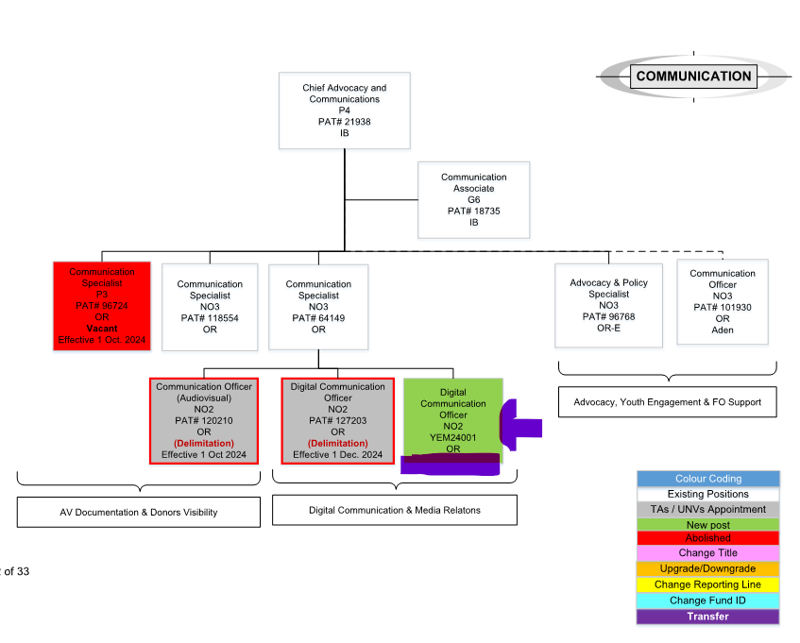

Purpose for the job:

Assist in planning, implementing, monitoring, and evaluating a social media strategy for; contributing to UNICEF Yemen’s broader communication strategy to get children’s and women’s issues into the public domain, to strengthen support of UNICEF mission and objectives in the country, and enhance the organization’s presence on social media platforms as well as credibility and brand.

- Management of YCO social media platforms: Social media tools are successfully managed and regularly updated; providing active engagement platforms for youth, civil society, donors, media, and other partners.

- Management of UNICEF Yemen website: YCO Website is successfully managed and regularly updated; providing active engagement platforms for youth, civil society, donors, media, and other partners.

III. Key functions, accountabilities and related duties/tasks:

Within the delegated authority and the given organizational set-up, the incumbent may be accountable for all or assigned areas of the following major duties and end results.
• Management of YCO social media platforms:
Ensure that the social media platforms are successfully managed and regularly updated, providing active engagement platforms for youth, civil society, donors, media, and other partners.

Duties & Tasks:
• Effective and timely professional management of the creative implementation of the digital and social media strategy
• In close cooperation with the Communication Specialist and in coordination with other colleagues working on content development, maintain and regularly update the UNICEF Yemen social media channels to increase engagement with the public, youth, partners, donors, and other key stakeholders.
• Identify and develop content and update messages for social media, including translation into Arabic.
• Prepare weekly YCO social media calendar to be finalized every week
• Prepare/update monthly Q&A document to respond to social media frequent questions and comments.
• Identify new social media opportunities and develop UNICEF Yemen’s presence on new social media platforms as appropriate
• Monitor, evaluate and report quarterly on the use and effectiveness of UNICEF Yemen’s engagement online and on social media
• Upload YCO relevant content on ICON.

• Management of UNICEF Yemen website
Ensure UNICEF Yemen’s website is successfully managed and regularly updated, providing active engagement platforms for youth, civil society, donors, media, and other partners.

Duties & Tasks
• In close cooperation with the Communication Specialist and in coordination with other colleagues working on content development, maintain and regularly update the UNICEF Yemen website to increase engagement with the public, youth, partners, donors, and other key stakeholders
• Monitor, evaluate, and report quarterly on the traffic on and the performance of UNICEF Yemen’s website using different analytical tools.

IV. Impact of Results
UNICEF Yemen will leverage digital platforms to amplify the organization's message, engage with diverse audiences, and drive positive change for children in Yemen. Impact includes but is not limited to:
1. Increased Awareness and Reach: By crafting compelling content and implementing effective social media strategies, UNICEF's visibility and reach across various social media platforms will increase. UNICEF Yemen can attract new followers, engage with existing ones, and ensure that UNICEF's messages reach a broader and more diverse audience.
2. Engagement and Community Building: Meaningful engagement and dialogue with UNICEF's online community will be fostered.
3. Advocacy and Campaigning: UNICEF will harness the power of social media, through strategic social media advocacy campaigns, to raise awareness, drive conversation and inspire action on children’s issues.
4. Data Analysis and Insights: By analyzing metrics such as engagement rates, reach, and audience demographics, UNICEF can refine strategies to optimize effectiveness and achieve organizational goals.
Overall, the impact of a Social Media Officer at UNICEF is substantial, contributing to increased awareness, engagement, advocacy, fundraising, and collaboration in support of the organization's mission to protect and promote the rights and well-being of every child, everywhere.

V. UNICEF values and competency Required (based on the updated Framework)

i) Core Values

- Care
- Respect
- Integrity
- Trust
- Accountability

ii) Core Competencies (For Staff with Supervisory Responsibilities)

- Nurtures, Leads and Manages People ()
- Demonstrates Self Awareness and Ethical Awareness ()
- Works Collaboratively with others ()
- Builds and Maintains Partnerships ()
- Innovates and Embraces Change ()
- Thinks and Acts Strategically ()
- Drive to achieve impactful results ()
- Manages ambiguity and complexity ()

iii) Core Competencies for Staff without Supervisory Responsibilities

- Demonstrates Self Awareness and Ethical Awareness (1)
- Works Collaboratively with Others (1)
- Builds and Maintains Partnerships (1)
- Innovates and Embraces Change (1)
- Thinks and Acts Strategically (1)
- Drives to Achieve Impactful Results (1)
- Manages Ambiguity and Complexity (1)

*The 7 core competencies are applicable to all employees. However, the competency Nurtures, Leads and Managers people is only applicable to staff who supervise others.

VI. Recruitment Qualifications

Education: | University degree in Communications, Journalism, Public Relations, Graphic Design, Multimedia Production, or a related field.
Experience: | Two years practical professional work experience in communication, print and broadcast media, management of social media platforms, or interactive digital media.  Background/familiarity with Emergency situations.
Language Requirements: | Fluency in English and Arabic are required. Knowledge of another UN language is considered an asset.

VII. Technical Knowledge

Specific Technical Knowledge Required (for the job):
- Social media platforms community management.
- Social media content creation and adaptation to local context
- Websites content management
- UNICEF communication and other DOC guidelines
- Communication toolkit
- Brand Toolkit and Brand Book
- UNICEF Stylebook
- Ethical Guidelines on Reporting on Children

Common Technical Knowledge Required (for the job group)
General knowledge of:
- Communication practice, methodology and practical application. Knowledge of current theories and practices in communication research planning and strategy.
- Fundamentals of working in various media formats – print, audio, video, web etc.
- Computer systems, including internet navigation, office applications, and specifically, interactive digital media.
- United Nations or other international organizations; good understanding of world affairs, current events, and international development issues
- Global human rights issues, specifically relating to children and women, and current
- UNCEF position and approaches.
- UNICEF communication goals, visions, positions, policies, guidelines, and strategies.
- UNICEF policies and strategy to address national and international issues, including
- emergencies.
- UNICEF emergency communication policies, goals, strategies, and approaches,
- including emergency preparedness.
- Gender equality and diversity awareness

Technical Knowledge to be Acquired/Enhanced (for the Job)
- Knowledge and expertise in management, communication strategy and networking.
- Technical competence in producing content for various media formats – print, audio, video, web etc.
- UN policies and strategy to address international humanitarian issues and the responses.
- UN common approaches to programmatic issues and UNICEF positions
- UN security operations and guidelines.

VII. Child Safeguarding

IS THIS ROLE A REPRESENTATIVE, DEPUTY REPRESENTATIVE, CHIEF OF FIELD OFFICE, THE MOST SENIOR CHILD PROTECTION ROLE IN THE OFFICE, CHILD SAFEGUARDING FOCAL POINT, OR INVESTIGATOR (OIAI)? *: | NO
IS THIS POST A DIRECT CONTACT ROLE IN WHICH INCUMBENT WILL BE IN CONTACT WITH CHILDREN EITHER FACE-TO-FACE, OR BY REMOTE COMMUNICATION, BUT THE COMMUNICATION WILL NOT BE MODERATED AND RELAYED BY ANOTHER PERSON? *: | NO
IS THIS POST A CHILD DATA ROLE IN WHICH INCUMBENT WILL BE MANIPULATING OR TRANSMITTING PERSONAL-IDENTIFIABLE INFORMATION ON CHILDREN SUCH AS NAMES, NATIONAL ID, LOCATION DATA, OR PHOTOS)? *: | NO
THE SELECTED CANDIDATE FOR THIS POSITION WILL BE REQUIRED TO ENGAGE WITH VULNERABLE CHILDREN*: | NO

