JOB TITLE: Chief Planning, Post # 87210  JOB LEVEL: P-4  REPORTS TO: Deputy Representative (P5), Post #1869  Organizational Unit: Programme  LOCATION: Country Office - Jakarta, Indonesia | JOB PROFLE NO.: 60000010  CCOG CODE: 1.M.06  FUNCTIONAL CODE: MDPV/P-5
PURPOSE OF THE JOB (Principal Accountability)
Chief – Planning is accountable for providing coordination and guidance to the UNICEF Indonesia programme sections and field offices on programme planning and monitoring, including for emergency preparedness and response, risk-informed programming, and environment/climate.

KEY END-RESULTS
- Accurate, coherent and reliable information collected and reported on the performance of UNICEF-supported programmes including their relevance, efficiency, effectiveness, and sustainability, and in emergency contexts, their coverage, coordination and coherence.
- Coordination of programme preparation, planning and management mechanisms with Government is effectively conducted, in line with the GoI-UNICEF agreements and regulations.
- Technical guidance and support provided for the collection of accurate, reliable, gender-specific and coherent information for the Country Office to effectively assess programme performance, with the involvement of key partners, in terms of progress towards key end-results established in annual and multi-year workplans, including budget management.
- Technical guidance and support provided to ensure that Country Office Performance is systematically monitored and data for key indicators of the Annual Management Plan and management reports are collected, analyzed and made available to management and the Country Management Team.
- Office is well engaged in UN system-wide planning, strategizing, monitoring and reporting guidelines and compliant with relevant inter-agency guidelines and processes.
- The awareness and understanding of the shared responsibility of programme planning and monitoring functions among all staff members are promoted and senior management are committed to it.
- Technical assistance provided for the conduct of inter-agency rapid assessment to define humanitarian response, in line with core commitments for children in humanitarian action.
- Effective cross-sectoral coordination and oversight of emergency preparedness and response activities, including to appeals, response plans, performance monitoring, and reporting. This will include effective oversight to the environment/climate agenda of the office.
- Technical oversight provided to the field offices for planning, results-based management, monitoring, review and reporting functions.
KEY ACCOUNTABILITIES and DUTIES & TASKS
Within the delegated authority and under the given organizational set-up, the incumbent may be responsible for all or most of the following areas of major duties and key end results.
1. Leadership of the office planning function
Ensure the country programme is provided with sufficient guidance and coordination for the strategic planning, annual planning, budgeting, review and reporting functions.

Duties & Tasks
- Manage the country programme planning calendar, ensuring the key products and milestones such as the PSN, CPD, CPMP, CPAP and MTR are completed on time in a participatory and effective manner.
- Effective contributions to inter-agency planning and review processes are coordinated across the office, including for the CCA and UNSDCF planning and evaluation steps.
- Ensure that key government coordinating agencies are adequately involved and inform the strategic priorities of the country programme. This includes joint coordination of inter-ministerial mid-year and annual reviews and joint monitoring visits to field locations.
- Coordinate the annual workplanning function of the office, ensuring that programme sections and field offices involve appropriate line ministries and sub-national authorities, including by keeping them abreast of activity plans and programme documents with CSO implementing partners.
- Supervise the budget function of the office, helping to ensure that proposals, budget allocations and expenditure are in line with strategic objectives and planned amounts.
- Assist the Deputy Representative to co-chair the Partnership Review Committee, reviewing and providing quality assurance to implementing partnerships with CSOs at national and sub-national level.
- Coordinate the overall country office emergency preparedness and response throughout the development, planning, implementation, monitoring and evaluation of the emergency interventions to ensure the survival and well-being of children and mothers and affected communities in emergency.
- Mainstream emergency preparedness and response strategies in the country office's workplans and ensure incorporation of key evidence generation/use activities in the Emergency Preparedness and Response Plan, in order to anticipate and prepare for the information needs and operational modalities of an emergency.
- Support rapid assessment conducted through inter-agency mechanisms to define humanitarian response and measure the progress to identify and address results for children and women, in line with the Core Commitment for Children in humanitarian action. After the initial humanitarian response, support management of the medium-term response, outlining the key indicators on implementation and outputs and where possible, outcome indicators and the data collection systems and sources to be used (e.g. reporting by partner NGOs, field visits).
2. Programme performance monitoring
Ensure that the Country Office has quality information to assess programme and financial progress towards expected results established in annual and multi-year work plans.

Duties & Tasks
- Ensure that a set of equity-focused and gender–specific programme performance indicators is identified and adjusted as necessary, in the context of the the Annual Management Plan and Annual/Multi-Year Work Plans
- Provide guidance and support to the Deputy Representative and Chiefs of Field Offices to ensure that key annual programme indicators are tracked and analysed, appropriately reflect the contribution of implementing partners, are regularly entered in RAM, and are shared with the Country Management Team for effective programme and management decisions.
- Oversee efforts to ensure that data collection and analysis from field visits is coordinated and standardised across programmes to feed into to programme performance monitoring.
- Provide coordination for the appropriate integration of lessons learned in programme activities. Provide advice in order that management decisions based on Country Office performance monitoring are properly tracked and followed up.
- Provide technical advice in order that management reports including relevant sections of the annual reports are prepared drawing on monitoring and analysis of key management indicators.
- Ensure oversight to integration and coordination of planning and monitoring functions to emergency preparedness and response activities, at both national and sub-national levels.
3. Planning and monitoring capacity building
Ensure that the monitoring capacities of Country Office staff are strengthened enabling them to increasingly undertake quality results-based planning and monitoring.

Duties & Tasks
- In coordination with senior managers, develop staff capacity development strategy and plans, and exercise effective leadership in implementing them, ensuring that Country Office staffs have the basic knowledge and skills to fulfil their planning and monitoring responsibilities, and training is planned and carried out to fill identified gaps.
- Promote knowledge of and build capacity in monitoring practices within UNICEF. Oversee to ensure that Country Office staff and national partners are aware of and have access to UNICEF monitoring learning resources.
- Lead and guide the development of training materials, as well as delivery of training in risk-informed and results-based planning and monitoring for UNICEF staff and key partners.
- Oversee capacity building of national and sub-national partners on planning and monitoring requirements, including for emergency preparedness and response. Ensure integration of these activities into relevant national and sub-national workplans.

4. Technical support to field offices on programme planning, monitoring and reporting
Ensure that field offices are provided with regular, coherent and coordinated programme guidance, especially on planning and monitoring functions, and are seamlessly integrated with programme sections.
Duties & Tasks
- Provide regular guidance to the Chiefs of Field Offices in coordination to the Chief of Field Operations
- Together with the CFOs and relevant partners, coordinate the sub-national planning and monitoring of UNICEF programmes
- Liaise with programme sections to ensure coordinated sectoral and inter-sectoral programme guidance to field offices
- Consolidate programme monitoring data from field offices, and ensure integration with national reporting mechanisms, including donor reports, RAM and annual report
- Lead relationship with relevant national line ministries that provide guidance and coordination support to sub-national elements of UNICEF programmes
- Oversee documentation of lessons learned from pilots at field office level, and integration of such into relevant provincial and national plans

5. Communication and partnerships
Ensure that all of the above tasks are carried out and accomplished through effective communication and partnerships within the organization:
Duties & Tasks
- Facilitate macro level integrated planning and monitoring activities within the Country Office, with national partners, the UN Country Team and the wider international community, in the context of internal office management plans, the country programme process, the UNSDCF and sector wide approaches
- Build partnerships within the organization. Facilitate joint monitoring activities with national partners, the UN Country Team and donors, wherever possible in the context of the above processes.
- Provide synthesis of performance monitoring results to the country office senior management, the Country Management Team and key programme and operations staff.
- Facilitate learning from the results of monitoring within the Country Office and more widely within UNICEF in the region and globally, as well as among national partners and other key stakeholders
- Receive broad strategic and advanced technical support on planning and monitoring from Regional and HQ Advisors.
- Partner with relevant Regional Advisers to ensure the availability of current and accurate monitoring and data and results.
- Collaborate with Regional Advisers and HQ Officers for overall coordination of priority monitoring and planning activities.
- Promote the awareness and understanding of the shared responsibility of monitoring and planning functions among all staff members through communication, training, learning and development activities organization-wide.
- Ensure a unified approach of performance monitoring and evidence generation for emergencies.
JOB GRADE FACTORS
P-4 Level
- Accountable for overall management of programme planning and monitoring of a large UNICEF country office.
- The work requires professional expertise/technical competencies in programme planning and coordination with relevant national line ministries and sub-national authorities.
- The scope and nature of the job are broad and deep, involving all functional areas of Planning and Programme Monitoring, including for emergency preparedness and response.
- The critical focus of work is on planning, integrating and coordinating professional functional groups.
- Perform as an active participant within the CMT. Supervise Chiefs of Field Offices and coordinate sub-national planning, monitoring and review.
- Play leadership role in large or multiple teams and/or perform as a facilitator.
- Managerial focus is on facilitation, integration and coordination, as well as sharing of responsibilities for quality control.
- Focus on cross-functional interface, integrity and organizational competence in the areas of Planning and Programme Monitoring

QUALIFICATION AND COMPETENCIES ([ ] indicates the level of proficiency required for the job.)
- Education
Advanced university degree in international development, development planning, social sciences or other relevant disciplines.
- Work Experience
- Professional work experience in programme planning and monitoring
Level 4 - Eight years of relevant professional work experience, including both International and national work experiences.
- At least one instance of exposure to humanitarian contexts or emergency programming is preferred, including preparedness planning.
- Experience in supporting CO to design and submit a Country Programme Document (CPD) and the UN Sustainable Development Cooperation Framework.
- Language Proficiency
Fluency in English and another UN language. Additional language(s) an asset.
4. Competency Profile (For details on competencies please refer to UNICEF Professional Competency Profiles.)

i) Core Values
- Care
- Respect
- Integrity
- Trust
- Accountability
- Sustainability

ii) Core Competencies (For Staff with Supervisory Responsibilities) *
- Nurtures, Leads and Manages People (2)
- Demonstrates Self Awareness and Ethical Awareness (2)
- Works Collaboratively with others (2)
- Builds and Maintains Partnerships (2)
- Innovates and Embraces Change (2)
- Thinks and Acts Strategically (2)
- Drive to achieve impactful results (2)
- Manages ambiguity and complexity (2)
or
Core Competencies (For Staff without Supervisory Responsibilities) *
- Demonstrates Self Awareness and Ethical Awareness (1)
- Works Collaboratively with others (1)
- Builds and Maintains Partnerships (1)
- Innovates and Embraces Change (1)
- Thinks and Acts Strategically (1)
- Drive to achieve impactful results (1)
- Manages ambiguity and complexity (1)

*The 7 core competencies are applicable to all employees. However, the competency Nurtures, Leads and Managers people is only applicable to staff who supervise others.

iii) Technical Knowledge
a) Specific Technical Knowledge Required (for the job)
(Technical knowledge requirements specific to the job can be added here as required.)
  - Comprehensive understanding of various approaches and methods of Programme and Project Planning, Coordination and Monitoring.
  - Professional technical knowledge/expertise in methodological guides for all types of Results-Based Programme Monitoring.
  - Knowledge of Human Rights, Equity issues and their implications of projects/programmes.
  - Knowledge of Institutional Evaluation, Environment Assessment, Result Based Management and Strategic Evaluation.
  - Professional technical knowledge/expertise in Planning for Influential Evaluation, Project Evaluation.
  - Knowledge in UNICEF global guidance on CPD design, as well as UN Sustainable Development Framework (UNSDCF) global guidelines, and their processes.
b) Common Technical Knowledge Required (for the job group)
• Professional technical knowledge/expertise in international development programme planning, monitoring and reporting.

c) Technical Knowledge to be Acquired/Enhanced (for the Job)
• Professional/technical knowledge of best practices, lessons learned, follow-up on recommendations, communication and dissemination
• Understanding of UNICEF’s policies and procedures for programming, monitoring and evaluation guidelines.
• Latest programme monitoring and evaluation theory, methodology, technology and tools.
• Understanding of UN Mission and system, current key UN topics; and International Code of Conduct.
• Understanding of UNICEF Mission Statement and UNICEF Guiding Principles.

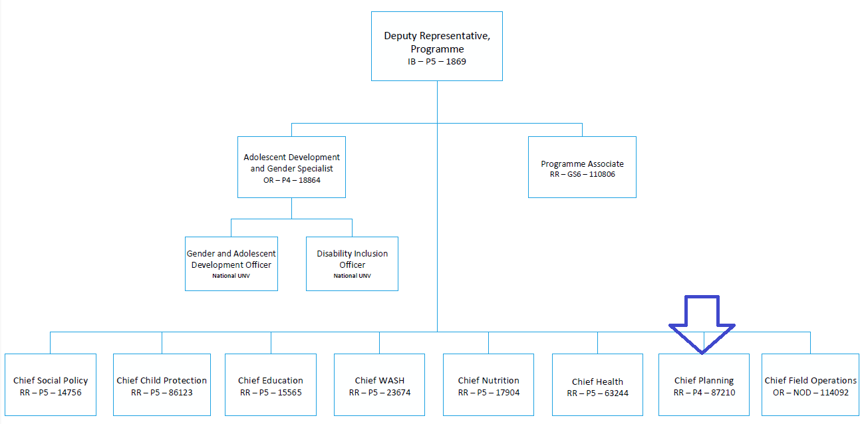

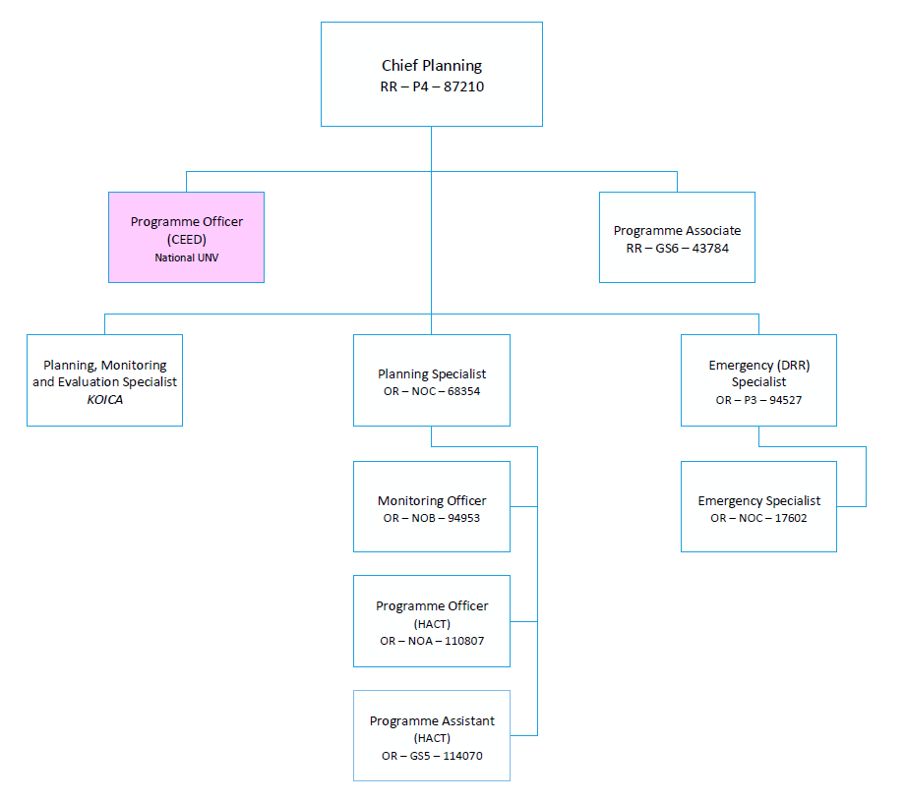

The differences in the grades of jobs and positions reflect various differences, among others, in the nature and scope of work, individual contribution, professional expertise required, organizational context, risks, coordination and networking, engagement, partners, beneficiaries, clients/stakeholders relations, impact of decisions, actions and consequences, and leadership roles.

