 | SPECIFIC JOB PROFILE

I. Post Information

POST NUMBER/ CASE NUMBER: N/A  POST/CASE NUMBER OF SUPERVISOR: 101323  REASON FOR CLASSIFICATION: Establishment  COUNTRY: Yemen  DUTY STATION: Sana’a  SECTION: Programme  UNIT: Health | CATEGORY: NOB  PROPOSED LEVEL:  JOB TITLE: Programme Officer (PHC- Financing and Budgeting)  Functional Code:  ICSC CCOG Code:

II. Strategic Office Context and Purpose for the job

The fundamental mission of UNICEF is to promote the rights of every child, everywhere, in everything the organization does — in programs, in advocacy and in operations. The equity strategy, emphasizing the most disadvantaged and excluded children and families, translates this commitment to children’s rights into action. For UNICEF, equity means that all children have an opportunity to survive, develop and reach their full potential, without discrimination, bias or favoritism. To the degree that any child has an unequal chance in life — in its social, political, economic, civic and cultural dimensions — her or his rights are violated. There is growing evidence that investing in the health, education and protection of a society’s most disadvantaged citizens — addressing inequity — not only will give all children the opportunity to fulfill their potential but also will lead to sustained growth and stability of countries. This is why the focus on equity is so vital. It accelerates progress towards realizing the human rights of all children, which is the universal mandate of UNICEF, as outlined by the Convention on the Rights of the Child, while also supporting the equitable development of nations.

Job organizational context:

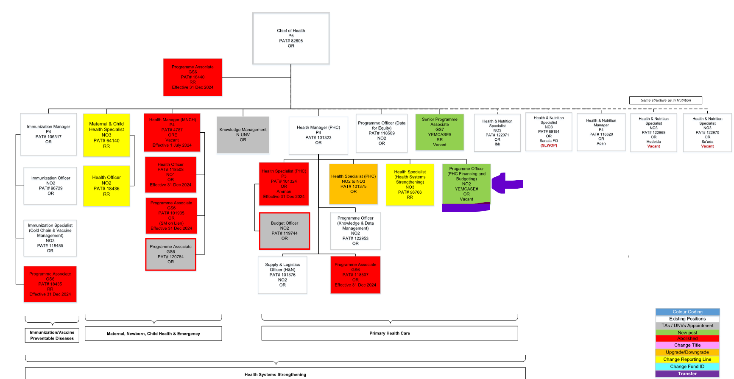

Purpose for the job:

The Primary Health Care (PHC) Financing and Budgeting Officer is responsible for providing support to the Health Manager - PHC, Health Section programme colleagues, and expert implementing partners supporting UNICEF work by leading on PHC financial data analytics and modeling work in relation to PHC Financing Systems Strengthening support to the Ministry of Public Health and Population (MoPHP) of Yemen; And is overall lead on budget planning and management of pooled funding for PHC. The Primary Health Care (PHC) Financing and Budgeting Officer will ensure the requisite excellence in PHC Financing Systems Strengthening and management of pooled funding is upheld by applying theoretical skills and thorough knowledge of organizational goals, objectives, rules, regulations, policies, and procedures to complete the tasks.

III. Key functions, accountabilities and related duties/tasks:

1. Support to PHC financing Systems Strengthening planning and management
2. PHC pool fund budget planning and management
3. Financial reporting and pooled fund donor compliance monitoring
4. Knowledge and capacity building

- Support to PHC financing Systems Strengthening planning and management

- Financial analytics for PHC financing systems strengthening work, including the development of the PHC investment case, preparing/analyzing financial data and documentations to support modeling for optimizing efficiencies in PHC financing approaches.
- Technical finance input for establishing Public Finance Monitoring (PFM) mechanisms for the PHC platform, and under-taking monitoring of PFM functionality and analysis for learning and adjustment.

- PHC pool fund budget planning and management

- Lead in budget planning and budget implementation, including carrying our transactions when required, for all components of UNICEF’s PHC investments that includes forecasting budget needs for the vital organs of the PHC and community systems.
- Provide budget planning support and inputs to donor proposals in collaboration with other team members of the section.
- Monitor and analyze financial transactions to ensure accurate and current financial information for applicable compliance (e.g., donor reporting particularly for pooled fund, internal policies) and management oversight, planning and/or action.
- Complete bi-weekly budget utilization update reports specific to the World Bank, FCDO and Gavi and any other donor that will be on board with the pooled funding arrangement, on a timely basis and per grant conditions.
- Review budget expenditures for pooled funding according to allotment and codes and verify compliance with guidelines, procedures, and specific donor grant conditions; And keep stakeholders informed for timely action.
- Provide technical support to programme counterparts, e.g. review budgets and financial plans of implementing partners; monitor compliance with HACT framework, including support to assessments, assurance and capacity development of MoPHP implementing partners.
- Review financial and reputational risks in the transactions carried out on particularly on the high priority and pooled fund grants, and raise flags when action is needed by the programme team and Health Manager - PHC.
- Monitor and evaluate project financial utilization progress for adjustment, acceleration and improvement of program delivery and sustainability.
- Financial reporting and pooled fund donor compliance monitoring

- Maintain a system to monitor and forecast periodic cash requirements for the pooled fund arrangements that includes multiple donors.
- Provide current information on cash position/forecast to the Health Section programme team and make recommendations or take action to ensure sufficient availability of resources for programmes and operations activities.
- Prepare financial report for the pooled fund grants including submission through the World Bank Client Connection portal and other donor’s systems as appropriate, and prepare funds draw-down requests for submission through the World Bank Client Connection portal.
- Knowledge and capacity building
- Promote a culture of highest ethical standards and behavior in management of UNICEF and donor resources.
- Support initiatives for internal UNICEF and partner (MoPHP) management improvement by capturing, institutionalizing and sharing best practices and lessons learned. Recommend improvements in processes and procedures to enhance efficiency across grants and programme outputs, and performance including implementation of cost saving strategies.
- Participate and/or organize training and learning events to build capacity of staff and stakeholders/partners.
- Support the administration and operations of the Health Section as required.
- Any additional critical tasks as assigned by the supervisor.

IV. Impact of Results
The ability of the Primary Health Care (PHC) Financing and Budgeting Officer to effectively manage and execute pooled fund budget management transactions and services, and to deliver necessary expertise on PHC financing systems strengthening directly impact on meeting organizational mandates and program delivery of goals and objectives, thereby positioning UNICEF as a preferred partner with donors and unlocking much needed additional PHC financing; And increasing MoPHP capacity for sustainable PHC strengthening. This in turn contributes to maintaining/enhancing the credibility of UNICEF as an effective and responsible manager of resources entrusted to the organization and to furthering UNICEF’s image as a competent organization for delivering cost effective and sustainable program results.

V. UNICEF values and competency Required (based on the updated Framework)
i) Core Values

- Care
- Respect
- Integrity
- Trust
- Accountability
- Sustainability

ii) Core Competencies (For Staff with Supervisory Responsibilities)

- Nurtures, Leads and Manages People ()
- Demonstrates Self Awareness and Ethical Awareness ()
- Works Collaboratively with others ()
- Builds and Maintains Partnerships ()
- Innovates and Embraces Change ()
- Thinks and Acts Strategically ()
- Drive to achieve impactful results ()
- Manages ambiguity and complexity ()

iii) Core Competencies for Staff without Supervisory Responsibilities

- Demonstrates Self Awareness and Ethical Awareness (1)
- Works Collaboratively with Others (1)
- Builds and Maintains Partnerships (1)
- Innovates and Embraces Change (1)
- Thinks and Acts Strategically (1)
- Drives to Achieve Impactful Results (1)
- Manages Ambiguity and Complexity (1)

*The 7 core competencies are applicable to all employees. However, the competency Nurtures, Leads and Managers people is only applicable to staff who supervise others

VI. Recruitment Qualifications
Education: | A first level university degree in accounting, financial management or another related financial field is required. Supplemental formal financial / accounting training may be accepted if university degree is not in a related financial field.
Experience: | A minimum of two years of professional experience in financial management or project management is required.  Experience in an international organization and/or large corporation is preferred.  Experience in a UN system agency or organization some of which served in a developing country is considered as an asset.  Advanced knowledge of Microsoft Office, especially Excel required.  Experience in database packages, web based management systems and ERP systems (preferably SAP financial modules) is considered as an asset.
Language Requirements: | Fluency in English and Arabic is required both in written and verbal communications. Knowledge of another UN language is considered an asset.

VII. Child Safeguarding

IS THIS ROLE A REPRESENTATIVE, DEPUTY REPRESENTATIVE, CHIEF OF FIELD OFFICE, THE MOST SENIOR CHILD PROTECTION ROLE IN THE OFFICE, CHILD SAFEGUARDING FOCAL POINT, OR INVESTIGATOR (OIAI)? *: | No
IS THIS POST A DIRECT CONTACT ROLE IN WHICH INCUMBENT WILL BE IN CONTACT WITH CHILDREN EITHER FACE-TO-FACE, OR BY REMOTE COMMUNICATION, BUT THE COMMUNICATION WILL NOT BE MODERATED AND RELAYED BY ANOTHER PERSON? *: | No
IS THIS POST A CHILD DATA ROLE IN WHICH INCUMBENT WILL BE MANIPULATING OR TRANSMITTING PERSONAL-IDENTIFIABLE INFORMATION ON CHILDREN SUCH AS NAMES, NATIONAL ID, LOCATION DATA, OR PHOTOS)? *: | No
THE SELECTED CANDIDATE FOR THIS POSITION WILL BE REQUIRED TO ENGAGE WITH VULNERABLE CHILDREN*: | No

