 | SPECIFIC JOB PROFILE

I. Post Information

Post Number/ Case Number: 122954  Post/Case Number Of Supervisor: 18449 / Finance & Accounts Officer  Reason For Classification: Upgrade  Country: Yemen  Duty Station: Sana’a  Section: Operations  Unit: Finance | Category: GS  Proposed Level: G5  Job Title: Finance Assistant  Functional Code:  ICSC CCOG Code:

II. Strategic Office Context and Purpose for the job

The fundamental mission of UNICEF is to promote the rights of every child, everywhere, in everything the organization does — in programs, in advocacy and in operations. The equity strategy, emphasizing the most disadvantaged and excluded children and families, translates this commitment to children’s rights into action. For UNICEF, equity means that all children have an opportunity to survive, develop and reach their full potential, without discrimination, bias or favoritism. To the degree that any child has an unequal chance in life — in its social, political, economic, civic and cultural dimensions — her or his rights are violated. There is growing evidence that investing in the health, education and protection of a society’s most disadvantaged citizens — addressing inequity — not only will give all children the opportunity to fulfill their potential but also will lead to sustained growth and stability of countries. This is why the focus on equity is so vital. It accelerates progress towards realizing the human rights of all children, which is the universal mandate of UNICEF, as outlined by the Convention on the Rights of the Child, while also supporting the equitable development of nations.

Strategic office context :

The Finance Assistant, at the G-5 level, is based in the UNICEF Yemen Country Office (YCO) and reports to the Finance & Accounts Officer who is at the NOB level.

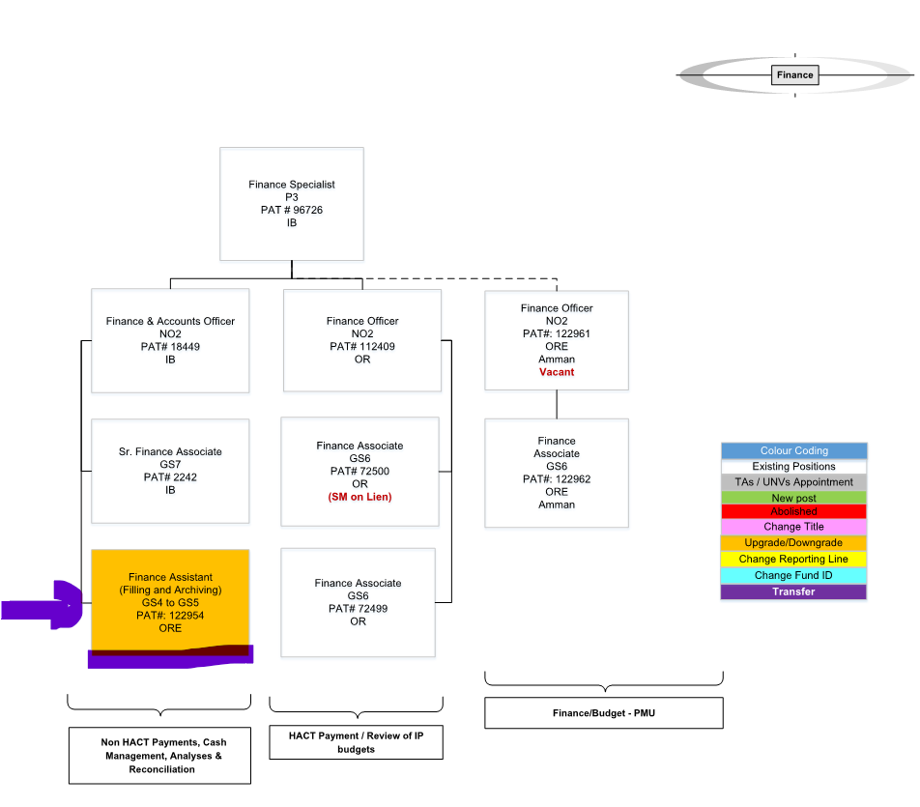

Purpose for the job:

Under the direct supervision of the Finance & Accounts Officer, the Finance Assistant will be responsible for providing a variety of finance functions, requiring thorough knowledge of UNICEF financial procedures, processes, and policies.

III. Key functions, accountabilities and related duties/tasks:

- Reviewing the cash payments to individuals that sent from FOs/CO and working closely with Programme staff and Finance in FOs for any comment related to cash payments to individuals and provide the required support.
- Maintain and update a tracker (Record) for the cash payments to individuals in a timely manner.
- Maintain the recording of bank deposits from all partners, staff, UN agencies and others in the SAP.
- Maintain the adjustments of the accommodation deductions for IPs and other UN staff in UNICEF guesthouses.
- Act as Focal point for processing the cash payments to individuals between YCO, MIS/YSC and banks through working closely with all of them for any comment related to cash payments to individual.
- Supports with processing of all other day to day transactional load in finance including but not limited to invoice processing, HACT transactions, Petty Cash transactions, and travel postings and clearings.
- Close year-end account and assist in the preparation of year-end reports through clearing the open item for bank GL, AR, SM PAR, and unapplied receipts other GL plus any other year and month end support required.
- Advise and assist on all aspects related to preparation of reports, compilation of data and answering queries on pledges recorded, funds received, adjustments made to ensure financial compliance, accuracy and completeness of data for its inclusion into statement of accounts and adjustment of budgets. Advise units of discrepancies and assist to resolve differences in their records.
- Maintains liaisons with officials of local banks to obtain day-to-day information on exchange and interest rates, changes in procedures and regulations, and matters pertaining to maintenance of office bank accounts. This includes prepares recurring reports and bank reconciliation.
- Assist higher level Officers in all aspects of accounts maintenance and providing reports on financial status, procedures, costs and expendentures, and potentional funding problems.
- Contributes to the operations budget management through being responsible for assigning correct funding sources and allocations to operational expenses across YCO while supporting with other related budget tasks as required.
- Performs other duties, as required

IV. Impact of Results
The efficiency and efficacy of the Finance Assistant directly impacts on theoptimum, appropriate and effective use of resources and efficient financial recording, accounting and reporting, which in turn facilitates management oversight, decision making and quality control.

V. UNICEF values and competency Required (based on the updated Framework)
i) Core Values
- Care
- Respect
- Integrity
- Trust
- Accountability
- Sustainability

ii) Core Competencies (For Staff with Supervisory Responsibilities)
- Nurtures, Leads and Manages People ()
- Demonstrates Self Awareness and Ethical Awareness ()
- Works Collaboratively with others ()
- Builds and Maintains Partnerships ()
- Innovates and Embraces Change ()
- Thinks and Acts Strategically ()
- Drive to achieve impactful results ()
- Manages ambiguity and complexity ()

iii) Core Competencies for Staff without Supervisory Responsibilities
- Demonstrates Self Awareness and Ethical Awareness (1)
- Works Collaboratively with Others (1)
- Builds and Maintains Partnerships (1)
- Innovates and Embraces Change (1)
- Thinks and Acts Strategically (1)
- Drives to Achieve Impactful Results (1)
- Manages Ambiguity and Complexity (1)
*The 7 core competencies are applicable to all employees. However, the competency Nurtures, Leads and Managers people is only applicable to staff who supervise others.

VI. Recruitment Qualifications

Education: | Completion of secondary education is required.  Professional/university level courses in Accounting, Finance and Business Administration are considered as an asset, or any other related field.
Experience: | A minimum of five (5) years of clerical experience in the area of finance and accounting is required.  A bachelor’s degree from a recognized academic institution in one of the above fields may replace three years of related work experience. A master’s degree may replace an additional two years.  - Experience in international organization is an asset.  - Experience in ERP systems is an asset.  - Good skills in Microsoft office are a desirable
Language Requirements: | Fluency in English and Arabic is required both in written and verbal communication. Knowledge of another UN language is considered an asset.

VII. Child Safeguarding
IS THIS ROLE A REPRESENTATIVE, DEPUTY REPRESENTATIVE, CHIEF OF FIELD OFFICE, THE MOST SENIOR CHILD PROTECTION ROLE IN THE OFFICE, CHILD SAFEGUARDING FOCAL POINT, OR INVESTIGATOR (OIAI)? *: | No
IS THIS POST A DIRECT CONTACT ROLE IN WHICH INCUMBENT WILL BE IN CONTACT WITH CHILDREN EITHER FACE-TO-FACE, OR BY REMOTE COMMUNICATION, BUT THE COMMUNICATION WILL NOT BE MODERATED AND RELAYED BY ANOTHER PERSON? *: | No
IS THIS POST A CHILD DATA ROLE IN WHICH INCUMBENT WILL BE MANIPULATING OR TRANSMITTING PERSONAL-IDENTIFIABLE INFORMATION ON CHILDREN SUCH AS NAMES, NATIONAL ID, LOCATION DATA, OR PHOTOS)? *: | No
THE SELECTED CANDIDATE FOR THIS POSITION WILL BE REQUIRED TO ENGAGE WITH VULNERABLE CHILREN*: | No

VIII. Signatures- Post Description Certification

Supervisor, Sumaya Mahfoudh, Finance & Accounts Officer (Signature & Date)

 May 6, 2024

HR Reviewed, Beverley Mitchell, Chief HR
(Signature & Date)

Head of Section, Randa Osman Omer, Finance Specialist
(Signature & Date)

Deputy Representative Operations, Lana Kataw
(Signature & Date)

YCO Representative, OIC
(Signature & Date)

