 | UNITED NATIONS CHILDREN’S FUND  Specific JOB PROFILE

I. Post Information

Post Number/ Case Number: YEM24010  Job Title: Programme Officer (Risk Management and Safeguarding)  Supervisor Title/ PAT #: Programme Manager (Risk Management) PAT# 118484  Reason For Classification: Established  Organizational Unit: Operations/ RMU  Post Location: Sana’a, Yemen Country Office | Category: NO/ NO1  CCOG Code:  Functional Code:  Job Classification Level: Level 1

II. Organizational Context and Purpose for the job

The fundamental mission of UNICEF is to promote the rights of every child, everywhere, in everything the organization does — in programs, in advocacy and in operations. The equity strategy, emphasizing the most disadvantaged and excluded children and families, translates this commitment to children’s rights into action. For UNICEF, equity means that all children have an opportunity to survive, develop and reach their full potential, without discrimination, bias or favoritism. To the degree that any child has an unequal chance in life — in its social, political, economic, civic and cultural dimensions — her or his rights are violated. There is growing evidence that investing in the health, education and protection of a society’s most disadvantaged citizens — addressing inequity — not only will give all children the opportunity to fulfill their potential but also will lead to sustained growth and stability of countries. This is why the focus on equity is so vital. It accelerates progress towards realizing the human rights of all children, which is the universal mandate of UNICEF, as outlined by the Convention on the Rights of the Child, while also supporting the equitable development of nations. The functions and objectives of this section are as follows:

- Risk and ESS – providing YCO with policy and implementation of integrated Risk Management and ESS;
- Supporting all programs with Risk Management, ensuring that ESS are integrated into it and that monitoring happens at least on a quarterly basis, to improve programme quality and effectiveness;
- Conducting IPM/HACT assurance activities according to the policy;
- Reporting and monitoring all incidents affecting project stakeholders (including SEA ones) and ensuring victim assistance is provided for.

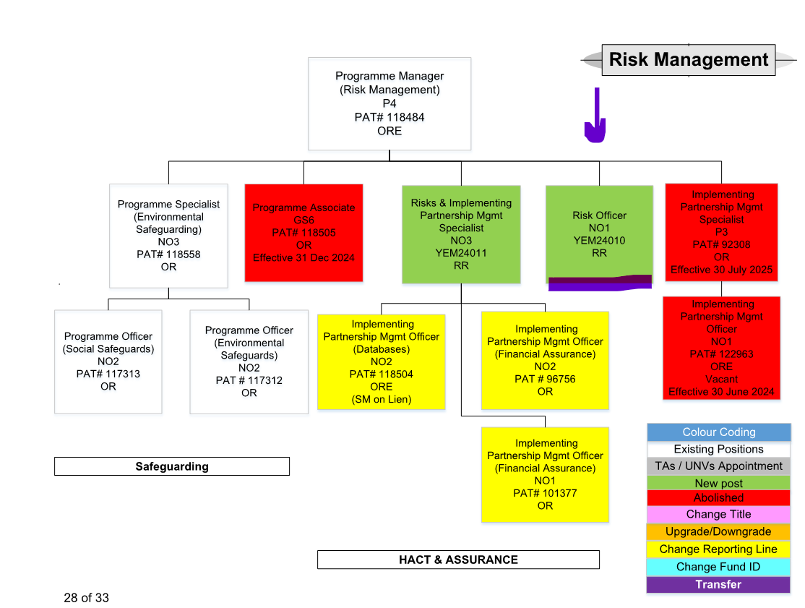

Purpose for the job:

Under the supervision and guidance of the Programme Manager (Risk Management), Programme Officer (Risk Management and Safeguarding) supports the Risk Management Unit and the other sections in assessing and managing the risks pertaining to their scope of work – both from an operational and programmatic perspective – to help develop, implement and monitor their country programme, ensuring effective and timely delivery that is consistent with UNICEF rules and regulations.

The Programme Officer (Risk Management and Safeguarding) works in close collaboration with a range of staff in the CO, external partners and agency counterparts in support of programme design, delivery and monitoring. S/He provides regular feedback on the status of risk management at programme and project levels (and, when requested, at subproject level too), through monitoring risks assessments and related mitigation measures, and advises on improvements to keep activities on track.

III. Key functions, accountabilities and related duties/tasks:
Summary of key functions/accountabilities:

- Support the risk units in the development and update of the office risk matrix and act as a penholder of the office risk matrix itself, contributing to the implementation of the overall enterprise risk management
- Act as GPRC/PRC Secretariat, contributing to the improvement of the quality of Programme Documents – in line with Partnership SOP, HACT guidelines, CSO Procedure, and Environmental and Social Safeguarding Standards (ESS)
- Support the implementation of IPM/HACT procedures and the programmes’ compliance with ESS standards within Yemen CO, contributing to the quality and effectiveness of programme delivery and to the system strengthening
- Support the risk units in the development and update of the office risk matrix and act as a penholder of the office risk matrix itself, contributing to the implementation of the overall enterprise risk management
- Regularly update the office risk matrix in collaboration with the relevant risk units – monthly, through the senior weekly management meeting; quarterly, through the Country Management Team meeting.
- Follow up with the relevant risk units to ensure that the risks and mitigation measures included in the risk matrix are implemented, monitored and regularly reassessed.
- Ensure that the risk matrix included in the Programme Documents to be approved by the PRC is aligned with the office risk matrix and vice versa.
- Support the Implementing Partnership Management subunit in ensuring that the IPM/HACT activities are aligned with the office risk matrix and vice versa.
- Support the Environmental and Social Safeguarding subunit in ensuring that the related risks and mitigation measures are aligned with the office risk matrix and vice versa.
- Contribute to the simplification process, by developing, updating and improving (whenever relevant) a digital office risk matrix.

- Act as GPRC/PRC Secretariat, contributing to the improvement of the quality of Programme Documents – in line with Partnership SOP, HACT guidelines, CSO Procedure, and Environmental and Social Safeguarding Standards (ESS)
- Centralize, organize and archive all GPRC and PRC requests from all Field Offices and Sections.
- Perform quality check, accuracy and completeness of submissions (LoCs, PDs/HPDs/SSFAs, AIP, Requests) to ensure compliance with YCO SOP and Local SOP for GPRC/PRC; ensure documentation files pertaining to the submissions and meetings is complete.
- Organize, manage and coordinate GPRC/PCR meetings, by among others i) informing GRPC/PRC members who are in the roster of the meetings in a timely manner, ii) by distributing relevant GPRC/PRC documentation to G-PRC members for their timely review, iii) submitting final GPR/PRC documents to G-PRC members, Deputy Representative, Representative for signatures.
- Take minutes and document G-PRC Review and Recommendation on the G-PRC Submission Form, and any other exchanges pertaining to the GPR/PRC meetings.
- Provide administrative guidance for Program staff on GPRC/PRC processes.
- Centralize, organize and archive all documentation for government projects i.e LOCs, PDs/HPDs/SSFAs.
- Follow up with the sections and FOs to update partnership information in eTools.
- Manage communications between UNICEF and implementing partners on GPR/PRC related issues.
- Organize all logistics related to GPRC trainings/orientations and contribute to delivering the relevant training and orientations.
- Ensure the Programme Documents reflect the office risk matrix, including the environmental and social safeguarding standards.
- Support in managing the partnership database for central repository of hard and electronic GPRC/PRC copies.

- Support the implementation of IPM/HACT procedures and the programmes’ compliance with ESS standards within Yemen CO, contributing to the quality and effectiveness of programme delivery and to the system strengthening
- Based on HACT assurance activities’ plan, centralize, organize and archive supporting documentations for spot checks, audits and micro assessments i.e., liquidation FACE forms and other related documents. Share these documents with outsourced audit firms and ensure uploads in eTools.
- Prepare HACT background information for use in discussions with governments and other organizations; participate in the briefing and debriefing of project personnel.
- Contribute to the preparation of monthly partnership analytical products.
- Collect information from sections when it is needed, including partner progress reports, compliance with ESS, assurance activity reports, registration and documentation to support Enhanced Risk Assessments (ERA).
- Facilitate and contribute to the delivery of integrated training modules for UNICEF staff and partners, including suppliers, on both IPM/HACT procedures and ESS standards,
- Whenever needed, support in the administrative tasks for the implementation of the above activities – e.g., Purchase Requests (PR), Purchase Orders (PO), Funds Commitments (FC), correspondences and contact lists, e-Tools documentation, etc.

IV. Impact of Results
The incumbent will be accountable for the full spectrum of project/programme support activities, with a focus on risk management-related ones. The key results have an impact on the overall performance of the country office and success in the implementation of project/programme activities. Accurate programme monitoring and recommendations, data entry and presentation of information ensure proper programme decision-making.

V. Competencies and level of proficiency required (based on UNICEF Professional Competency Profiles)
i) Core Values
- Care
- Respect
- Integrity
- Trust
- Accountability

ii) Core Competencies (For Staff with Supervisory Responsibilities)
- Nurtures, Leads and Manages People ()
- Demonstrates Self Awareness and Ethical Awareness ()
- Works Collaboratively with others ()
- Builds and Maintains Partnerships ()
- Innovates and Embraces Change ()
- Thinks and Acts Strategically ()
- Drive to achieve impactful results ()
- Manages ambiguity and complexity ()

iii) Core Competencies for Staff without Supervisory Responsibilities
- Demonstrates Self Awareness and Ethical Awareness (1)
- Works Collaboratively with Others (1)
- Builds and Maintains Partnerships (1)
- Innovates and Embraces Change (1)
- Thinks and Acts Strategically (1)
- Drives to Achieve Impactful Results (1)
- Manages Ambiguity and Complexity (1)

*The 7 core competencies are applicable to all employees. However, the competency Nurtures, Leads and Managers people is only applicable to staff who supervise others.

VI. Skills
- In-depth knowledge of risk management within UNICEF.

- Strong organizational, planning and prioritizing skills and abilities.

- High sense of confidentiality, initiative, and good judgment.

- Willingness to innovate and simplify.

- Ability to work effectively with people of different national and cultural backgrounds.

- Strong office management skills.

- High attention to detail.

- Good analytical skills.

- Experience using MS Word, Excel, PowerPoint and other UNICEF software such as SharePoint.

VII. Recruitment Qualifications
Education: | A university degree in one of the following fields is required: Development Studies, International Development, Business Administration, Financial Management, Economics, Auditing, Project/Programme Management, or another related field.
Experience: | A minimum of one year of relevant professional experience in Administration, Financial Management, Business Administration, Accounting, or related field is required.  Prior experience in program support functions is an asset.  Prior experience in risk management support functions is an asset.  Relevant experience in a UN system agency or organization is considered as an asset.
Language Requirements: | Fluency in English and Arabic is required both in written and verbal communications. Knowledge of another UN language is considered an asset.

VIII. Child Safeguarding
IS THIS ROLE A REPRESENTATIVE, DEPUTY REPRESENTATIVE, CHIEF OF FIELD OFFICE, THE MOST SENIOR CHILD PROTECTION ROLE IN THE OFFICE, CHILD SAFEGUARDING FOCAL POINT, OR INVESTIGATOR (OIAI)? *: | No
IS THIS POST A DIRECT CONTACT ROLE IN WHICH INCUMBENT WILL BE IN CONTACT WITH CHILDREN EITHER FACE-TO-FACE, OR BY REMOTE COMMUNICATION, BUT THE COMMUNICATION WILL NOT BE MODERATED AND NoRELAYED BY ANOTHER PERSON? *: | No
IS THIS POST A CHILD DATA ROLE IN WHICH INCUMBENT WILL BE MANIPULATING OR TRANSMITTING PERSONAL-IDENTIFIABLE INFORMATION ON CHILDREN SUCH AS NAMES, NATIONAL ID, LOCATION DATA, OR PHOTOS)? *: | No
THE SELECTED CANDIDATE FOR THIS POSITION WILL BE REQUIRED TO ENGAGE WITH VULNERABLE CHILDREN*: | No

