**TERMS OF REFERENCE**

**Purpose of the Assignment:** Individual consultancy to conduct baseline survey for KOICA phase 2 programme

**Section Submitting:** Education

1. **Purpose and Objective:**

Mozambique has been struggling to improve the access to and quality of primary education for the last decade due to a few reasons, including an economic setback caused by misuse of funds and natural disasters. While no data is available for 2019 onwards, primary completion rate was improved by only 2% from 2011 to 2018 (MINEDH, 2020 RAR report). Learning achievement is already very low but still showcases a downward trend. According to a national learning assessment (Table 1), national reading competency for grade 3 in 2013 was 6.3% and the situation got even worse in 2016 to 4.9% (MINEDH, National Learning Assessment 2013 and 2016). Besides, the absenteeism is a huge issue as table 2 indicates[1] (2015 WB SDI report).

**Table 1: Reading competency level for Grade 3 per province in 2013 & 2016**

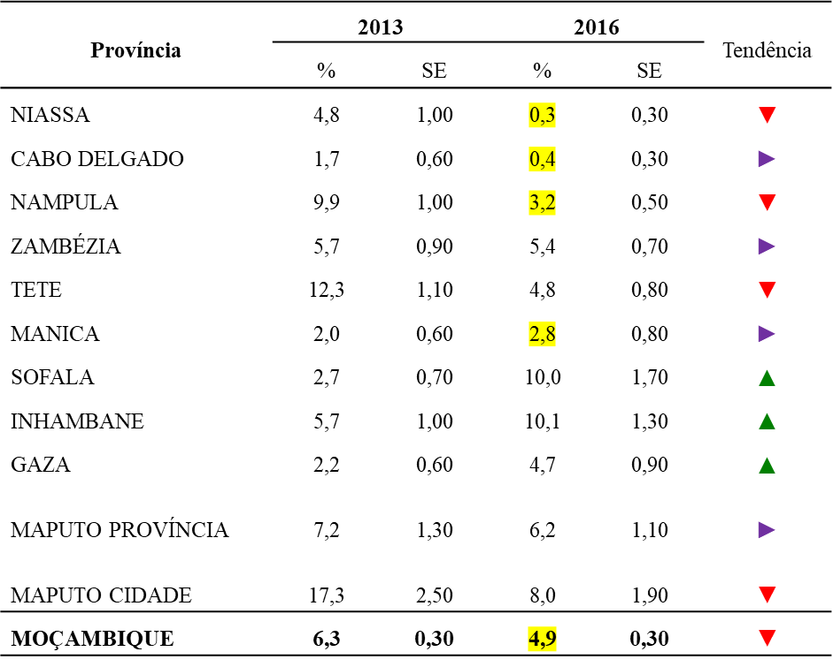

Source: Relatório do 2º Estudo da Avaliação Nacional da 3ª Classe (2016).

**Table 2: Education indicators comparing with other African countries**

Source: WB Service Delivery Indicator (SDI) report 2014.

To improve the current situation, the Education section of UNICEF will implement a project called “Improving Equity and Quality in Primary Education”, starting in 2021 with a duration of 3 years. The project will support education authorities in the Nampula and Zambezia provinces (Provincial and district education offices) on various areas by the generous funding from the Korean International Cooperation Agency (KOICA) – Project proposal and logframe attached.

The overarching objective of the proposal is to improve the equitable access and quality education of children and especially girls in target districts in the Zambezia (Milange, Molumbo and Pebane) and Nampula provinces (Lalaua, Liupo, Murrupula). To this aim, the project has the following three outcomes:

* *Outcome 1: The first outcome is aimed to support the pre-service and in-service teacher training systems with the following expected outputs*:
  + Capacity of teachers is strengthened through support to pre-service training system and in-service teacher distance learning system
  + Support is provided to the implementation of the Ministry’s reading and numeracy improvement strategy with focus on school-based activities
* *Outcome 2: The second outcome aims to enhance inclusive education through promotion of access and retention and provision of improved learning environment*.
  + Children and adolescents (especially girls) age 10-19 years are equipped with life skills to protect themselves against violence through using referral and reporting mechanism for VAC/ and benefiting from the using MHM approach
  + Capacity of school council in school management and in the use of tools to prevent drop out and absenteeism is strengthened.
  + Capacity building of IE MINEDH officials on the operationalization of the IE strategy is strengthened;
  + WASH facilities are constructed in targeted schools in accordance with the agreed designs;
  + Hygiene education is conducted in target schools and roster for maintenance and cleaning of sanitation facilities established at school level;
  + Water committees for operation and maintenance (O&M) of water supplies are established and supported by the communities;
  + Education opportunity is provided students through prevention measures against COVID-19
* *Outcome 3: The third outcome aims to support the system and governance of the education sector to have a gender sensitive approach with the following outputs:*
  + Government officials at decentralized level acquire knowledge on gender sensitive analysis to inform planning and budgeting processes;
  + District officials have increased capacity to implement District Supervision and online District Supervision data management;
  + School managers obtain capacity of implementing best school management practices;

It is expected that the project will benefit an estimated 220,000 students (47.6% are girls), 1,000 teachers, 400 school directors and over 500 school councils in 3 districts in Zambezia and 3 districts in Nampula through the regular programme with an additional 100,000 students in over 1,000 schools and 700 teachers being reached through the COVID-19 response.

For the project achievement to be measured after the project is completed, data/information on the pre-project implementation status for each activity must be collected as baseline before the actual implementation starts and means of verification for these must be clearly identified.

The education section of UNICEF, therefore, is seeking a Consultant to review proposed means of verification (MoVs) for each indicator in the project and collect baseline data for all indicators before the project implementation actually starts in the 2nd half of 2021.

1. **Methodology and Technical Approach:**

For this to take place, the consultant is expected to work with concerned parties such as the Ministry of Education and Human Development (MINEDH) at central level, Provincial education authorities (DPE) and District education authorities (SDEJT?) as well as UNICEF staff responsible for each output under the supervision of the UNICEF Education Manager. More concretely, the following objectives are to be completed after this consultancy is concluded:

* Review target and means of verification (MoVs) for each indicator in the logframe and propose new ones where deemed necessary;
* Develop proper MoV and collect baseline data for outcome indicator 3 (% of Districts with evidence-based plans);
* Collect baseline data for all other outcome and output indicators;

As a result, the education section of UNICEF expects that indicators and MoVs are identified and baseline data for these indicators are collected to be measured against achievement when the project is completed.

The Consultant would review target and MoV for each activity from the points whether they are realistic and propose new ones if they are not deemed adequate to collect data.

The work will consist of (i) Discussion with UNICEF staff responsible for each output (and concerned staff from MINEDH side as required) to verify whether targets are realistic and MoVs are adequate to measure indicators; (ii) Obtaining/verifying baseline data for each output; (iii) Developing outcome indicator 3 (% of Districts with evidence based plans) and collecting baseline data for this indicator in target districts (Milange, Molumbo and Pebane in Zambezia province and Lalaua, Liupo, Murrupula in Nampula province) ; and (iv) submission of baseline survey report

It is expected that the work (i) & (ii) are conducted through reviewing logframe, project output description and output description (attached) as well as (e-) meeting with relevant UNICEF staff, while the work (iii) requires consulting existing planning documents for outcome indicator 3 and discussion with UNICEF responsible staff and MINEDH concerned colleagues in both target provinces and districts for developing MoVs. These MoVs must be recognised/approved by MINEDH target provinces/districts. Lastly, the draft report (iv) will be shared with UNICEF for our comments before finalisation.

1. **Activities and Tasks:**
2. **Submission of consultancy work plan**

The Consultant would produce and submit to UNICEF a proposal for a work plan for this consultancy, including detailed information on the activities to be implemented, partners contacted and strategy for each work in order to achieve the planned results. **10%**

1. **Review of proposed targets and MoVs for each output and collection of baseline data**:

In this phase, the Consultant is expected to review targets and means of verification (MoVs) for all indicators except outcome indicator 1 (% of students (by gender) in grade 3 that have basic competencies in reading and math of the 1st cycle (grade 1-2) of primary education in target districts) and 3 (% of Districts with evidence-based plans) through consulting logframe, project output description and output description (all attached) and propose new MoVs if proposed ones cannot serve as MoV. The Consultant would agree with UNICEF on these new MoVs after discussion with UNICEF relevant staff, after which the Consultant will collect baseline data. **20%**

1. **Drafting MoV for outcome indicator 3 (% of Districts with evidence-based plans)**

For this to take place, the Consultant needs to analyse the existing planning documents from target districts and consult with their related planning officers to understand the degree of use of evidence for planning for outcome indicator 3. UNICEF Education section will provide necessary documents and contact information for relevant staff at MINEDH side to help the Consultant to draft MoVs. **35%**

1. **Finalizing MoV for outcome indicator 3 and baseline set**

The Consultant will discuss with MINEDH to finalise the MoV for outcome indicator 3 and set baseline. Then, once all the above work are completed, the consultant will draft the baseline report responding to all activities requiring baseline data with useful information obtained and suggestion generated during the consultancy work. The draft will be reviewed by UNICEF before finalization. **35%**

1. **Deliverables and Payments:**

The period of time determined for this consultancy is 60 days in a period of 3 months, distributed between July 12, 2021 until October 31st, 2021.

This consultancy is related to 6890/A0/06/400/004/038 and will be financed by KOICA Ph2 project.

All payments will be processed upon acceptance of the corresponding deliverables by UNICEF and against an invoice that will refer to the contract and the planned result. Payment will be approved by UNICEF Head of Education.

|  |  |  |
| --- | --- | --- |
| **Deliverable** | **Result** | **Number of days** |
| **1** | Detailed work plan for the consultancy | 5 days |
| **2** | A list of indicators and MoVs for all indicators expect outcome indicators 1 & 3 reviewed + baseline data | 15 days |
| **3** | Draft MoVs for outcome indicator 3 (% of Districts with evidence-based plans) submitted | 20 days |
| **4** | Final MoVs with baseline data for outcome indicator 3 and baseline report submitted | 20 days |

1. **Management and Supervision:**

The consultant will work remotely in principle with occasional visit at UNICEF office with trip to the field (Nampula and Zambezia) under the supervision of the Education Manager. The consultant will interact with UNICEF colleagues as well as counterparts.

Most of activities are conducted in Maputo, while the Consultant may also need to visit these provinces to discuss MoV for outcome indicator 3.

1. **Qualifications and Specialized Knowledge:**

**Academic qualifications:**

* Minimum Master degree in M&E, programme management or relevant social discipline, preferably education

**Work experience:**

* Possess at least eight years of relevant work experience in M&E and programme management in developing countries;
* Have completed at least 1 project on comprehensive education programme as coordinator;
* Have an enough working experience (at least 5 years) and knowledge in the education sector in Mozambique in the supervision function

**Language skills:**

* English (Mandatory) – Level: Fluent
* Portuguese (Mandatory) – Level: Working Knowledge (Ability to communicate with Government counterpart)

1. **Conditions of Work:**

|  |  |  |  |
| --- | --- | --- | --- |
| **Items** | **Provided by UNICEF** | | **Remarks** |
| **Yes** | **No** |
| Service incurred death, injury or illness | x |  | Per the provisions of CF/IC/2013-001 on insurance coverage “in cases of service-incurred injury, illness or death under a third-party provider”. |
| Health Insurance |  | x |  |
| In-country travel | x |  |  |
| Office Space | x |  |  |
| Computer in office premises | x |  |  |
| Access to printer in the office premises | x |  |  |
| Airtime |  | x |  |

1. **In-country Travel.**

Approved travel within Mozambique will be covered/reimbursed by UNICEF as follows:

Option a. Air tickets to be purchased by the consultant from approved airlines and reimbursed by UNICEF; per diem at 75% of the applicable UN Mozambique DSA rate (for the whole night spent outside the place of assignment), on a reimbursable basis; taxi/transport costs to and from the airport, on a reimbursable basis supported by the submission of original invoice/bill/receipt. All reimbursables to be included in their respective invoices.

Option b. Travel organised by UNICEF through a Travel Authorisation per the applicable policy, with standard terminal expenses, and per diem at 75% of the applicable UN Mozambique DSA rate.

1. **Evaluation Criteria**

The selection of the consultant will be based on a “best value for money” principle. Interested candidates should, in addition to submitting their CV and cover letter, indicate their all-inclusive fees (including travel, subsistence costs, etc.) for the services to be provided. The office shall select the individual who quoted the lowest fee from the list of individuals who are deemed technically suitable for achieving all tasks in time. The technical evaluation criteria are stipulated below.

|  |  |  |
| --- | --- | --- |
| **Item** | **Technical Criteria/Qualifications** | **Max. Points** |
| **1** | **Education** | **10** |
| **1.1** | Master degree in M&E, programme management or relevant social discipline, preferably education | 10 |
| **2** | **Work Experience** | **36** |
| **2.1** | Possess at least eight years of relevant work experience in M&E and programme management in developing countries; | 12 |
| **2.2** | Have completed at least 1 project on comprehensive education programme as coordinator - sharing sample of previous programme | 12 |
| **2.3** | Have an enough working experience (at least 5 years) and knowledge in the education sector in Mozambique in the supervision function - sharing sample of previous experiece | 12 |
| **3** | **Technical Skills and Knowledge** | **24** |
| **3.1** | Technical skills on M&E – sharing sample of previous programme monitoring | 14 |
| **3.2** | Language skills | 10 |
|  | ecblank**Total Technical Score** | **70** |
|  | **Minimum Technical for pass to financial assessment** | **50** |
|  | *Only those candidates meeting the minimum technical score will be eligible for further review.* | |
|  | **Financial score** | **30** |
|  | ecblank**Total Score** | **100** |

|  |  |  |
| --- | --- | --- |
| **Child Safeguarding**  Is this project/assignment considered as “[Elevated Risk Role](https://unicef.sharepoint.com/sites/DHR-ChildSafeguarding/DocumentLibrary1/Guidance%20on%20Identifying%20Elevated%20Risk%20Roles_finalversion.pdf?CT=1590792470221&OR=ItemsView)” from a child safeguarding perspective?       YES       NO     If YES, check all that apply:      **Direct contact role** YES       NO   If yes, please indicate the number of hours/months of direct interpersonal contact with children, or work in their immediately physical proximity, with limited supervision by a more senior member of personnel:     |  | | --- | |  |     **Child data role** YES      NO   If yes, please indicate the number of hours/months of manipulating or transmitting personal-identifiable information of children (name, national ID, location data, photos):     |  | | --- | |  |   More information is available in the [Child Safeguarding SharePoint](https://unicef.sharepoint.com/sites/DHR-ChildSafeguarding/SitePages/Amendments-to-the-Recruitment-Guidance.aspx) and [Child Safeguarding FAQs and Updates](https://unicef.sharepoint.com/sites/DHR-ChildSafeguarding/DocumentLibrary1/Child%20Safeguarding%20FAQs%20and%20Updates%20Dec%202020.pdf) |

1. The situation was improved according to 2018 SDI report. However, the data still indicates the alarming situation.