**DRAFT Terms of Reference**

***Country Programme Evaluation***

***of the Government of Lesotho and UNICEF***

***Country Programme of Cooperation 2019-2023***

**Summary**

|  |  |
| --- | --- |
| **Type of Contract** | Individual Contract |
| **Title of the Evaluation** | Evaluation of Lesotho-UNICEF Country Programme of Cooperation (2019-2023) |
| **Purpose** | * Identify best practices, results and key lessons from the ongoing Country Programme to inform the development of the next Lesotho Country Programme Document. * Reinforce accountability of UNICEF to national and international stakeholders. * Reinforce accountability of UNICEF to the Executive Board. |
| **Objectives** | * To assess the relevance, effectiveness, efficiency, coherence and sustainability of the Lesotho Country Programme from its inception to date, with particular focus on equity, gender equality, the convergence of programme components and achieving results at scale, as well as UNICEF's strategic positioning in relation to its child rights mandate. * To reflect on how UNICEF responded/adapted to a changing environment (COVID-19) that impacted on the implementation of the country programme and implications for the development of shock resilience programme. * To identify and document key lessons learned, good practices and innovations in implementing the current (2019-2022) Country Programme that can inform and support advocacy efforts for scale-up and replication. * To provide a set of forward-looking and actionable recommendations to strengthen programmatic strategies in the design of the next Lesotho Country Programme, considering national development priorities and plans and the 2030 Agenda for Sustainable Development in the country. |
| **Location** | Lesotho |
| **Duration** | Six months |
| **Start Date** | January 2021 |
| **Reporting to** | UNICEF Eastern and Southern Africa Regional Office (ESARO) |
| **Grant reference** | Non-grant (RR) |
| **Activity and WBS details** | 2520/A0/05/883/003 |

# Introduction

As per UNICEF's Evaluation Policy 2018, every UNICEF Country Programme must be evaluated at least once every two-country programme cycles. Such Country Programme Evaluations (CPEs) are conducted by the Evaluation Section of the respective UNICEF Regional Office.

CPEs intend to capture and demonstrate evaluative evidence of UNICEF's contributions to development results at the country level and the effectiveness of UNICEF's strategy in facilitating and leveraging national efforts for achieving development results. Their purpose is to:

* Identify best practices, results and key lessons from the ongoing Country Programme to inform the development of the next UNICEF Country Programme Document (CPD)
* Strengthen accountability of UNICEF to national and international stakeholders
* Strengthen accountability of UNICEF to the Executive Board

The CPE will be managed by the Evaluation Section of UNICEF's East and Southern Africa Regional Office, under the overall oversight of the ESARO Regional Director, and in close collaboration with the UNICEF Lesotho Country Office (LCO), Government of Lesotho and development partners. Quality assurance will be provided by UNICEF's Evaluation Office, which reports directly to UNICEF's Executive Director, and is functionally independent within the Organization. The CPE will be conducted in accordance with the provisions of UNICEF's 2018 Evaluation Policy and the norms and standards of the United Nations Development Group (UNEG).

The terms of reference outline a brief description of the Country Programme; the evaluation's scope, objectives and key questions; evaluation methodology; stakeholder involvement; roles and responsibilities; evaluation process; deliverables; and evaluators' qualifications.

# National Context

Lesotho is a high-altitude and landlocked country of 2.1 million people, encircled by South Africa. With a gross national income per capita of $1,390, Lesotho has been classified as a lower middle-income country by the World Bank. However, poverty remains higher than neighboring countries and Lesotho faces frequent shocks, which include severe draughts, widespread HIV/AIDS and most recently, the COVID-19 pandemic. While the country has been making consistent, though slow, progress in reducing poverty and child mortality, and improving access to social services, the COVID-19 pandemic and strict lockdowns had a serious impact on households and the well-being of children. The prolonged global economic slowdown will adversely impact the implementation of the 2030 Agenda for Sustainable Development, directly affecting children and adolescents who make up 38% of the population[1].

Economic growth was expected to contract by 4.8% in 2020[2] due to national lockdown which resulted in restricted movement, closed borders and closure of businesses. COVID-19 is expected to increase the poverty rate by 1.2 to 1.9% by the end of 2020. Mitigating the impact will require a massive increase in spending, including for social protection and humanitarian assistance. Overall, 28% of the population of Lesotho live on less than US$1.90 a day, while 50% of the population live below the national poverty line[3]. People living in rural areas, women and children are disproportionately poor. Despite numerous child-focused poverty reduction programmes, children remain the hardest hit by poverty in Lesotho: 65% of all children in Lesotho are simultaneously deprived of at least three basic social services.

COVID-19, prolonged strikes and ad hoc “go slow” movements in the health sector, coupled with lockdown restrictions had a serious negative impact on Lesotho’s already weak health system. Lesotho has the second highest HIV prevalence in the world and the impact of HIV on women and children continues to be significant. Young women (10-24 years) and adolescent girls (10-19 years) in particular account for a disproportionate number of new HIV infections. In 2019, HIV incidence in young women stood at 1.5%, nearly three times that of young men (0.6%), while over 12,000 children in Lesotho are estimated to be living with HIV and 1,000 children were newly infected with HIV[4]. Lesotho has made significant progress in the HIV response, however, children fair more poorly than adults in terms of access to treatment and viral suppression.

There are high national levels of antenatal care (95% for the first visit) and delivery in a health facility (77%)[5]. However, under-five mortality remains a challenge, especially for boys (102 per 1,000 live births). Common causes of death amongst children include prematurity, birth asphyxia, pneumonia, and malnutrition[6]. Maternal mortality is also extremely high, at 1,024 deaths per 100,000 live births[7], and skilled birth attendance displays wide disparities between urban and rural areas (90% vs. 73%) and wealth quintiles (richest, 94%; poorest, 60%)[8].

In 2020, COVID-19 further exacerbated serious food insecurity, which had a direct impact on the nutritional well-being of children. One third of children in Lesotho are stunted (92,000 children under the age of five), a number that has increased in recent years from 33% in 2014 (DHS) to 35% in 2018 (MICS).The persistent nutritional deprivation that causes stunting also causes long-term irreversible physical and cognitive damage. Micronutrient deficiencies amongst children aged 6 to 59 months stands at 51%; iron deficiency anemia is the most common deficiency.

Primary education is free and compulsory, and before COVID-19, Lesotho was close to achieving universal primary education with a primary net enrolment at 85% and a good retention util completion of primary school[9]. For Basotho learners, 2018 and 2020 can be characterized as two years of education loss. School disruptions due to teachers on strike then school closures due to COVID-19 have affected over 500,000 learners[10]. This will have short and long-term consequences for children and the country, as educational outcomes were already low in Lesotho: only 45% of children aged 7-14 demonstrate foundational reading skills in English or Sesotho, and only 15% demonstrate foundational numeracy skills[11].

In terms of child protection, Lesotho launched the Violence Against Children Survey in 2020. The VACS shows that girls and boys experience unacceptable high rates of sexual and physical violence, with more than half of boys and almost one in three girls experiencing physical violence[12]. On birth registration, fewer than half of children under five are registered (45% of boys and 43% of girls were registered). This varies widely across districts and increases with household wealth quintile (poorest, 34%; richest, 63%).

As households struggle to make ends meet, as caregivers’ capacity to care for children in a nurturing environment is diminished due to illness and stress, there are early indications of an increase in negative coping mechanisms, including early marriage and child labour. The impact of COVID-19 on health, livelihoods, food security, learning and well-being is profound. As part of delivering as One UN, UNICEF Lesotho continues to highlight issues affecting children in joint advocacy and resource mobilization efforts.

The Government of Lesotho is highly committed to the implementation of the 2030 Agenda for Sustainable Development and recognizes the transformative goal of the Agenda. Lesotho has mainstreamed regional and international commitments, including the Sustainable Development Goals, into national priorities, defined through the National Strategic Development Plan (NSDP II) 2018/19-2022/23. The UNICEF Lesotho Country Programme 2019–2023 is aligned with the NSDP II, the Convention on the Rights of the Child, Convention on the Elimination of All Forms of Discrimination Against Women, Convention on the Rights of Persons with Disabilities, the SDGs and the UNICEF Strategic Plan 2018–2021. Recently, contributing to the COVID-19 response and recovery, with specific emphasis on saving lives, enhancing household coping capacities, and improving community resilience, have become our priority.

# UNICEF Programme in Lesotho

The vision of the country programme, 2019–2023, is to reach every child, everywhere, every time, with opportunities to survive, develop and reach her or his full potential. The UNICEF Country Programme 2019–2023 was developed in alignment with the Lesotho National Strategic Development Plan II, 2019–2023, the Convention on the Rights of the Child, the Convention on the Elimination of All Forms of Discrimination Against Women, the Convention on the Rights of Persons with Disabilities, the Sustainable Development Goals (SDGs) and the UNICEF Strategic Plan 2018–2021. It also contributes to the governance, human capital development and economic growth pillars of the Lesotho United Nations Development Assistance Framework (UNDAF). Since early 2020, contributing to the COVID-19 response and recovery, with specific emphasis on saving lives, enhancing household coping capacities, and improving community resilience, have become a priority.

UNICEF’s work in Lesotho is anchored in an integrated approach around the first and second decades of a child’s life. To do so, our country programme are implemented through three programme components:

* Young children survive, thrive and attain learning outcomes
* Children and adolescents are protected from violence and HIV and have improved learning outcomes
* Reducing child poverty and enhancing equity and social protection

This first component envisions that by 2023 young children, particularly the most vulnerable, benefit from gender-responsive equitable social programmes. The component supports multiple Sustainable Development Goals, particularly Goals 1 (End poverty in all its forms, everywhere) to 6 (Ensure access to water and sanitation for all) and underpins national efforts to reduce maternal and under-five mortality and improve learning outcomes.

This second component focuses on: (a) ensuring the right of adolescents and children to protection from violence and exploitation; (b) reducing new HIV infections among adolescents, with focus on girls; and (c) helping children to achieve optimal learning outcomes through access to quality education options, including alternative pathways that enable transfer between formal and non-formal education. It aligns closely with Sustainable Development Goals 4 (Ensure inclusive and quality education for all and promote lifelong learning), 6 (Ensure access to water and sanitation for all) and 8 (Promote sustained, inclusive and sustainable economic growth, full and productive employment and decent work for all).

The third component works towards the realization of nearly all the Sustainable Development Goals, particularly Goals 1 to 5, 10, 16 and 17. To realize the country programme vision, UNICEF works to strengthen strategic partnerships to leverage resources and influence policy implementation. The specific priorities of this programme component include: (a) strengthening public finance for children to ensure that all children, including the most vulnerable, benefit optimally from government budgets at the central and decentralized levels; (b) supporting the establishment of an integrated child-sensitive and gender and shock-responsive social protection system; and (c) supporting robust evidence generation to inform social and economic policies and programmes for children.

Additionally, the focus of the country programme is to meet quality standards in achieving impactful results for children under the programmatic components above. This is achieved through several strategic areas that include programme performance monitoring and management, following UNICEF policies and procedures. UNICEF applies results-based management to ensure rigor in planning and monitoring, with regular annual and mid-year reviews, which provide opportunities to adjust for acceleration and scaling up. Evidence-based advocacy and partnerships strengthen child-sensitive policies, strategies, plans and programmes. UNICEF also uses communication for development to create and sustain demand for basic social services and to overcome harmful traditional norms and cultural practices, particularly child marriage and violence against children. UNICEF enhances cross-sectoral and multisectoral programming to achieve more impactful results.

All the above components collectively aim to secure the well-being and future potential of children in Lesotho.

# Evaluation Objectives

The ***overall objectives***of the CPE are:

* To assess the relevance, effectiveness, efficiency, coherence and sustainability of the Lesotho Country Programme from its inception to the present, with particular focus on equity, gender equality, convergence of programme components and achieving results at scale, as well as UNICEF's strategic positioning in relation to its child rights mandate.
* To identify and document key lessons learned, good practices and innovations in implementing the current (2019-2023) Country Programme that can inform and support advocacy efforts for scale-up and replication.
* To provide a set of forward-looking and actionable recommendations to strengthen programmatic strategies in the design of the next Lesotho Country Programme, taking into consideration national development priorities and plans and the 2030 Agenda for Sustainable Development in the country.

# Scope of the Evaluation

The proposed CPE will cover the Lesotho Country Programme (LCP) from 2019–2023, capturing and demonstrating evaluative evidence of the effectiveness of UNICEF in both leveraging of national efforts and the organisation's direct contributions in achieving development results for children at the country level. It is anticipated to begin in January 2021 with the inception phase and take 60 days over a span of five months to complete. As a country-level evaluation of UNICEF, the CPE will focus on the formal UNICEF CPD approved by the Executive Board but also consider any changes/revisions from the initial CPD during the period under review. Subject to specific areas of focus identified below, the scope of the CPE includes the entirety of UNICEF's engagement in the country, and therefore covers interventions funded by all sources. The CPE will also cover any humanitarian or emergency response supported by UNICEF Lesotho during the period under evaluation.

The CPE should have a particular focus on UNICEF's positioning within the development community and national partners in relation to its child rights mandate. The CPE will also examine the following areas of concern:

* Equity;
* Gender Equality;
* Convergence of programme components.

While the unit of analysis will be the LCP as a whole, each of the components making up UNICEF's programme will be assessed with a focus on how equity, gender and programme convergence have been approached. The CPE will also have a strong focus on gender as a cross-cutting theme across evaluation criteria and evaluation questions. It will also specifically examine the coherence of the LCP with the Core Commitments for Children in Humanitarian Action and the Gender Action Plans (GAP) (2014 – 2017 and 2018 – 2021).

The LCP is entering year 4 of a 5-year cycle. It is not expected that programmatic results will manifest sufficiently to draw conclusions about the impact of the present LCP. The CPE aims to foster learning of what has worked, what has not and why, in the current LCP with a view to designing the next LCP.

# Evaluation Criteria and Preliminary Evaluation Questions

The CPE will be guided by key evaluation criteria and aim to answer the following evaluation questions:

**Relevance:** The CPE will seek to assess the extent to which the objectives of the Country Programme and its design were and remain appropriate within the country context, as well as whether UNICEF's approach towards addressing them was the most suitable considering its mandate, resource base, comparative advantages, and operational structures. It will assess both whether UNICEF has identified the most relevant goals or strategies to solve the programme challenges posed and whether these are equity focused and gender responsive.

To what extent is the Country Programme guided by national priorities, clear programme theories and relevant programme strategies appropriate to the changing context and emerging issues, and has the capacity to respond and adjust as necessary?

To what extent has UNICEF been able to position itself as a strategic partner in the country context? What are UNICEF's comparative strengths in the country – particularly in comparison to other UN agencies and development partners - and how were these harnessed to help achieve the results?

**Coherence:** The CPE will assesspolicy consistency with key UNICEF strategies and international commitments including gender equality and women's empowerment, equity for children, and the human rights-based approach; and UNICEF's coordination and convening role, within the UN, with government sectors and donors in Lesotho.

To what extent have LCP strategies to address gender equality and equity, particularly the alignment of the LCP with the Core Commitments for Children in Humanitarian Action and UNICEF's Gender Action Plans (2014-2017 and 2018–2021), been consistently integrated in all aspects of programming and implementation, including policy and advocacy? Did the Country Office's strategic approach to address the challenges of equity and gender equality play a complementary role to that of Government and other development actors?

To what extent is the Country Programme linked to and achieving synergies and coordination with other UN agencies, particularly in response to emergencies, such as COVID-19?

**Effectiveness**: The CPE will assess the extent to which the Country Programme results were achieved and whether the adopted strategies by UNICEF, particularly the convergence of programme components, were gender responsive/transformative and demonstrated a reasonable contribution at the outcome level, including any differential results across groups.

To what extent has the Country Programme achieved its outcomes, or is likely to achieve them, including any differential results across gender, income, ethnicities, etc.? What results have been achieved through convergence, and what are the other major factors influencing the achievement (or not) of Country Programme outcomes?

Did the country programme contribute to the reduction of inequities and exclusion and progress towards the achievement of greater gender equality? To what extent are programmes, communications and advocacy efforts gender responsive/transformative, and, relatedly, are UNICEF LCO staff capacitated to integrate and implement gender responsive/transformative programmes?

**Efficiency:** The CPE will measure how resources/inputs (funds, expertise, time, etc.) were converted into and affected results. It is also understood as the way in which UNICEF manages its partnerships, to operationalize its strategies, implement activities and deliver outputs.

Were resources (funds, human resources, time, expertise etc.) allocated and utilized strategically to track and achieve results, including equity and gender-related objectives?

To what extent have the convergence strategy, the programme structure, and the office structure supported the delivery of the Country Programme? Were the chosen strategies and approaches the most cost effective and efficient? Were there alternatives that would have worked better and what are those?

**Sustainability:** The CPE will assess the extent to which continuation of benefits from Country Programme interventions was ensured, including the likelihood of and risks to continued long-term benefits, and its potential for scale-up and/or replication.

To what extent are the positive changes and effects of the Country Programme sustainable at the relevant levels (e.g. community, provincial/state, national)? To what extent have the programme strategies adopted by UNICEF contributed to or were designed in a way that they will contribute to sustainability of results, especially equity and gender-related results?

To what extent have the programme strategies, plans, and tools, particularly those with an equity and gender focus, been institutionalised in systems, policies, mechanisms and strategies among government, NGO/civil society, and other partners and stakeholders? Will the strategies/plans/tools be more widely replicated or adapted? What’s the scalability of models introduced by UNICEF?

To answer these overarching questions, the evaluator will be expected to develop sub questions as part of the evaluation matrix to further focus the evaluation, not expand the scope, during the inception phase and will be reviewed with all stakeholders during the inception period.

# Evaluation Approach and Methods

The evaluation methodology will adhere to the United Nations Evaluation Group (UNEG) Norms & Standards[13]. The detailed evaluation design will be developed by the external evaluators or evaluation consultancy firm to be contracted to conduct the evaluation during the inception phase, in close consultation with the ESARO Evaluation Section managing the evaluation and key evaluation stakeholders. The design should specify how data collection and analysis methods integrate gender considerations throughout the evaluation process, including to the extent possible, inclusion of girls and boys, women and men, as well as a range of Country Programme stakeholders.

The CPE will be conducted at the outcome level. A Theory of Change (ToC) approach (including reconstructing a theory of change for the entire Country Programme) will be used in consultation with stakeholders, as appropriate, to better understand how and under what conditions UNICEF's interventions are expected to lead to improved wellbeing of children in Lesotho. Discussions of the ToC will focus on mapping the assumptions behind the programme's desired change(s) and the causal linkages between the intervention(s) and the intended Country Programme outcomes. As part of this analysis, the implementation of the Country Programme over the evaluation period will also be examined, covering UNICEF's capacity to adapt to the changing context in Lesotho and responsiveness to changing needs and priorities will also be looked at. Where possible and appropriate, the evaluation should seek to obtain evidence as to what may or may not have occurred in the absence of UNICEF's programme.

The effectiveness of UNICEF's Country Programme will be analysed to understand the extent to which the Country Programme achieved (or is likely to achieve) its intended objectives. This will include an assessment of the achieved results and the extent to which these results have contributed to the intended CPD objectives. In this process, both positive and negative, direct and indirect, and unintended results will be identified, as well as the contribution of programme strategies to the development of these results.

To better understand UNICEF's performance, the specific factors that influenced performance - positively or negatively - and the sustainability of results in Lesotho will be examined. In addition to country-specific factors that may explain UNICEF's performance, the utilization of resources to deliver results (including managerial practices), the extent to which LCO fostered partnerships and synergies with other actors, and the integration of equity and gender in design and implementation of the CPD are some of the aspects that will be assessed.

It is expected that the CPE apply a strong equity and gender focus by: i) including equity and gender in evaluation criteria and evaluation questions; ii) making evaluation methodology and data collection and analysis methods equity and gender-responsive; and iii) reflecting equity and gender analysis in evaluation findings, conclusions and concrete recommendations and action points that can be addressed in the design of the next CPD both for a better integration of equity and gender in the office and programming efforts, and for strengthened results for children.

The CPE should rely on a mix of quantitative and qualitative information that will need to be triangulated. The design should specify how data collection and analysis methods will integrate equity and gender considerations throughout the evaluation process, including to the extent possible, inclusion of girls and boys, women and men, as well as a range of Country Programme stakeholders. Primary data gathering from implementing partners via key informant interviews and/or focus group discussions is highly advisable. Participatory methods, especially those involving adolescents and children, should be considered along with any potential ethical issues and approaches (see section 10 below).

The stakeholders for this evaluation are relevant Government partners, NGO partners implementing programmes with UNICEF through cooperation agreements and rights holders who are targeted by UNICEF programmes. A stakeholder analysis that goes beyond government and NGO implementing partners to ensure the views of all relevant stakeholders are incorporated in the evaluation and the reconstructed TOC will be part of the approach and undertaken during the inception phase.

In view of the COVID-19 pandemic, the evaluation approach will have to be adaptive to the evolving situation[14]. For now, it is expected that the inception phase will likely need to be conducted remotely, and how to proceed with data collection will be assessed during the inception phase.

## Assessment of data availability and data constraints

As part of the inception phase, the evaluator will conduct an assessment to ascertain the available information, identify data constraints, and determine the data collection needs and methods. The methodology should be aware of and prepared to take advantage of the accumulated and in-process evidence generated through research, studies, surveys and evaluations conducted within the UNICEF Lesotho Country Programme.

With respect to indicators, the CPD results framework is updated annually during the annual reporting to show progress towards outputs. A Country Office Annual Report (COAR) is produced annually, covering all the programme components and implementation strategies and their status. Other relevant programmatic surveys and studies will be availed to the evaluator.

The following secondary data will be reviewed, among others: background documents on the national context, documents prepared by international partners during the period under review and documents prepared by UN system agencies; programme plans and frameworks; progress reports; monitoring self-assessments such as the UNICEF Country Office Annual Reports; national surveys (e.g. Multiple Indicator Cluster Surveys (MICS); national reports; and evaluations conducted by the country office and partners. Sex-disaggregated data will be collected, where available, and assessed against programme outcomes.

This evaluation will take place during the global COVID-19 pandemic. The evaluator will maintain continuous consultations with the country office and UNDSS for the preparation of the in-country mission to determine the feasibility of accessing project sites and in-person meetings with key stakeholders during the data collection phase. UNICEF will facilitate, wherever feasible, the contact of the evaluator with staff that transferred from the Lesotho Country Office for other duty stations or employers.

## Data collection methods

The evaluation will use data from primary and secondary sources, including desk review of documentation and information as well as interviews with key informants. A multi-stakeholder approach will be followed, and interviews will include Government representatives, civil-society organizations, private-sector representatives, UN agencies, multilateral organizations, bilateral donors, and rights holders under the programme. Focus group discussions may be used to consult different groups of rights holders and duty bearers as appropriate.

At the time of commissioning, it is uncertain when, or if at all, face-to-face data collection will take place. Sufficient flexibility has been built into the ToR to allow for adjustment and immediate feedback during the course of the evaluation. While face-to-face contact may not be possible, the evaluation may also rely on remote data collection through remote meetings and remote interviews (phone calls and online conferencing calls). This may be supplemented by online/email questionnaires and surveys or computer-assisted telephone interviewing (CATI) according to the necessity.

It is expected that programme sites in two to three select districts where UNICEF has a concentration of initiatives (in several programme areas), as well as those where critical projects are being implemented, will be considered for field visits, if allowed. Coverage should include a sample, as relevant, of both successful initiatives and those reporting difficulties where lessons can be learned, both larger and smaller initiatives, as well as both completed and ongoing initiatives. The evaluator should propose alternative working modalities should international travel and/or domestic travel not be permitted.

Validation. The evaluation will use triangulation of information collected from different sources and/or by different methods to ensure that the data is valid.

Stakeholder Involvement. A participatory and transparent process will be followed to engage with multiple stakeholders at all stages of the evaluation process. During the inception phase a stakeholder analysis will be conducted to identify all relevant UNICEF partners, including those that may have not worked with UNICEF but play a key role in the outcomes to which UNICEF contributes. This stakeholder analysis will play a key part in informing the reconstructed TOC, serve to identify key informants for interviews during the main data collection phase of the evaluation, and will examine any potential partnerships that could further improve UNICEF's contribution to the country.

# Specific Tasks, Deliverables and Timeline

The CPE is anticipated to begin in January 2021 with the inception phase and take 60 days over a span of five months to complete.

| Timeline | Activity | Deliverable | Other elements to be aware of or link to |
| --- | --- | --- | --- |
| 5 days | Preparatory phase   * Secondary data collection and desk review * Preliminary stakeholder analysis * Preparation for the inception phase | **1. Plan for inception phase**  Recipients: members of the evaluation reference group | Evaluation Reference Group is formed.  UNICEF and other stakeholders are informed to secure cooperation for the effort.  Documentation and data are assembled by UNICEF for use by the evaluator. |
| 10 days | Inception phase   * May include a inception mission to Maseru, Lesotho * (Re)Construction of Theory of Change * Preparation of draft inception report (see Annex 2 for the indicative table of contents) and data collection tools * Engagement with stakeholders on inception report * Ethical approval process * Finalization of inception report | **2. Draft inception report**  Recipients: members of the evaluation reference group  **3. Presentation of the draft inception report and instruments – in person or via video link – to the Evaluation Reference Group;**  **4. Final inception report (plus completed audit trail addressing all comments)**  Recipients: members of the evaluation reference group |  |
| 25 days | Data collection phase   * Preparation for data collection, including piloting of instruments * Mission in Lesotho to collect data and meet with stakeholders * Preparation of interview reports * Population of evaluation matrix * Preparation and delivery of Country Mission Debrief | **5. Country Mission Debrief with key LCO staff at the end of the in-country mission** |  |
| 20 days | Drafting, validation and completion phase   * Data analysis and drafting * Preparation of a PowerPoint presentation on emerging findings, conclusions and recommendations * Engagement with stakeholders on draft report * Finalization of report and summary PowerPoint presentation | **6. Presentation of Preliminary Findings – in person or via video link – on emerging findings, conclusions and recommendations, with key evaluation stakeholders, including the Evaluation Reference Group.**  Recipients: members of the evaluation reference group  **7. A complete first draft evaluation report**  Recipients: members of the evaluation reference group  **8. Presentation of the findings, conclusions and recommendations at the LCO Strategic Moment of Reflection;**  **9. A final evaluation report (plus completed audit trail addressing all comments).** The final report should be illustrated with data and infographics. Detailed recommendations on each theme should be presented in a separate concluding chapter. Equity and gender should also be included as cross-cutting themes throughout the findings.  Recipients: members of the evaluation reference group  **10. Final PowerPoint presentation that summarizes the evaluation findings.**  Recipients: members of the evaluation reference group  **11.** **Other agreed dissemination products including: evaluation brief, two or three thematic evaluation briefs, evaluation poster etc. are completed.** | Presentations of key findings and recommendations need to be ready for the UNICEF Lesotho Strategic Moment of Reflection (preparation of the next CP) and other identified events in Q2 of 2022.  The report structure, format and quality should adhere to the [UNICEF Evaluation Report standards](https://www.unicef.org/evaluation/files/UNICEF_adapated_reporting_standards_updated_June_2017.pdf) and the [GEROS Quality Assessment System](https://www.unicef.org/media/54781/file).  Dissemination and use strategy commences as deliverables are received. |
| 60 days | TOTAL |  |  |

Important notes:

* Data archive: Data gathered in the exercise is transferred in an organized archive that will permit follow-on users to replicate or extend the analysis. Suitable care to be taken in assuring the anonymity of respondents and documented in inception and final reports.
* Monitoring work progress on deliverables which are not listed in the TOR will be periodically required.
* The format of and page limits for the final deliverables will be decided in the inception period. A high value will be placed on products that are concise and communicate well with different audiences. Thus, the final products should be edited and produced to include infographics and print layout in an easy to read format.

# Management Arrangements and Quality Assurance

The evaluatorwill be recruited by and report to the ESARO Evaluation Section under the overall oversight of the ESARO Regional Director. For the day-to-day management of the CPE, the Evaluation Section will appoint an Evaluation Manager who will be accountable to the Regional Evaluation Adviser. Quality assurance will be provided by UNICEF's Evaluation Office.

LCO will appoint an Evaluation Focal Point who will act as the primary liaison with the Evaluation Manager and will facilitate the data collection and evaluation process at the country level.

The Evaluation Manager will work with LCO to constitute an Evaluation Reference Group (ERG), comprising key stakeholders of the CPE, including Government counterparts; several senior LCO and ESARO staff members; select development, civil society and private sector partners; and, if possible, adolescents. The ERG's responsibilities are described in the ERG terms of reference. The ERG has an advisory capacity whose primary role is to review evaluation milestones (terms of reference, inception report, draft evaluation report) and to provide comments. The ERG Secretariat will maintain a written record, as part of an audit trail, of all ERG comments, which the evaluator is expected to respond to in writing (agree – actions taken; disagree – justification).

The ERG will, by default, be chaired by the Evaluation Manager. Upon the request of the LCO Representative, the ERG may be chaired by the Regional Evaluation Adviser or the Regional Director.

Reports are also required at each payment schedule. Inception report and draft final report will be subject to a satisfactory rating by an external quality assurance facility, using quality assurance checklists provided in Annexes 3 and 4, before payment can be made.

# Ethical Considerations

The evaluator should adhere to the following UN and UNICEF norms and standards and is expected to clearly identify any potential ethical issues and approaches, as well as the processes for ethical review and oversight of the evaluation process in their proposal. Copies of all these documents will be provided upon request:

* United Nations Evaluation Group (UNEG) Standards for Evaluation in the UN System
* United Nations Evaluation Group (UNEG) Norms for Evaluation in the UN System, including impartiality, independence, quality, transparency, consultative process
* Ethical Guidelines for UN Evaluations and the UNICEF procedure for ethical standards in research, evaluation, data collection and analysis will guide the overall process
* UNICEF adapted evaluation report standards and GEROS
* The evaluation should incorporate the human rights-based and gender perspective and be based on results-based management principles and logical framework analysis.

The evaluator is required to clearly identify any potential ethical issues and approaches, as well as the processes for ethical review and oversight of the evaluation process in their proposal. Owing to the envisaged participation of human subjects in the evaluation.

# Expected Background and Experience of the Evaluator

It is envisioned that the CPE can be completed by one experienced individual. However, if the consultant proposes a team, the number of team members shall be determined by the consultant, as seen most suitable for the successful completion of the assignment, and the level of involvement of each team member must be specified in the proposal. However, UNICEF will not be involved in the contractual and financial agreement between the team leader and team members.

The consultant shall minimally meet the following requirements:

* Advanced university degree in one or more of the disciplines relevant to evaluation (social policy, economics, demography, anthropology, public health).
* Minimum of ten years of experience in conducting similar or related strategic programme evaluations or evaluative reviews, including proven track record of evaluation or evaluative review of similar large multisectoral and multi-stakeholder country programmes supported by UN or UNICEF.
* Demonstrated expertise in evaluating institutional support systems including operations and the human resource function.
* Knowledge of programming theories and strategies employed in each of the programme outcome components.
* A work record in an Middle Income Country in Africa.
* Excellent command of English, with a proven ability to prepare high-quality reports.
* Strong quantitative and qualitative analytical skills.
* Demonstration of capacity to carry out the CPE and complete deliverables.
* The evaluator must submit samples (at least two) of similar work they have conducted.

Significant advantages

* Proven ability to develop attractive evidence products that present complex information via Infographics and other communication means.
* Knowledge of the social, economic, and political context of Lesotho.
* Record of top ranked evaluation reports by GEROS.

# Administrative issues

This consultancy will be carried in 60 working days. The individual consultant is expected to provide their own space and equipment to carry out the work.

As per UNICEF DFAM policy, payment is made against approved deliverables. No advance payment is allowed unless in exceptional circumstances against bank guarantee, subject to a maximum of 30 per cent of the total contract value in cases where advance purchases, for example for supplies or travel, may be necessary

The candidate selected will be governed by and subject to UNICEF’s General Terms and Conditions for individual contracts.

**Annexes**

1. Lesotho Country Programme Document results and resources framework
2. Inception report outline
3. UNICEF quality review checklists for inception reports
4. UNICEF quality review checklist for draft evaluation reports

**TOR Clearance and Approval**

|  |  |  |
| --- | --- | --- |
| **Name**  **Designation** | Urs Nagel  Regional Evaluation Adviser, UNICEF Eastern and Southern Africa Regional Office | Anurita Bains  Representative, UNICEF Lesotho |
| **Date** |  |  |
| **Signature** |  |  |

Annex 1. Lesotho Country Programme Document results and resources framework

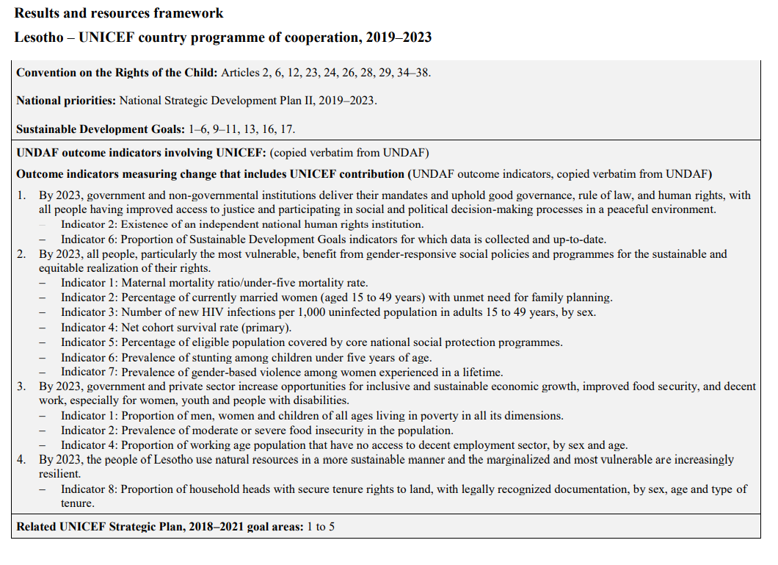

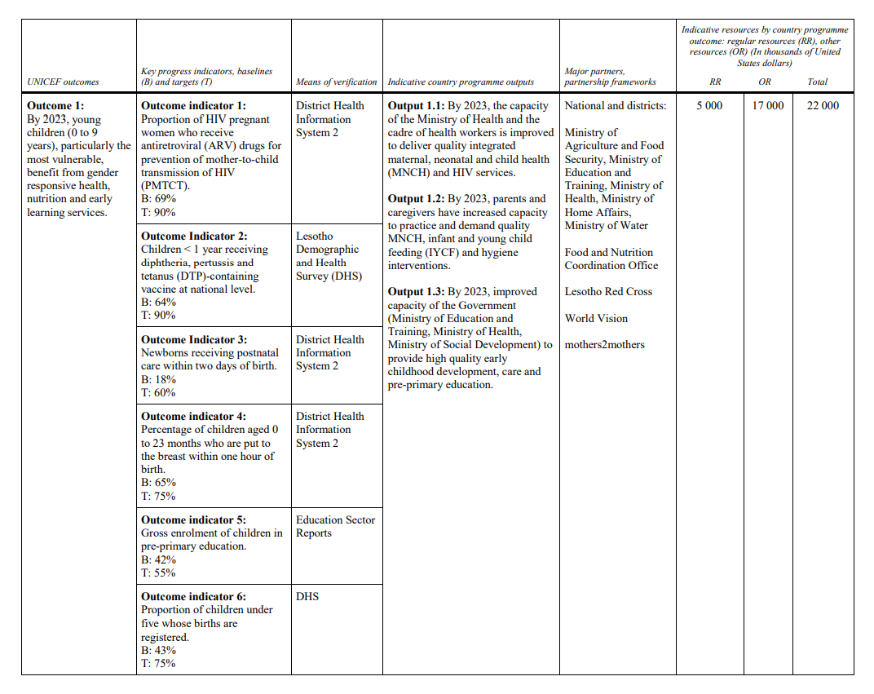

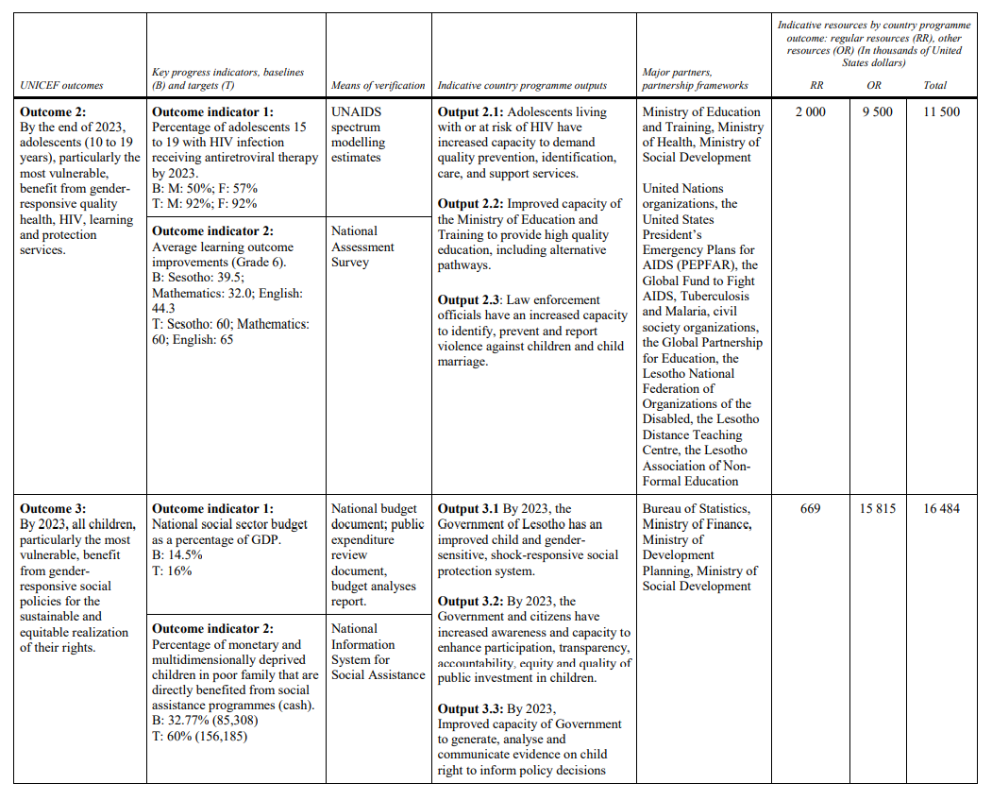

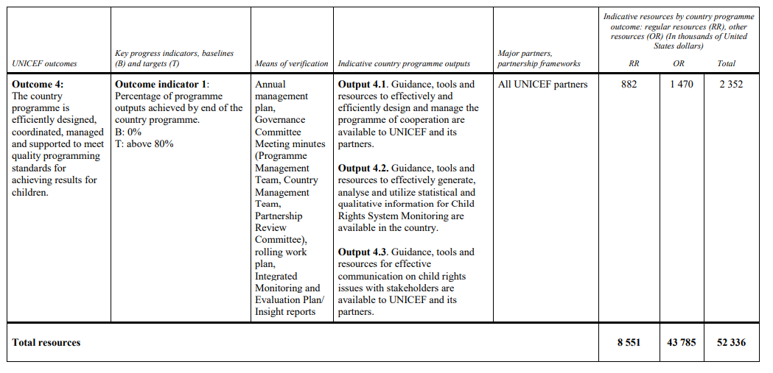

Annex 2. Inception report outline

**CONTENTS**

**1. INTRODUCTION\***

1.1. Objective of the evaluation

1.2. Background and context

1.3. Scope of the evaluation

**2. METHODOLOGY**

2.1. Evaluation criteria and questions

2.2. Conceptual framework

2.3. Evaluability

2.4. Data collection methods

2.5. Analytical approaches

2.6. Risks and potential shortcomings

**3. PROGRAMME OF WORK**

3.1. Phases of work

3.2. Management and logistic support

3.3. Calendar of work

**ANNEXES**

1. Terms of reference of the evaluation
2. Evaluation matrix
3. Stakeholder map
4. Tentative outline of the main report
5. Interview checklists/protocols
6. Theory of change / outcome model
7. Reference documents
8. Document map
9. Project list
10. Project mapping
11. Detailed work plan

The structure of inception reports may be adjusted depending on the scope of the evaluation.

Annex 3. UNICEF quality review checklist for inception reports









Annex 4. UNICEF quality review checklist for draft evaluation reports

**UNICEF Adapted UNEG Evaluation Report Standard**

**The title page and opening pages provide key basic information**

1. Name of the evaluation object

2. Timeframe of the evaluation and date of the report

3. Locations (country, region, etc.) of the evaluation object

4. Names and/or organizations of evaluators

5. Name of the organization commissioning the evaluation

6. Table of contents which also lists Tables, Graphs, Figures and Annexes

7. List of acronyms

**Executive Summary** is a stand-alone section of 2-3 pages that includes:

1. Overview of the evaluation object

2. Evaluation objectives and intended audience

3. Evaluation methodology

4. Most important findings and conclusions

5. Main recommendations

**Annexes increase the credibility of the evaluation report. They may include, inter alia:**

1. ToRs

2. List of persons interviewed and sites visited

3. List of documents consulted

4. More details on methodology, such as data collection instruments, including details of their reliability and validity

5. Evaluators biodata and/or justification of team composition

6. Evaluation matrix

7. Results framework

**Object of Evaluation**

**The report presents a clear and full description of the 'object' of the evaluation**

1 The **logical model and/or the expected results chain** (inputs, outputs, and outcomes) of the object is clearly described

2 The **context of key social, political, economic, demographic, and institutional factors** that have a direct bearing on the object is described. For example, the partner government's strategies and priorities, international, regional or country development goals, strategies and frameworks, the concerned agency's corporate goals and priorities, as appropriate.

Scale and complexity of the object of the evaluation are clearly described, for example:

3 **The number of components**, if more than one, and the size of the population each component is intended to serve, either directly or indirectly

**- The geographic context and boundaries** (such as the region, country, and/or landscape and challenges where relevant).

**- The purpose and goal, and organization/management of the object**

**-** The **total resources** from all sources, including human resources and budget (s) (e.g. concerned agency, partner.

4 The **key stakeholders involved** in the object implementation, including the implementing agency (s) and partners, other key stakeholders and their roles

5 The report identifies **the implementation status of the object**, including its phase of implementation and any significant changes (e.g. plans, strategies, logical frameworks) that have occurred over time and explains the implications of those changes for the evaluation

**Evaluation Purpose, Objective(s) and Scope**

**The evaluation's purpose, objectives and scope are fully explained**

1 The purpose of the evaluation is clearly defined, including why the evaluation was needed at that point in time, who needed the information, what information is needed, how the information will be used by different intended audiences.

2 The report should provide a clear explanation of the evaluation objectives and scope including main evaluation questions and describes and justifies what the evaluation did and did not cover

3 The report describes and provides an explanation of the chosen evaluation criteria, performance standards, or other criteria used by the evaluators

4 As appropriate, evaluation objectives and scope include questions that address issues of gender and human rights

**Evaluation Methodology**

**The report presents transparent description of the methodology applied to the evaluation that clearly explains how the evaluation was specifically designed to address the evaluation criteria, yield answers to the evaluation questions and achieve evaluation purposes.**

1 The report describes the data collection methods and analysis, the rationale for selecting them, and their limitations. Reference indicators and benchmarks are included where relevant.

2 The report describes the data sources, the rationale for their selection, and their limitations. The report includes discussion of how the mix of data sources was used to obtain a diversity of perspectives, ensure data accuracy and overcome data limits.

3 The report describes the sampling frame – area and population to be represented, rationale for selection, mechanics of selection, numbers selected out of potential subjects, and limitations of the sample

4 The evaluation report gives me complete description of stakeholder's consultation process in the evaluation including the rationale for selecting the particular level and activities of consultation

5 The methods employed are appropriate for the evaluation and to answer its questions.

6 The methods employed are appropriate for analysing gender and human rights issues including child rights issues identified in the evaluation scope.

7 The report presents evidence that adequate measures were taken to ensure data quality, including evidence supporting the reliability and validity of data collection tools (e.g. interview protocols, observation tools etc.)

8 The evaluation design was ethical and included ethical safeguards where appropriate, including protection of confidentiality, dignity, rights and welfare of human subjects particularly children, and respect of the values of the beneficiary community.

|  |
| --- |
| **5. Findings**  **4.0 Findings respond directly to the evaluation criteria and questions detailed in the scope and objectives section of the report are based on evidence derived from data collection and analysis methods described in the methodology section of the report**  1 Reported findings reflect systematic and appropriate analysis and interpretation of the data  2 Reported findings address the evaluation criteria (such as efficiency, effectiveness, sustainability, impact and relevance) and questions defined in the evaluation scope  3 Findings are objectively reported on the evidence  4 Gaps and limitations in the data and/or unanticipated findings are reported and discussed  5 Reasons for accomplishments and failures, especially continuing constraints, were identified as much as possible  6 Overall findings are presented with clarity, logic and coherence |
| **6. Conclusions and Lessons Learned**  **Conclusions present reasonable judgements based on findings and substantiated by evidence and provide insights pertinent to the object and purpose of the evaluation**  1 The conclusions reflect reasonable evaluative judgements relating to key evaluation questions  2 Conclusions are well substantiated by the evidence presented and are logically connected to evaluation findings  3 Stated conclusions provide insights into the identification and/or solutions of important problems issues pertinent to the prospective decisions and actions of evaluation users  4 Conclusions present strengths and weaknesses of the object (policy, programmes, projects or other intervention) being evaluated, based on the evidence presented in taking due account of the views of a diverse cross-section of stakeholders  5 Lessons learned, when presented, were generalized beyond the immediate intervention being evaluated to indicate what wider relevance there might be. |
| **7. Recommendations**  **Recommendations are relevant to the object and purpose of the evaluation, are supported by evidence and conclusions, and were developed with involvement of relevant stakeholders**  1 The report describes the process followed in developing the recommendation including consultation with stakeholders  2 Recommendations are firmly based on evidence and conclusions  3 Recommendations are relevant to the object and purpose of the evaluation |

1. Lesotho Census, 2016
2. IMF, World Economic Outlook, October 2020
3. World Bank, World Development Indicators, 2020
4. Spectrum estimates, 2020
5. World Bank, World Development Indicators, 2020
6. UNICEF Situation Analysis 2015
7. Government of Lesotho, Annual Joint Review 2015- 2016
8. Government of Lesotho, Annual Joint Review 2015- 2016
9. Ministry of Education and Training, 2018, Education Statistics Bulletin
10. Based on EMIS enrolment data from 2019 as 2020 data is not yet available.
11. 2018 Multiple Indicator Cluster Household Survey (MICS)
12. Lesotho Violence Against Children and Youth Survey, 2018
13. http://www.unevaluation.org/document/detail/1914
14. For UNICEF guidance on undertaking evaluations during the COVID-19 pandemic, please see the [UNICEF Technical Note on Evaluation and the COVID-19 response](http://www.unevaluation.org/document/detail/2804).