JOB TITLE: Private Sector Fundraising (PSFR) Associate (Database Management), Case # IDS20033  JOB LEVEL: GS-6  Organizational Unit: PFP  REPORTS TO Donor Relation Specialist (NOC), Post # 105646  LOCATION: Country Office - Jakarta, Indonesia | JOB PROFLE NO.:___ _  CCOG CODE:________________  FUNCTIONAL CODE: __ __  JOB CLASSIFICATION ________
PURPOSE OF THE JOB
UNICEF’s work in Indonesia is entirely funded by voluntary contributions, with an essential part being regular monthly contributions from almost 60,000 individual donors – our “Pendekar Anak”. An additional 10,000 donors donate one-off or repeated times over a year, without monthly commitment.

Responsible for managing UNICEF Indonesia’s donor database, with the goal to continuously improve donation processing, payment mechanisms, donor insights, donor service, and data analysis.

KEY END-RESULTS
Seamless donor data management from various sources to obtain profiles, motivations, and behaviours of our donors: the team gets regular recommendations based on high-quality analysis of our donor data, and technical challenges and bottlenecks are quickly identified and resolved.
KEY ACCOUNTABILITIES and DUTIES & TASKS
- Improve effectiveness of database tools and application services. (30%)
• Build the infrastructure required for optimal extraction, transformation, and loading of data from a wide variety of data sources using SQL and cloud technologies.
• Develops and maintains scalable data pipelines and builds out new API integrations to support continuing increases in data volume and complexity.
• Conceptualizing and generating infrastructure that allows data to be accessed and analyzed.
• Testing such structures to ensure that they are fit for use.
• Preparing raw data for further manipulation.
• Analyze the existing data and contribute relevant insights

- Ensures integrity of data and database at all times. (25%)
• Monitor accuracy of data input from various sources before input into database.
• Ensure data is secured and comply with PCI.
• Manage import and export of donor data with outsource data or processing supplier such as F2F agencies, telemarketing agency, online, etc.
• Manage users’ security access.

- Run various fundraising reports as per standard operating procedure. (20%)

- Monitor database performance (15%)
• Keeping database up to date.
• Puts in place back-up and disaster recovery plans.

- Support with Donation Processing and Customer Service when required. (5%)
• Support telephone enquiries from individual donors such as donor pledge upgrades, pledge cancellation, change of donor information and dissuade donor form cancellation; and also general donation enquiries.
• Redirect other enquiries such as those related to CSR, partnership proposals from corporates or questions related to fund utilization to respective officers.
• Opening, registering incoming mails containing donation forms, cheques, bank drafts and liaise with finance.
• Ensure forms and other documents containing donor information are stored as per standard operating procedure.

- Undertake any necessary additional work to support the wider fundraising programme, as agreed by supervisor. (5%)
JOB GRADE FACTORS
- Reports to Donor Relations Specialist (NOC)
- Operates in the context of a medium-sized country office or an area office.
- The work is task- and results- oriented.
- Responsible for evaluation of data to produce analysis, and reports
- Work under the general supervision of Donor Relation Specialist. The supervisor defines the parameters of assignments and outlines approaches to problem areas.
Incumbent operates within rules and regulations, and report to supervisor when a deviation from guidelines or changes in procedures is required.
QUALIFICATION and COMPETENCIES ([ ] indicates the level of proficiency required for the job.)
- Education

Completion of secondary education. Courses in Computer Science, IT Service Management, Engineering will be an asset. Business, or related field or equivalent work experience.
- Work Experience

At least six (6) years of experience, three years managing database. Knowledge of computer programming will be an added advantage. Experience as a Data Engineer, Software Developer, or similar is a benefit.
- Language Proficiency [ II ]
Fluency in English and Bahasa Indonesia required.
4. Competency Profile (For details on competencies please refer to the UNICEF Professional Competency Profiles.)
ii) Core Values (Required)
- Care
- Respect
- Integrity
- Trust
- Accountability
ii) Core Competencies (Required)
• Communication [ II ] • Working with People [ II ] • Drive for Results [ II ]

- Functional Competencies (Required)
• Analyzing [ I]
• Learning & Researching [ I]
• Applying Technical Expertise [ I]
• Planning and Organizing [ I]
iii) Technical Knowledge
a) Specific Technical Knowledge Required
Specific and up-to-date working knowledge of:
- SQL and Microsoft excel.
- Web backend programming
- API programming for integration. Understand XML API will be a benefit.

b) Common Technical Knowledge Required (for the job group)
General knowledge of:
- Resource mobilization / marketing practice, methodology and practical application. Knowledge of current theories and practices in resource mobilization and/or marketing research planning and strategy.
- Computer systems, including internet navigation, office applications, and digital media.
- Good understanding of the context of United Nations/international organizations, world affairs, current events and international development issues
c) Technical Knowledge to be Acquired/Enhanced (for the Job)
- Technical knowledge of UNICEF’s regular donor strategies and techniques
- All relevant technical aspects of the IT and database systems used by UNICEF
- UN common approaches to programmatic issues and UNICEF positions
- UN security operations and guidelines.

SIGNATURES – Certification of Job Description
Chief of Section: Gregor Henneka, Chief Resource Mobilization and Partnerships | Signature Date
Debora Comini, Representative | Signature Date

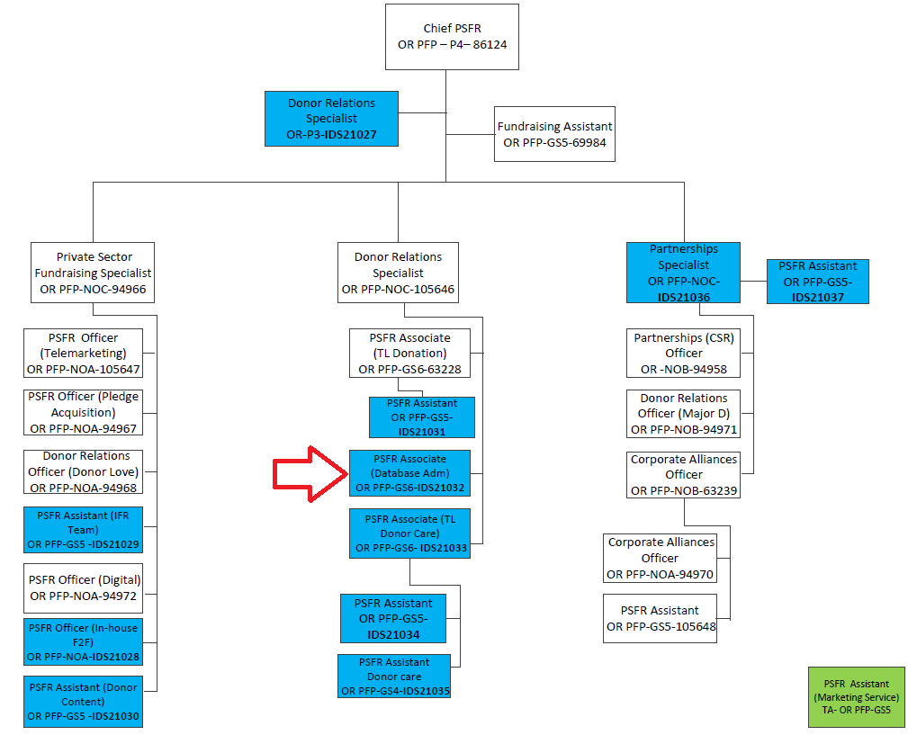

The differences in the grades of jobs and positions reflect various differences, among others, in the nature and scope of work, individual contribution, professional expertise required, organizational context, risks, coordination and ,etworking, engagement, partners, beneficiaries, clients/stakeholders relations, impact of decisions, actions and consequences, and leadership roles.

