JOB TITLE: Private Sector Fundraising (PSFR) Specialist (Individual Fundraising), Post # 94966  JOB LEVEL: NO-C  REPORTS TO: Chief PSFR (P4), Post # 86124  Organizational Unit: PFP  LOCATION: Country Office - Jakarta, Indonesia | JOB PROFILE NO.:___ _  CCOG CODE:________________  FUNCTIONAL CODE: __ __  JOB CLASSIFICATION ________
PURPOSE OF THE JOB
Lead UNICEF Indonesia’s Individual Fundraising team to raise funds from the Indonesian public, especially through recruiting and retaining regular monthly donors (“Pendekar Anak”) in support of the GOI-UNICEF Indonesia Country Programme.

KEY END-RESULTS
- Grow donation income from the general public: UNICEF globally has high expectations for UNICEF Indonesia being able to fund our own activities in the coming years without needing additional funding from outside the country. You lead our IFR team to recruit new donors, reduce attrition of existing donors, identify additional income opportunities, grow existing channels and diversify our donor recruitment channel portfolio, especially towards digital channels.
- Fundraising is driven in a strategic way and aligned with relevant national and global plans and strategies: UNICEF Indonesia’s fundraising team is operating in a complex environment. You make sure that the individual fundraising part is strategically aligned with global and regional plans as well as national priorities. This includes responsibility for key reports and budget submissions to headquarters. You also ensure compliance with the operating environment, including the national legal framework as well as data security.
- The team is motivated and eager to do their best for disadvantaged children in Indonesia every day: This includes your own team you are leading, consisting of a number of Fundraising Officers and Assistants, as well as your collaboration with the Data Processing and Donor Care team, the Digital team, Corporate Partnerships team, and other relevant stakeholders within the office as well as in UNICEF regional and global.
KEY ACCOUNTABILITIES and DUTIES & TASKS
- Lead UNICEF Indonesia’s individual fundraising team, with a focus on pledge donors
- Grow funding from individuals in Indonesia as per agreed targets
- Plan, monitor and report budgets and targets through different reports and platforms to senior management, Regional Office and Headquarters
- Supervise and guide Fundraising Officers responsible for acquisition of high-quality pledge donors through different channels (F2F, Telephone, Digital, Corporate channels, etc.), including the relationship with relevant agencies and other external service providers
- Supervise and guide Fundraising Officers responsible for the donor journey and the retention of donors, including the production of compelling content and managing the relationship with relevant agencies and other external service providers
- Closely collaborate and integrate processes with the Data Processing and Donor Care team to ensure accurate and up-to-date data in the donor database, to produce insightful reports from the donor database on donor insights as well as past and predicted future donor behavior, and to ensure the security of our donors’ data
- Work with the Corporate Partnerships team to identify opportunities to partner with business to reach new pledge donors
- Collaborate with Specialists in Regional Office and Headquarters to ensure good practice and learnings from other markets are used in Indonesia
- Closely work with the Communications team on integrated initiatives combining public fundraising and advocacy, and find ways that our donors are appreciated and featured in the organization’s ongoing communication and brand work
- Monitor trends in the market, competition, and regulatory framework in Indonesia to inform the organization’s strategy and advise senior management of any required action. Engage with the relevant colleagues in the office responsible for Government relations to ensure all required permits are in place.

JOB GRADE FACTORS
Level 3
- Reports to Chief of Private Sector Fundraising (P4) in a large area or medium-size country office
- Operates in the context of a medium-sized country office or an area office.
- Accountable for private sector resource mobilization from individual donors. The work is task- and results- oriented.
- Responsible for research, analysis and evaluation of data/information to produce situation analysis, reports, and resource mobilization materials.
- Assist in organizing special events in consultations with counterparts, community and partners to support programme delivery.
- Work under the general supervision of Chief of Private Sector Fundraising. The supervisor defines the parameters of assignments and outlines approaches to problem areas. Research is carried out independently. Work may be reviewed while in progress, and upon completion.
- Incumbent operates within rules and regulations, and makes recommendations to supervisor when a deviation from guidelines or changes in procedures is required.
- Supervise and follow-up on production and qualitative monitoring of resource mobilization materials.

QUALIFICATION and COMPETENCIES ([ ] indicates the level of proficiency required for the job.)
- Education
Advanced university degree in marketing, business administration or related fields. A non-graduate degree can be accepted with additional specific experience and technical training.
- Work Experience
Min. five years of progressively responsible experience in fundraising/marketing/sales, including staff management and budget control.
- Language Proficiency [ III ]
Fluency in English and Bahasa Indonesia required.
4. Candidate Profile

- Experienced in raising significant amounts of funds for non-profit organizations from the general public and/or successful marketing for consumer goods/services etc.
- Experienced in running marketing / fundraising campaigns in different channels and media
- Excellent command of budget calculations, ROI projections, growth scenarios, and financial reporting
- Experienced in leading a fundraising/marketing/campaign team
- Excellent team player, but also able to work independently
- Attention to detail
- Experience in managing agencies and other external service providers
- Strategic thinker, able to plan ahead
- Literate in all standard Office applications and other software solutions like customer databases etc.
- Knowledge of the Indonesian non-profit sector and the UN an advantage
- Strong communication skills also with external partners, including Government and other relevant authorities
- Good negotiator

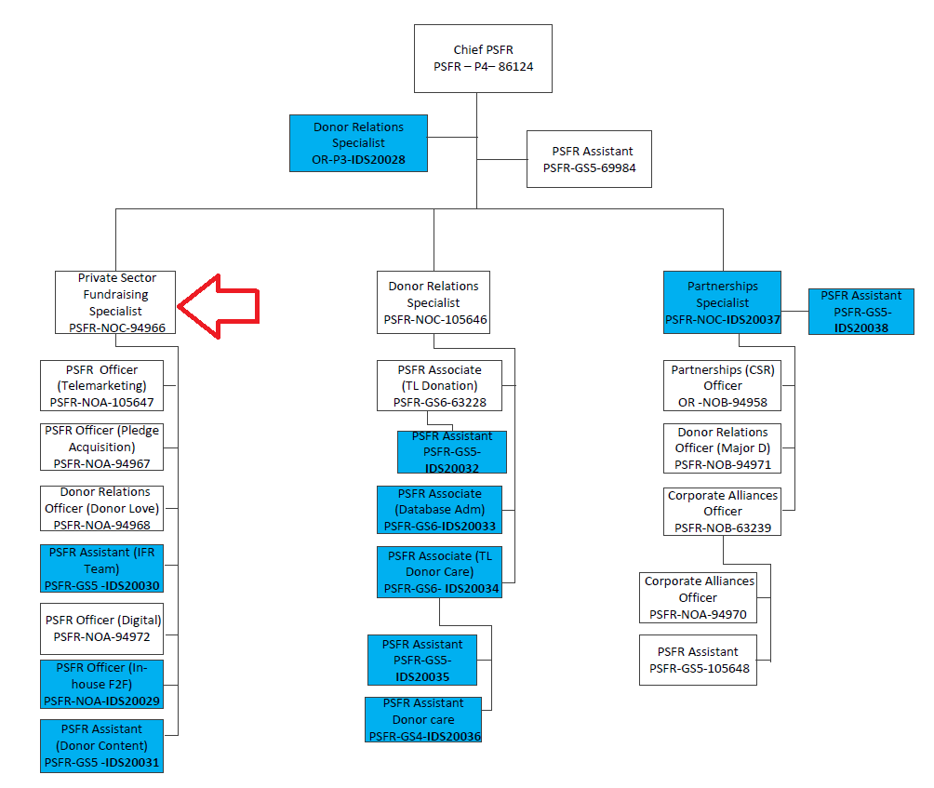

The differences in the grades of jobs and positions reflect various differences, among others, in the nature and scope of work, individual contribution, professional expertise required, organizational context, risks, coordination and networking, engagement, partners, beneficiaries, clients/stakeholders relations, impact of decisions, actions and consequences, and leadership roles.

