JOB TITLE: Private Sector Fundraising (PSFR) Assistant (Donor Content), Case # IDS21030, Post # 114079  JOB LEVEL: GS-5  REPORTS TO: PSFR Specialist (NOC), Post # 94966  Organizational Unit: PFP  LOCATION: Country Office - Jakarta, Indonesia | JOB PROFLE NO.:_____  CCOG CODE:________________  FUNCTIONAL CODE: ___  JOB CLASSIFICATION________
PURPOSE OF THE JOB
UNICEF’s work in Indonesia is entirely funded by voluntary contributions, with an essential part being regular monthly contributions from almost 60,000 individual donors – our “Pendekar Anak”. An additional 10,000 donors donate one-off or repeated times over a year, without monthly commitment.

To inspire people to sign up as a UNICEF donor and to continue to inspire them throughout their journey as a UNICEF donor, we need excellent content that explains why children in Indonesia need our help – and show the difference a donor’s contribution makes. This includes videos, photos, and stories, but also thank you messages, website content, customized content pieces for our business donors, etc.

UNICEF Indonesia’s Private Fundraising and Partnerships team (PFP) is now recruiting an Assistant at GS-5 level to help us develop this donor content. The job will be positioned within the fundraising team, and closely work together with communications and our programmes.

KEY END-RESULTS
- Provide support to the smooth running of the PFP unit through development of Donor Content
- Knowledgeable delivery of quality services contributing to achievement of work objectives for the PFP.
- Professional image projected through in-person interaction. Discretion exercised with confidential donor/partner information and sensitive subject matters.

KEY ACCOUNTABILITIES and DUTIES & TASKS
Within the delegated authority and under the given organizational set-up, the incumbent may be assigned the primarily, shared, or contributory accountabilities for all or part of the following areas of major duties and key end-results.

- Develop inspiring donor communication content as per the agreed donor communication plan for both new and existing donors
- This includes full start-to-end production of material including photo and videography, as well as re-editing existing materials from other parts of the organization into a compelling narrative for donors
- In case of an emergency fundraising campaign, use existing material provided through the organization and be ready to produce additional material at short notice and under extremely tight timelines
- Archive and manage all final and raw content professionally, so they are available and accessible for office-wide use
- All content has to be developed and produced in accordance with UNICEF branding and communication guidelines, programme accuracy, consent code, as well as prevailing rules and regulations, especially when working with contractors
- Organize and coordinate any required field travel in close collaboration with the responsible field office
JOB GRADE FACTORS GS-5
The post will cover a variety of tasks linked to a specific work plan. While detailed instructions will be given to the incumbent, the volume and variety of work require the incumbent to check own work and to take initiative in identifying potentially problematic situations and discussing with supervisor.
Key work relationships are within and outside the organization.

Inside the Organization
Broad range of contacts at all levels throughout the Organization, with regard to coordination of work, follow-up matters, meeting arrangements, dissemination of information and sharing.

Outside the Organization
Senior managers from external organizations and agencies - for the purpose of meeting coordination and arrangements, exchange of information, and requests for materials.

Independence
The post works independently within broad guidelines and is proactive in accomplishing tasks amid competing priorities and deadlines. Familiar with organizational systems and structure, and is resourceful and motivated in gauging appropriate course of action in order to meet objectives.
QUALIFICATION and COMPETENCIES ( [ ] indicates the level of proficiency required for the job.)
- Education
Completion of secondary education. Skills in the operation of electronic data / word processing
equipment – computer knowledge or any accounting are required.
- Work Experience
At least five years of administrative/clerical experience in the field of sales/marketing/fundraising or related fields office support work experience.

Computer literacy and the ability to effectively use standard office software tools and other office technology to create documentation, exchange and archive e-mail, and maintain electronic filing systems.

Ability to work with minimum supervision. Ability to extract and format data and to solve operational problems. Ability to organize own and others work, set priorities and meet deadlines. Ability to organize meetings and events. Ability to handle work quickly and accurately under time constraints

Experience and knowledge of the UN / UNICEF operations is an asset.

- Language Proficiency
Proficiency in English – working language and proficiency in Bahasa Indonesia is required.

- Other Skills and Attributes

- Professional qualifications and relevant training background in content production for Fundraising, Marketing, Advertising, Communications or related subject
- Professional experience with a particular focus on storytelling, content development, and production of communication materials, including but not limited to blog stories, photos and captions, videos, social media posts, email marketing
- Video and photo editing skills and experience
- Fluency in Bahasa Indonesia and English, both speaking and writing.
5. Competency Profile (For details on competencies please refer to the UNICEF Professional Competency Profiles.)
i) Core Values (Required) Care, Respect, Integrity, Trust and Accountability and Sustainability (CRITAS) underpin everything we do and how we do it.

- Competencies: (1) Builds and maintains partnerships (2) Demonstrates self-awareness and ethical awareness (3) Drive to achieve results for impact (4) Innovates and embraces change (5) Manages ambiguity and complexity (6) Thinks and acts strategically (7) Works collaboratively with others.

- Technical Knowledge
- Specific Technical Knowledge Required
(semi- professional managerial and administrative / video/ photo editing is required)
- Common Technical Knowledge Required - Conceptual and analytical knowledge
- Technical Knowledge to be Acquired/Enhanced – captions, video and photos, digital editing

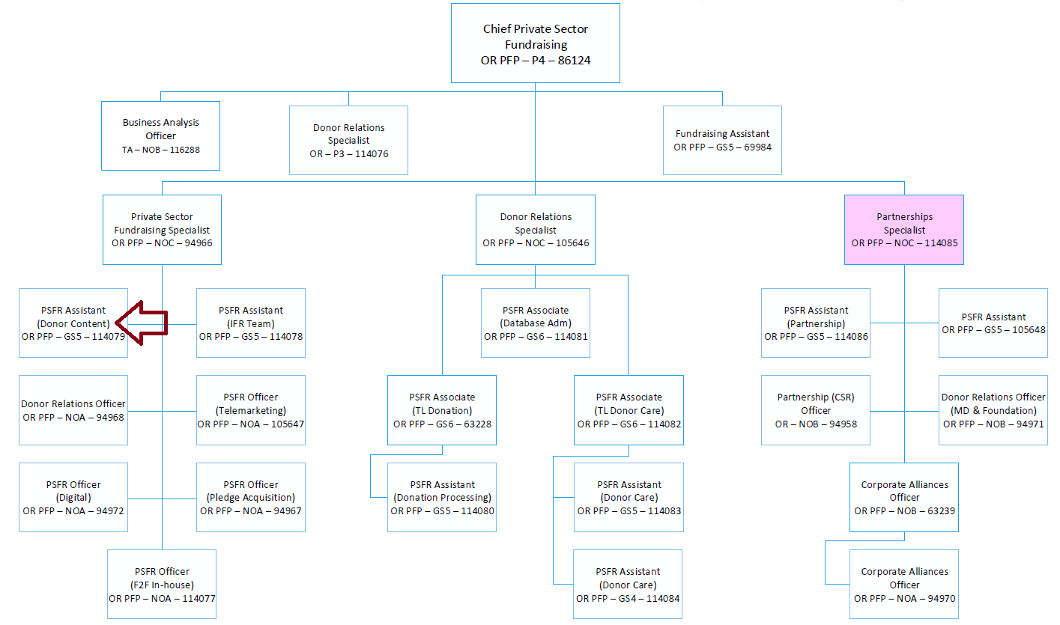

The differences in the grades of jobs and positions reflect various differences, among others, in the nature and scope of work, individual contribution, professional expertise required, organizational context, risks, coordination and networking, engagement, partners, beneficiaries, clients/stakeholders relations, impact of decisions, actions and consequences, and leadership roles.
Reference to UNICEF and/or UN in terms of technical knowledge requirements (and b above) is applicable only to those who are or have been the staff members of UNICEF or the UN common system.

