SENDER: Su Sandi Aung
JOB DESCRIPTION TYPE: Specific Job Description
POST NUMBER/ CASE NUMBER: MAM21006
POST/CASE NUMBER OF SUPERVISOR: Child Protection Cluster Coordinator P3, MAM21004
REASON FOR CLASSIFICATION: Establishment of new post
REGION/DIVISION: EAPRO
COUNTRY: Myanmar
DUTY STATION: Yangon
OFFICE:
SECTION:
UNIT: Emergency Unit
CATEGORY: NO
PROPOSED LEVEL: NOA
JOB TITLE: Information Management Officer
Functional Code: RPM
ICSC CCOG Code: 1M06
STRATEGIC OFFICE CONTEXT:
UNICEF’s 2021 Humanitarian Action for Children appeal requests $62 million for UNICEF/Myanmar’s humanitarian response in Rakhine, Chin, Kachin, Shan and Kayin States. Myanmar also is at significant risk of natural disasters—particuarly floods, cyclones, and earthquakes. As such, emergency response activities are a daily part of UNICEF’s ongoing work and has both it’s own acute need provision as well as ties to durable solutions, human rights, and the humanitarian/development nexus.
The IASC Humanitarian Coordinator (HC) retains the principle responsibility for the overall humanitarian response and thus the UNICEF-led clusters/sectors will report to the Humanitarian Coordinator, through the Inter-Cluster Coordination Group, and Representative and/or his/her designee on all issues related to the functioning of the clusters. The IASC HC will be supported by OCHA and may delegate some reporting tasks to others.
UNICEF retains responsibility to ensure that the obligations for Cluster leadership that the agency has made to the IASC made at the global level are fulfilled to the satisfaction of the HC and the UNICEF Country Representative.
The role of the Information Management Officer (IMO) is to support the coordination process. The success of the IMO will be dependant on the level of participation and contributions that the IMO working with the cluster coordinator can generate from the various actors in order to generate data and strengthen the response.
PURPOSE OF THE JOB:
On behalf of the IASC Humanitarian Coordinator in Myanmar and UNICEF as the lead agency multiple clusters and sub-clusters in the country, the main purpose of the IMO is to support monitoring, reporting and data0driven advocacy; liaising with other partners and the ICCG on data-related issues; developing and managing key information management products in line with the needs of the assigned clusters and Emergency Specialist; visualizing data through infographics and maps for presentations and dissemination. The IMO is also responsible for capcity building of relevant cluster members on IM tools and will support innovations in information systems to facilitate decision-making, planning and monitoring of cluster interventions.
Currently, the Myanmar Country Office is operating under a matrix-management model, where individuals will have more than one reporting line. This position will be “matrixed” and will report to the Education in Emergency Cluster Coordinator (Save the Children), who will act as a secondary supervisor.
KEY ACCOUNTABILITIES and DUTIES & TASKS

Summary of key functions/accountabilities:

Information management
• Help assess, maintain and update information management systems of assigned clusters at the national level and support sub-national leads and agencies to use system.
• Contribute in identifing gaps in data management and strengthen them in line with cluster monitoring and reporting needs.
• Collect, analyze, verify and synthesize information to facilitate information sharing and planning.
• Prepare technical reports and inputs for related to programmes ensuring accuracy, timeliness and relevance of information.
• Assist in the development/establishment of cluster-related outcome and output results, as well as related strategies, through analysis of cluster needs and priorities.
• Provide technical and administrative support throughout all stages of programming processes and humanitarian planning cycle.
• Help coordinate the deployment and/or management of new information management tools as needed.
• Assist in the preparation of learning/knowledge products, covering innovative approaches and good practices, to support overall cluster development.

Data analysis and visualization
• Help establish information flow and inventory management system, and monitor progress and disseminate results to cluster/sector partners.
• Support the clusters and Emergency Unit in data analysis and data visualization through infographics and maps
• Support the data analysis for monitoring purposes and in data quality and consistency control.
• Participate in monitoring and evaluation exercises, programme reviews and annual sectoral reviews with government and other counterparts and prepare minutes/reports on results for follow up.
• Provide inputs for progress reports, donor briefing papers and donor reports.

Technical and operational support, capacity building
• Undertake field visits and surveys, collect and share reports with partners/stakeholders. Report critical issues, bottlenecks and potential problems to supervisor, for timely action.
• Help develop and support the development of needs assessment and monitoring tools
• Contribute to the development of the cluster capacity building and the implementation of capacity building activities related to information mangagmenet and data analysis. If required, develop use-friendly manuals to maintain institutional knowledge.

Networking, coordination and partnership building
• Build and sustain close working partnerships with cluster partners including government counterparts and national stakeholders through active sharing of information and knowledge
• Draft communication and information materials for programme advocacy to promote awareness, establish partnership/alliances and support fundraising for the cluster.
• Participate in meetings/events on cluster programming and collaborate with other clusters
• Prepare information to be used for resource mobilization and fundraising briefs.
• Liaise with the Myanmar Information Management Unit and OCHA information management groups.
• Support data analysis, visualization and mapping for programmes which require a multi-sectoral approach.
IMPACT OF RESULTS
This position will contribute to the development, deployment and management of key information and data-related tools and databases, which will support the monitoring, reporting and advocacy for the cluster which will further inform programme activities, fundraising, reporting and monitoring. Developed products will also be utilized by the Emergency Unit and Country Office for overall humanitarian fundraising and reporting, decision-making and advocacy. This position will support localization efforts of the office through capacity building of UNICEF staff and cluster partners in information management which will help improve overall humanitarian response in the country. These services will help the Emergency Unit achieve the cluster-related output results of the country programme including meeting the Core Commitments for Chidlren in Humanitarian Action.
COMPETENCIES AND LEVEL OF PROFICIENCY REQUIRED
i) Core Values

· Care
· Respect
· Integrity
· Trust
· Accountability

ii) Core Competencies

· Demonstrates Self Awareness and Ethical Awareness (1)
· Works Collaboratively with others (1)
· Builds and Maintains Partnerships (1)
· Innovates and Embraces Change (1)
· Thinks and Acts Strategically (1)
· Drive to achieve impactful results (1)
· Manages ambiguity and complexity (1)

iii) Functional Competencies (Required)

· Analyzing (2)
· Applying Technical Expertise (2)
· Planning and Organizing (2)
RECRUITMENT QUALIFICATIONS

Education:

University (first) degree in social sciences, information management, computer science, management of information systems, statistics, or other relevant field is required.

Experience:

- At least one year of proven experience in:
• data collection, data management, using tools such as Kobo, ODK, or similar.
• Experience in database design, database distribution and map production and capacity building to give "hands-on" training on database management and reporting.
• Proficient in use of GIS, Advanced Excel, SPSS or STATA and other related software packages.
• Data visualization using graphic and mapping software like Tableau, ArcGIS, or similar.

Previous experience or formal training in cluster Information Management (IM), humanitarian assistance/cluster experience, or work with a UN agency is an asset.

Language Requirements:

Fluency in English is required. Knowledge of another official UN language (Arabic, Chinese, French, Russian or Spanish) or a local language is an asset.

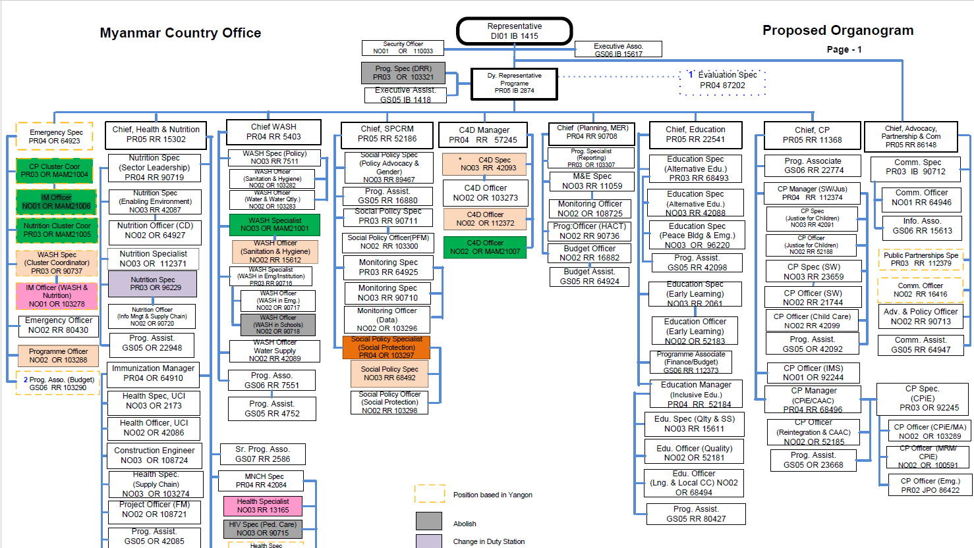

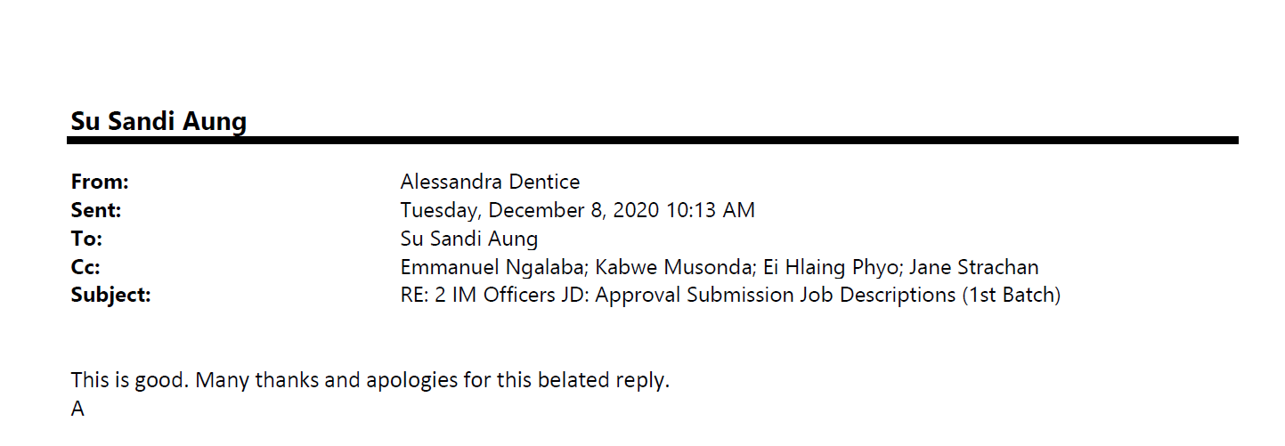

Classified by Hein Kyaw Soe (11/Dec/20)

