 | UNITED NATIONS CHILDREN’S FUND  GENERIC JOB PROFILE (GJP)

I. Post Information

Job Title: People and Culture Specialist  Supervisor Title: Representative  Organizational Unit: UNICEF Benin | Job Level: P3/NOC  Job Profile No:  CCOG Code: 1.A.06  Functional Code: HRE  Job Classification Level: P3/NOC

II. Organizational Context and Purpose for the job
UNICEF is a leading humanitarian and development agency working globally for the rights of every child. Child rights begin with safe shelter, nutrition, protection from disaster and conflict and traverse the life cycle: pre-natal care for healthy births, clean water and sanitation, health care and education. UNICEF has spent nearly 70 years working to improve the lives of children and their families. Working with and for children through adolescence and into adulthood requires a global presence whose goal is to produce results and monitor their effects. UNICEF also lobbies and partners with leaders, thinkers and policy makers to help all children realize their rights—especially the most disadvantaged.

Job Organizational Context:

People and Culture Specialist at the P3 level reports directly to the Representative and is considered as seasoned professional who is generally either responsible for executing a particular HR service or alternatively, responsible for supporting an assigned client on a broad range of HR services. Such responsibility is expected to be carried out independently, with the primary focus of the managerial oversight on the position being to ensure that results are delivered in accordance with the vision set forward by the leadership of the division. As a result, staff on these positions require an in-depth understanding of at least one HR function and how it relates to supporting the organization’s business objectives.

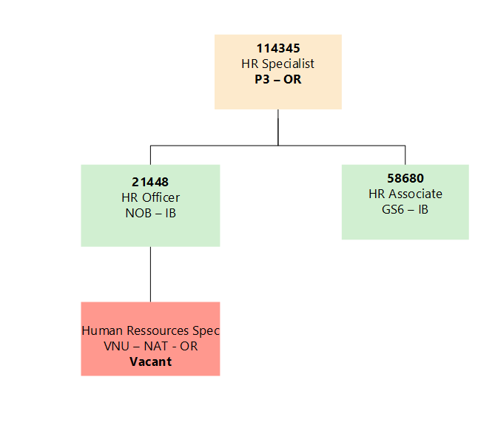

Purpose of the job:

The People and Culture Specialist, within their area of responsibility, is accountable for implementing HR services that enhance the capacity of their clients to deliver on their business goals and objectives. In doing so, the incumbent demonstrates the ability to anticipate HR-related needs and develop subsequent plans and solutions that align HR management with business objectives.

III. Key functions, accountabilities and related duties/tasks:
Summary of key functions/accountabilities:

Business Partnering

- Serve as the single point of contact for his/her client portfolio on advice pertaining to all aspects of the employment life cycle

- Provide accurate and timely advice to clients on HR processes and policies, ensuring the highest level of client-orientation.

- Proactively advise clients on the resolution of human resources issues ensuring equitable and transparent solutions that protects both the staff and organizations interests in accordance with policies, regulations and procedures.

- Promote the organizational goals and targets for gender equity and cultural diversity.

Strategic Human Resources

- Liaise with the HQ Divisions, regional and country offices to support and contribute to corporate HR strategy formulation and global implementation. Provide feedback and make recommendations on the establishment and improvement of HR systems, policies and processes.
- Keep abreast, research, benchmark, and implement best and cutting edge practices in HR management and contribute to the development of global policies, procedures and introduce innovation through sharing of best practices and knowledge learned.

Implementation of assigned Human Resources Services

- Provide support to various or one specific HR occupation (recruitment, job classification, career development, performance management, data analytics, learning & development etc.) to help their supervisors in implementing efficient client services that help either attract, retain and/or motivate staff of the highest caliber.

- When assigned casework in the relevant area on either a routine or non-routine basis, analyze and synthesize issues and problems, and interpret established, formal guidelines to address and recommend solutions or further actions required.

Learning and Capacity Development

- In collaboration with business owners, design and deliver learning plans for staff to enhance their knowledge and build skills in new areas.

- Contributes to the mapping of competencies for all staff in assigned client portfolio, assisting in the development of a comprehensive framework in support of the development of the talent pipeline.

- Recommend efficient and cost-effective learning products which strengthen staff capacity to contribute effectively to business goals.

- Participate as a resource person in capacity building initiatives to enhance the competencies of clients/stakeholders.

- Provide orientation briefings to new staff.

- Provide day-to-day performance and talent management guidance to line management (e.g., coaching, counseling, career development, career conversations, and disciplinary actions).

HR Data Analytics

- Interpret and analyze HR data to help inform strategic decision making on HR processes and strategies.

- Develop data collection systems to optimize data quality.

- Coordinate with country offices and partners to provide assistance in their HR information management.

IV. Impact of Results:
Specialists at this level analyze proposals and requests received from managers, supervisors and staff and make recommendations or take technical sound actions. Examples of such actions at this level include the resolution of a range of staff entitlement matters; the recruitment of staff to atypical positions within UNICEF requiring the use of outreach recruitment services, such as social networks; revisions to procedures for the classification of jobs, or the design of specific training programmes to meet new staff development needs.

As seasoned HR professionals, the Specialists’ work reflects directly on the professionalism of the incumbent and the overall reputation of the HR community for technical quality in terms of both substantive depth and adaptive relevance to client needs and customer service approach to problem resolution.

Generalist positions cover a range of HR specialties and would normally have access to advice from specialists in the individual specialties (broad in scope but restricted depth of treatment of subject matter). Specialist positions, on the other hand, are more restricted in scope but require more in-depth analysis in order to solve case-by-case problems independently.

V. UNICEF values and competency Required (based on the updated Framework)

i) Core Values

- Care
- Respect
- Integrity
- Trust
- Accountability
- Sustainability

ii) Core Competencies (For Staff with Supervisory Responsibilities) *

- Nurtures, Leads and Manages People (1)
- Demonstrates Self Awareness and Ethical Awareness (2)
- Works Collaboratively with others (2)
- Builds and Maintains Partnerships (2)
- Innovates and Embraces Change (2)
- Thinks and Acts Strategically (2)
- Drive to achieve impactful results (2)
- Manages ambiguity and complexity (2)

or

Core Competencies (For Staff without Supervisory Responsibilities) *

- Demonstrates Self Awareness and Ethical Awareness (1)
- Works Collaboratively with others (1)
- Builds and Maintains Partnerships (1)
- Innovates and Embraces Change (1)
- Thinks and Acts Strategically (1)
- Drive to achieve impactful results (1)
- Manages ambiguity and complexity (1)

*The 7 core competencies are applicable to all employees. However, the competency Nurtures, Leads and Managers people is only applicable to staff who supervise others.

VI. Skills
Strategic

Experience and ability to implement targeted and innovative human resources strategies to address clients’ people-related needs.

Ability to implement innovative HR programs within a fast paced, evolving, and wide organizational setting.

Technical

In-depth technical knowledge of the principles and concepts of human resources management.

Ability to identify and analyze systemic issues, formulate opinions and make conclusions and recommendations to resolve same.

Excellent knowledge of organizational and HR information technology systems and tools.

Interpersonal and Communication

Demonstrated ability to communicate effectively in a diverse organization tailoring language, tone, style and format to match audience.

Ability to empathize with client managers, supervisors and staff while advocating for consistent and equitable applications of promulgated HR regulations and rules.

VII. Recruitment Qualifications
Education: | An Advanced University Degree in human resource management, business management, international relations, psychology or another related field is required.
Experience: | Five years of increasingly responsible professional experience in human resource management in an international organization and/or large corporation is required.
Language Requirements: | Fluency in French and English is required. Knowledge of another official UN language (Arabic, Chinese, Russian or Spanish) or a local language is an asset.

