 | UNITED NATIONS CHILDREN’S FUND  GENERIC JOB PROFILE

I. Post Information

Job Title: Education Officer  Supervisor Title: Chief Education, P5  Organizational Unit: Programme  Post Location: Jordan Country Office | Job Level: Level 2  Job Profile No.:  CCOG Code: 1F  Functional Code: EDU  Job Classification Level: Level 2

II. Organizational Context and Purpose for the job

The fundamental mission of UNICEF is to promote the rights of every child, everywhere, in everything the organization does — in programmes, in advocacy and in operations. The equity strategy, emphasizing the most disadvantaged and excluded children and families, translates this commitment to children’s rights into action. For UNICEF, equity means that all children have an opportunity to survive, develop and reach their full potential, without discrimination, bias or favoritism.

The Ministry of Education in Jordan is ambitious to improve the quality of teaching and learning, while embedding good practices in inclusion, gender equality and diversity and creating positive psycho-social environments in its public schools in partnership with parents and the community. Although significant progress has been made in recent years, education quality requires continued investment and learning outcomes remain low. In its efforts to raise standards, the Ministry has embarked upon a comprehensive improvement programme as detailed in the Ministry of Education Sector Plan and is supported in its efforts by a range of development partners. The MOE and UNICEF are working together to design and implement programs in the Syrian Refugee camps and host community to improve disadvantaged children’s access, regular attendance and learning.

Job Organizational Context: The Education Officer is supervised by the Chief Education P5.

Purpose for the job: Under the overall guidance and direction of the Chief, the Education Officer P2 provides operational support throughout all stages of programming to facilitate the management and delivery of results on strengthening national education systems to improve learning outcomes and to promote universal access to quality, equitable and inclusive education, especially for children who are marginalized, disadvantaged and excluded in society.

III. Key functions, accountabilities and related duties/tasks

Summary of key functions/accountabilities:

- Programme coordination, monitoring, and delivery of results
- Knowledge management
- Technical and operational support to programme implementation
- Partnership building and resource mobilization support

- Programme coordination, monitoring, and delivery of results

- Work closely and collaboratively with component leads to collect, analyse and share information on implementation issues.

- Suggest solutions on routine programme implementation and submit reports to alert appropriate officials and stakeholders for higher-level intervention and/or decisions. Keep record of reports and assessments for easy reference and/or to capture and institutionalize lessons learned.

- Lead on the programme coordination to ensure the quality and timely planning and implementation of the programme components in support of the Education Manager. Organise regular team meetings with component leads to reflect actions in team plans and support in identifying and solving implementation challenges.

- Establish and update a plan to ensure coordination of training and activities at schools and Field Directorate level across all components and partners.

- Coordinate the preparation and implementation of advocacy and engagement meetings and workshops with stakeholders at national, sub-national and school level.

- Participate in strategic discussions on programme development supporting the teams in the design of research tools and monitoring and evaluation plans.

- Contribute to monitoring reports for internal and external reporting (3RP, RAM, COAR etc.)

- Knowledge management

- Manage and coordinate the production of research and knowledge products for the JCO Education programme advocacy to promote awareness internally, regionally and globally.

- Contribute to effective knowledge management of the JCO Education programme including creating, sharing, using, and managing information on programmes.

- Contribute to identifying, capturing, synthesizing, and sharing lessons learned for knowledge development and capacity development of stakeholders.

- Research and report on best and cutting-edge practices for development planning of knowledge products and systems

- Technical and operational support to programme implementation

- Contribute to the effective management of education consultants through developing and implementing the planning and tracking tools in coordination with the teams. Report on critical issues, bottlenecks and potential problems for timely action to achieve results.

- Support programme leads in grant management through monthly tracking of results and spend against the donor agreement.

- Provide technical and operational support across the teams, fostering enhanced collaboration within the Education Section.

- Partnership building and resource mobilization support

- Draft programme briefs, concept notes, and proposals to be used by the Education and Partnerships Sections.

- Draft communication and information materials for programme advocacy to promote awareness, establish partnerships and alliances, and support fund raising for education programmes.

- Plan, develop, compile, and edit donor reports in coordination with the teams and the Partnership Section.

IV. Impact of Results

The efficiency and efficacy of support provided by the Education Officer to programme preparation, planning and implementation, contributes to the achievement of sustainable results to improve learning outcomes and universal access to quality, equitable and inclusive education..

V. UNICEF values and competency Required

i) Core Values

- Care
- Respect
- Integrity
- Trust
- Accountability
- Sustainability

ii) Core Competencies

- Demonstrates Self Awareness and Ethical Awareness (1)
- Works Collaboratively with others (1)
- Builds and Maintains Partnerships (1)
- Innovates and Embraces Change (1)
- Thinks and Acts Strategically (1)
- Drive to achieve impactful results (1)
- Manages ambiguity and complexity (1)

VI. Recruitment Qualifications

Education: | A university degree in one of the following fields is required: education, psychology, development studies, sociology or another relevant technical field.
Experience: | A minimum of two years of professional experience in programme planning, coordination, management, and/or research in education is required.  Experience working on education programmes, such as reading recovery programmes etc. and donor partnerships is required.  Experience working in a developing country, especially in the MENAR region, is considered as an asset.  Relevant experience in a UN system agency or organization is considered as an asset.
Language Requirements: | Fluency in English is required. Knowledge of another official UN language (Arabic, Chinese, French, Russian or Spanish) or a local language is an asset.

VII. Child Safeguarding Risk Assessment

Is this position considered as ‘elevated risk role’ from a child safeguarding perspective? | Yes No  If Yes, check all that apply
Direct contact role | Yes No  If yes, please indicate the number of hours/months of direct interpersonal contact with children, or work in their immediate physical proximity, with limited supervision by a more senior member of personnel.
Child data role | Yes No  If yes please indicate the number of hours/months of manipulating or transmitting personal-identifiable information of children (names, national ID, location data, photos).
Assessed Risk Role | Yes No  If yes, please indicate the number of hours/months of direct engagement with particularly vulnerable children
Safeguarding response role | Yes No

VIII. Organizational Structure
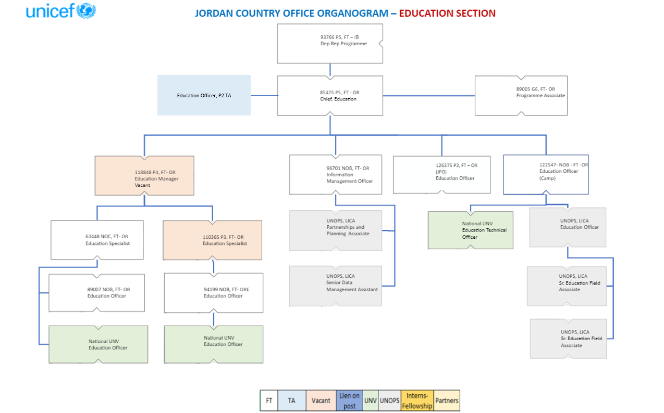

IX. Signatures- Job Description Certification
Title: Chief Education

Supervisor Name: Gemma Wilson-Clark Signature: Date:
Title: Deputy Representative (Programmes)

Name: Shairose Mawji Signature: Date:
Title: Representative

Name : Philippe Duamelle Signature : Date :

IX. Signatures- Job Description Certification
Title: Chief WASH

Supervisor Name: Jesus Trelles Signature: Date:
Title: ADAP Chief

Supervisor Name: John Barrett Trew Signature: Date: 15-Oct-2024
Title: Deputy Representative (Programmes)

Name: Shairose Mawji Signature: Date:
Title: Representative

Name : Philippe Duamelle Signature : Date :

